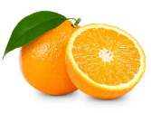
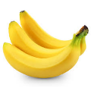
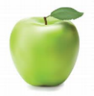
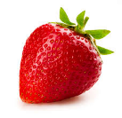
EDUCATION AUTHORITY – NORTH EASTERN REGION
MEAL PLAN SCHOOL MEALS KITCHEN

 | Monday | Tuesday | Wednesday | Thursday | Friday
WEEK  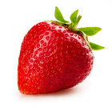  1 | Pasta Bologonaise with grated cheese and crusty bread  Or  Stuffed Bacon Rolls, sweetcorn,  Mashed potatoes and gravy  Custard and Oat cookie | Chicken Curry, Rice & Naan bread  Or  Baked potato with Beans & Cheese  Banana Muffin & Custard | Buffet:  Pizza Fingers, Sandwiches, Vegetable Sticks  Chicken Strip  and Potato wedges,  Ice cream and fresh fruit | Roast chicken, Broccoli and Carrots.  Mashed potatoes, Dry Roast Potatoes, stuffing and gravy.  Chocolate flavoured sponge and custard | Fish Bites / Peas  Or  Lasagne  Chips, mashed potato  or salad  Frozen yogurt & fruit cup
WEEK  2  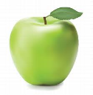 | Chicken Curry, Rice & Naan Bread  Or  Italian Pasta Bake with cheese  Crusty Bread  Flakemeal Biscuit & Fruit | Vegetable Soup  Beef Burger  Or  Homemade Pizza, Salad and Coleslaw  Muffin & fruit | Breaded Fish  Mashed Potatoes  Or  Chicken Pasta Bake & Side Salad  Date Krispie & Custard | Roast Chicken, Carrots, Cabbage, Mashed and Dry Roast Potatoes,Stuffing and Gravy.  Chocolate flavoured cookie and Custard | Chicken Nuggets, Beans and Chips / Potatoes  Or  Hot Chilli Chicken wrap,  Salad and Coleslaw  Yoghurt & Fruit
WEEK  3 | Fish fingers, peas and mashed potatoes  Or  Chicken Crumble, Peas Mashed potatoes and Gravy  Apple Sponge | Meatballs in gravy, Carrots and Mashed Potatoes  Or  Irish stew & Wheaten Bread  Chocolate Flavoured Brownie  & Pears | Chicken curry, Rice & Naan Bread  Or  Baked Potato filled with Tuna and Cheese  Flakemeal Biscuit & Custard | Roast Chicken, Carrots, Parsnips, Mashed potatoes, Dry Roast potatoes, Stuffing and Gravy  Egg Sponge & Custard | Salmon Fishcakes  Salad or Mashed Potatoes  Or  Hot Dog, Beans & Chips  Frozen Yogurt & Fruit Cup
WEEK  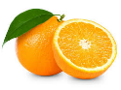  4 | Chicken Fried rice, Curry sauce, Naan Bread  Or  Chicken Nuggets, Beans  Mashed Potato  Flakemeal Biscuit and custard | Buffet:  Sandwiches, Potato Wedges  Pizza finger, Chicken strips Pasta Salad, Carrot sticks.  Ice cream & Fruit | Pasta Bologonaise, Ciabatta Bread and cheese  Or  Coddies with peas, Mashed potatoes & Gravy  Marble Sponge and custard | Roast Turkey, turnips, broccoli  Dry Roast potatoes, Mashed potatoes, Stuffing & gravy.  Chocolate flavoured Brownie  & Fruit | Home-made Chicken Burger  Peas & Chips  Or  Cheese & Tomato Panini, Coleslaw & Salad  Yogurt & Fruit
NB: Milk, water and fresh fruit / vegetables served alongside every set meal.

For further information on allergenic ingredients please contact the school.
Menu may change subject to Nutritional Guidelines and deliveries.

