BBC Bitesize Daily lessons
https://www.bbc.co.uk/bitesize/dailylessons
https://www.bbc.co.uk/iplayer/group/p089nk5f
and
www.bbc.co.uk/afternoonclub

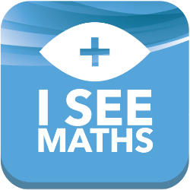

KS1 & KS2 Maths Lessons
http://www.iseemaths.com/home-lessons/

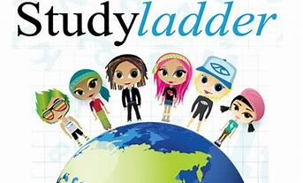
Studyladder
https://www.studyladder.co.uk/
Mathematics, English, Science and more! A comprehensive program of online educational activities for students aged 4 to 12, mapped to the curriculum.

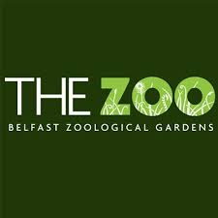

Some great activities and interaction on Belfast Zoo Facebook Page
https://www.facebook.com/belfastzoo/

IDEAS and ACTIVITIES
Stranmillis University College PGCE Early Years students have pulled together a great range of ideas and activities for you and your children to enjoy during the closure of schools and nurseries. We hope you have fun playing and learning together.
https://www.stran.ac.uk/ideas-for-active-minds/

THE HOUSE OF FUN
Everyday objects around the house are a great way to support your child learn numbers, colours, shapes, letters and a whole host of other skills. CLICK FOR IDEAS.

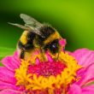

AN INQUISITIVE NATURE
You might be confined to the house but the garden is a great source for natural play and creativity ideas. CLICK HERE for some fantastic outdoor ideas and activities.

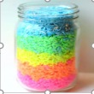

FOODIE HEAVEN
It’s time to open up the cupboards, get creative and have some fun with food – apron advised! CLICK HERE for some great ideas and activities.

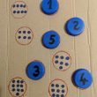

FIGURE IT OUT
Toys, objects and a bit of creativity are all that’s needed for a bit of playful learning with numbers. CLICK HERE for some fun with numeracy.

SCIENCE MADE SIMPLE
It doesn’t have to be Rocket Science. CLICK HERE for some simple experiments and activities to get your children thinking and enjoying playful science.

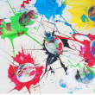

LET THEIR CREATIVITY FLOW
Children have a natural creativity. They love painting and making things. CLICK HERE for some ideas to unleash their inner Picasso.

HEALTH AND WELLBEING
Healthy minds, healthy bodies. During these difficult times, it’s vital to look after our children’s wellbeing. CLICK HERE for activities.

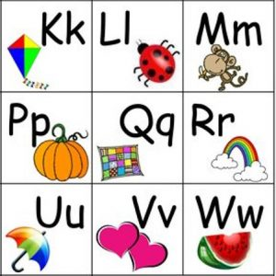

A-Z OF LITERACY
CLICK HERE for activities and ideas for some fun ways to help your child learn the alphabet.

WORLD AROUND US
Help your children learn more about the world around us. CLICK HERE for ideas to get them thinking and playing.

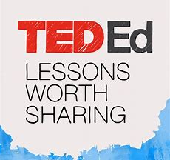
TedED
https://ed.ted.com
High-quality, interactive, video-based lessons on a daily basis, paired with questions and resources.

