**Ditch the Dark Day!!**



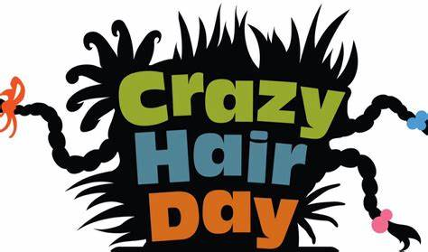

Crazy Hair and Bright Clothes Day

Friday 13 November 2020

**Ditch the Dark Day with a difference.**

* Crazy Hair (spikes, colours, bobbles etc.)
* Non-Uniform Day
* Wear bright, luminous clothes to celebrate Ditch the Dark day
* Walk to School or park a little further away and walk some of the way.