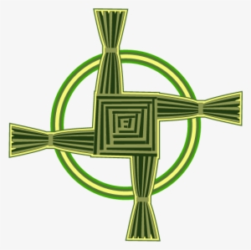
St.Brigid’s – Thank You for the Memories

Thank you to all the teachers for giving me the opportunity to learn, grow and make lots of friends.
From P1 to P7 you have all been welcoming, caring and kind, helping me along the way when I have felt unsure, scared or sad. I have had lots of happy times and made many memories which I will remember for a long time.
I have met lots of people in Primary School - teachers, classroom assistants, caretaker, cleaners, receptionist, the principal and many friends who I hope I will stay friends with for a long time.
All off these people have been nice, kind, helpful and friendly. I have always felt safe in school and as I got older became more confident because of all the help I got from everyone.
I am grateful to Susan our friendly receptionist who always had a big smile and helped look after me when I was feeling sick. Also thankful to our caring caretaker Don who was always on hand to help me find my lost coat or PE bag and pump up a flat tyre on my bike.
In St Brigid’s I have been taught to read, write and spell. I have enjoyed lots of subjects like history, geography, PE and English and also ones that I didn’t really like such as Spanish and Maths! I thank all the teachers for helping me to learn.
I have went on lots of school trips, my favourite being the Zoo, Carromena Activity Centre, Carnfunock Park and Airtastic. I had great fun on all of them and especially enjoyed the buses!
My most memorable trip was Airtastic which was so much fun, bouncing on the trampolines and doing front flips with all my friends.
I love sport and at school was lucky to be in lots of school teams, cross country, football, hurling and hockey. I got to take part in other sports too like tag rugby and swimming. I got to go on lots of tournaments, the best one was the mixed boys and girl’s hockey tournament in Coleraine where we went on to win!! My wee brother was also on the team. We celebrated a lot and were given a medal and trophy.
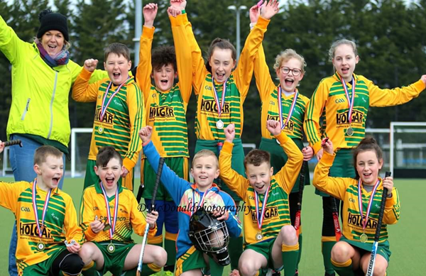

I have also enjoyed all my sports days from P1 to P7, my favourite event when I was younger was the obstacle race and the running race when I got older.
There have been lots of events which I have taken part in and had lots of fun! Here are some of my favourite:
- Green Day – St.Patrick’s Day and the Ceili dancing
- School Discos and the tuck shop
- Holy Communion, seeing everyone dressed up and having family meal at the restaurant
- Prize Days, receiving my medals and certificates
- Christmas concerts and Christmas Bazzars
I enjoyed lots more like shared education where I meet new people, school masses, non-uniform and fancy-dress days.
I have had many personal achievements like taking part in the winning hockey team and making it through to the NI tournament. Another big one for me was reaching my first AR target and receiving a reading certificate. I think being an altar boy was also a good achievement for me.
During my time in St.Brigid’s I have made many memories all of them are special and I will remember forever.
All my teachers and classroom assistants have been brilliant but finishing in P7 with Mrs Campbell has been great. She is super funny and kind all loves all types of music!
I am going to miss spending time with all my friends, playing football at lunch time and taking part in the school football and hockey teams.

