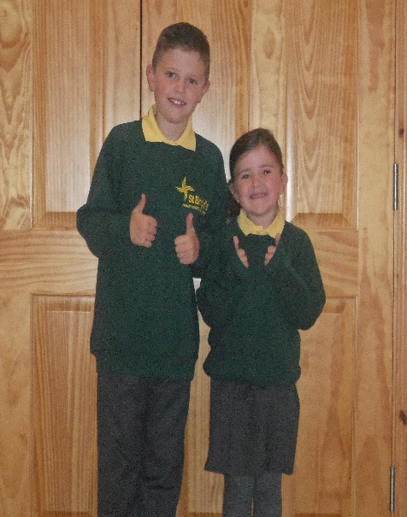
A MASSIVE THANK-YOU TO MY HOME FROM HOME;
ST BRIGID’S PRIMARY SCHOOL

I was so excited to start St Brigid’s in September 2013. Susan and I had decided to make the move from Ballymoney Nursery together, and I couldn’t wait to join my big brother Sean and all my cousins.

I still remember my very first day in P.1; I sat beside Naimh and we decorated our names together. I quickly learnt how to read, write and spell and am so grateful to Mrs. McKay and my aunt Angela for making my introduction to learning such fun. Those wee ants will be forever running up my arm

We had so much fun in P.2 that Mrs. Diamond came back to teach us again in P.4. Thank you for helping me prepare for my First Holy Communion – this is probably the only day I managed to dress just as stylish as you!!

P3 was time for First Confessions and I remember most of the class heading to Subway afterwards and then running back down the street for the school disco. I dressed up as a wind up doll for Halloween and won a prize. We had a big leaving party for Mr. Conlan.

P4 started with a bang as Mrs. McNally & Mrs. Campbell had organized a bouncy castle and ice-cream van for our first day back – this marked the start of a great year. I made my First Holy Communion, I couldn’t wait to get all dressed up and have a big party. Thank you to Mrs. McIlroy & Mrs. Diamond for making sure that I was well prepared. We also welcomed our new principle Mr. O’Neill and said good-bye to Mrs. McNally – another excuse for a big party.

In P5 I was taught by Mrs. McMullan and loved every minute of it. Although your manner was mild the weather was anything but ... first came storm Ophelia and then it was storm Cara. I loved doing my space presentation and watching newsround every day.

P6 was the start of the hard work and I was so lucky to have Ms. McCormick come back to help get me prepared. I want to say a massive thank you to you, Mrs. Campbell & Mr. O’Neill for teaching and guiding me through my Transfer Test. It was hard work but I got into the secondary school that I’ve always wanted to go to, so thank you for helping me with that!!

P7, although shorter than expected, was a fantastic year and I loved being taught by Mrs. Campbell. Although the year didn’t end the way we would’ve wanted it to, and we didn’t get to do all the fun things you had planned for us, like Big Business Day and final plays, I’m extremely grateful for the fun tasks you set and for the personal encouragement you gave me, as I got used to lockdown and online learning.

I have honestly loved my time at St Brigid’s, and have so many happy memories of fancy dress, school plays, special assemblies, school discos, sports clubs and school trips. I loved it so much my mum sometimes had to come back to collect me later from afterschool’s. A special thank you to Jayne for organizing the Connect 4, Pool and Chess tournaments - I had great fun competing in them.

Susan thank you for always making me smile. I would love for you to come to St Louis with me, but I know that all the other children would miss you too much.

To all the other staff, (Classroom Assistants, Teachers, Cleaners and Don) THANK YOU for making St Brigid’s the fun and creative learning environment it is.

I will always look back at my time at St Brigid’s with great fondness, remembering all the fun I had with all my friends and my fab extended St Brigid’s family who made learning so much fun. Thank you for the memories. Cara Moore #2020
