

**School Information for Parents/Guardians**

**Monday 12 November 2018**

Follow us now on **the web** for news updates

**www.stbrigidspsballymoney.com**

**Monday 12 November**

* Yr6 Library Visit 11-12noon (bring coats)
* Be Unique - After School Drama Club 3-4pm **(Payment required as per plan option)**
* Guitar Lessons 9.00-4.20 pm **(Payment required as per plan option)**

**Tuesday 13 November**

* Yr 4 Shared Education Session in St Brigid’s PS 9.30 – 11.30 am
* Year 5 and Class B swimming
* Doherty Cup v Hezlett PS 1.00 pm at University

**Wednesday 14 November**

* Year 2 & 3 Musical Pathways Programme 1.00-2.00pm (10 weeks- £10 or £1 per week)
* Tag Rugby After School 3-4pm (Year 6 & 7) £2 per week/£10 5 weeks

**Thursday 15 November**

* Yr 5 Shared Education Session in Joey Dunlop Leisure Centre 9.30am – 12noon
* Year 2 visit to Causeway Hospital 9.15 am - Lunch
* Music Lessons: Violins
* PTA Meeting 7pm

**Friday 16 November**

* Principal’s Assembly
* Football 1.30-3.00 pm
* Music Lessons: Piano

**Up and coming information & dates for your Diary**

* **Open Day 2018 for children starting school in September 2019 is on Thursday 29 November 2018 at 10.00 am**
* **If you cannot make the general Open Day, please contact the school to arrange a suitable date and time at your convenience to get a tour of the school.**
* **Reminder: There is a child in the school with a Nut Allergy – Please do not send in Nuts or Nut Spreads to school.**
* **PTA Christmas Bazaar Sunday 25 November 12.30 – 2.30 pm**

**Registration P1 September 2019**

**If you have a child starting school in September or know someone who is, please contact the school to register your interest.**

**Application process is online this year and open during the month of January 2019. Please contact the school if you require any assistance in completing the online application.**

Have a very enjoyable weekend and thanks for your continued support.

Mr K O’Neill Principal

**St Brigid’s Primary School – Castle Street – Ballymoney – BT53 6JX – 028 27662664**

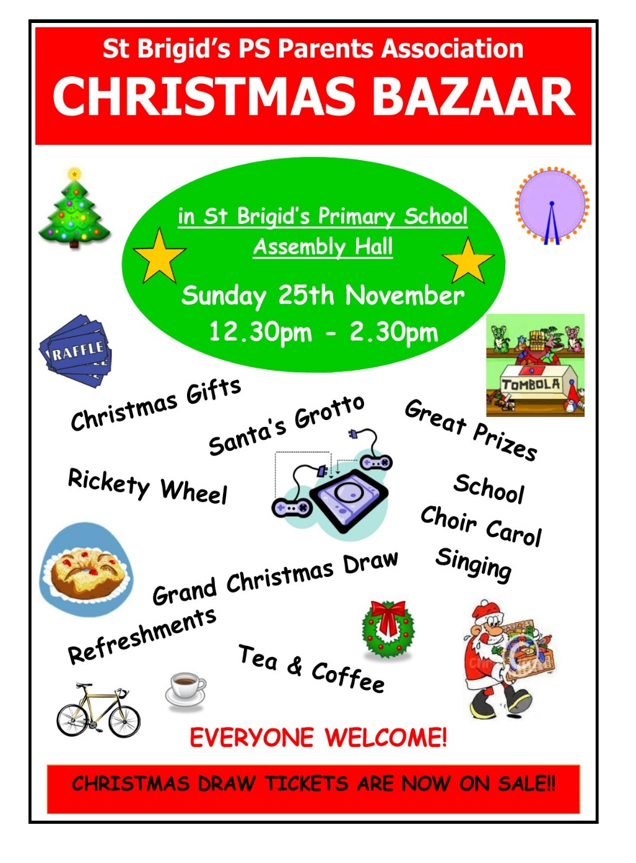

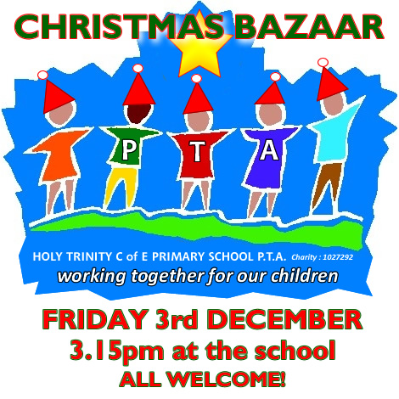

**The Grand Christmas Draw**

Tickets have gone out to every family. If you need any more contact the school.

Please return any tickets (sold/unsold) to the school on or before Friday 16 November. We can try to sell any unsold tickets before the 25 November draw.

[](https://www.google.co.uk/url?sa=i&rct=j&q=&esrc=s&source=images&cd=&cad=rja&uact=8&ved=0ahUKEwiXjriqhsrWAhVNaVAKHXhhDDQQjRwIBw&url=https://twitter.com/roadofhope44&psig=AFQjCNFEro0zYGQfbOsMoIxtnUWD5sDPRw&ust=1506762605508762)

The annual Road of Hope Shoeboxes were collected on **Thursday 8th November**. Thank you for supporting this very worthwhile appeal. Thanks to your great generosity we collected 120 shoeboxes.

If you would still like to fill a shoebox they can be left into the school and we will make sure they are delivered to The Road of Hope Appeal.

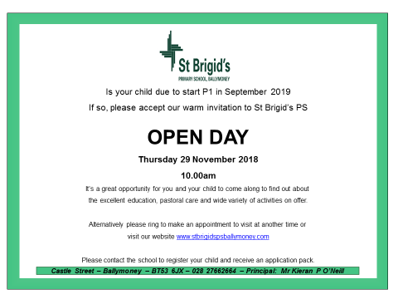



**Sunshine Club**

In order for the Sunshine Club (3:00 – 5:30pm) to run as efficiently and safely as possible we would ask for your co-operation on the following three issues:

* Contracts need to be completed
* Children must be picked up promptly at the agreed times recorded in contracts
* Booking forms should to be returned on time
* Due to the high demand of places in the Sunshine Club, we apologise that there **cannot** be a ‘drop in’ approach.