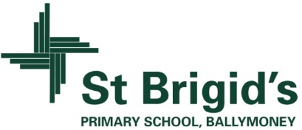
School Information for Parents/Guardians
Monday 13 November 2017

Follow us now on the web for news updates
www.stbrigidspsballymoney.com
The weekly note is now available on the website and will be uploaded into the downloads section.

Monday 13 November
- Be Unique - After School Drama Club 3-4pm (Payment required as per plan option)
- Guitar Lessons 9.00-4.20 pm (Payment required as per plan option)
- Yr 2/Class A visit from RNIB (am)

Tuesday 14 November
- Year 5 and Class B swimming
- Singing lessons 9.00-3.00 pm (Payment required as per plan option)

We no longer accept the round £1 coin.
Thank you.
Wednesday 15 November
- Tag Rugby After School 3-4pm (Year 6 & 7) £2 per week

Thursday 16 November
- Doherty Cup Match v Harpur’s Hill 2.15pm @ University
- Music Lessons: Violins

Friday 17 November
- Return all Christmas Draw tickets (sold/unsold). Thank you.
- Principal’s Assembly
- Class A Assembly
- Football 1.30-3.00 pm
- Music Lessons: Piano

Up and coming information & dates for your Diary

- Sunshine Club: 2.00 – 3.00 pm (£2) 3.00 – 5.30 pm (£2 per hour or part thereof)
- Any pre-payment made for Sunshine Club on Monday 16 & Tuesday 17 October (Storm Closures) will be deducted from the November bill.
- Breakfast Club: 8.00 – 9.00 am (£1 per day)
- Morning Drop Off: Please be careful when entering and exiting the chapel gate. It is a two-way traffic system but please consider the space needed for cars entering and leaving at the gate.
- Reminder: There is a child in the school with a Nut Allergy – Please do not send in Nuts or Nut Spreads to school.
- Tickets for the Grand Christmas Draw can be returned at any time to the school office.

Have a very enjoyable weekend and thanks for your continued support.

Mr K O’Neill Principal
St Brigid’s Primary School – Castle Street – Ballymoney – BT53 6JX – 028 27662664
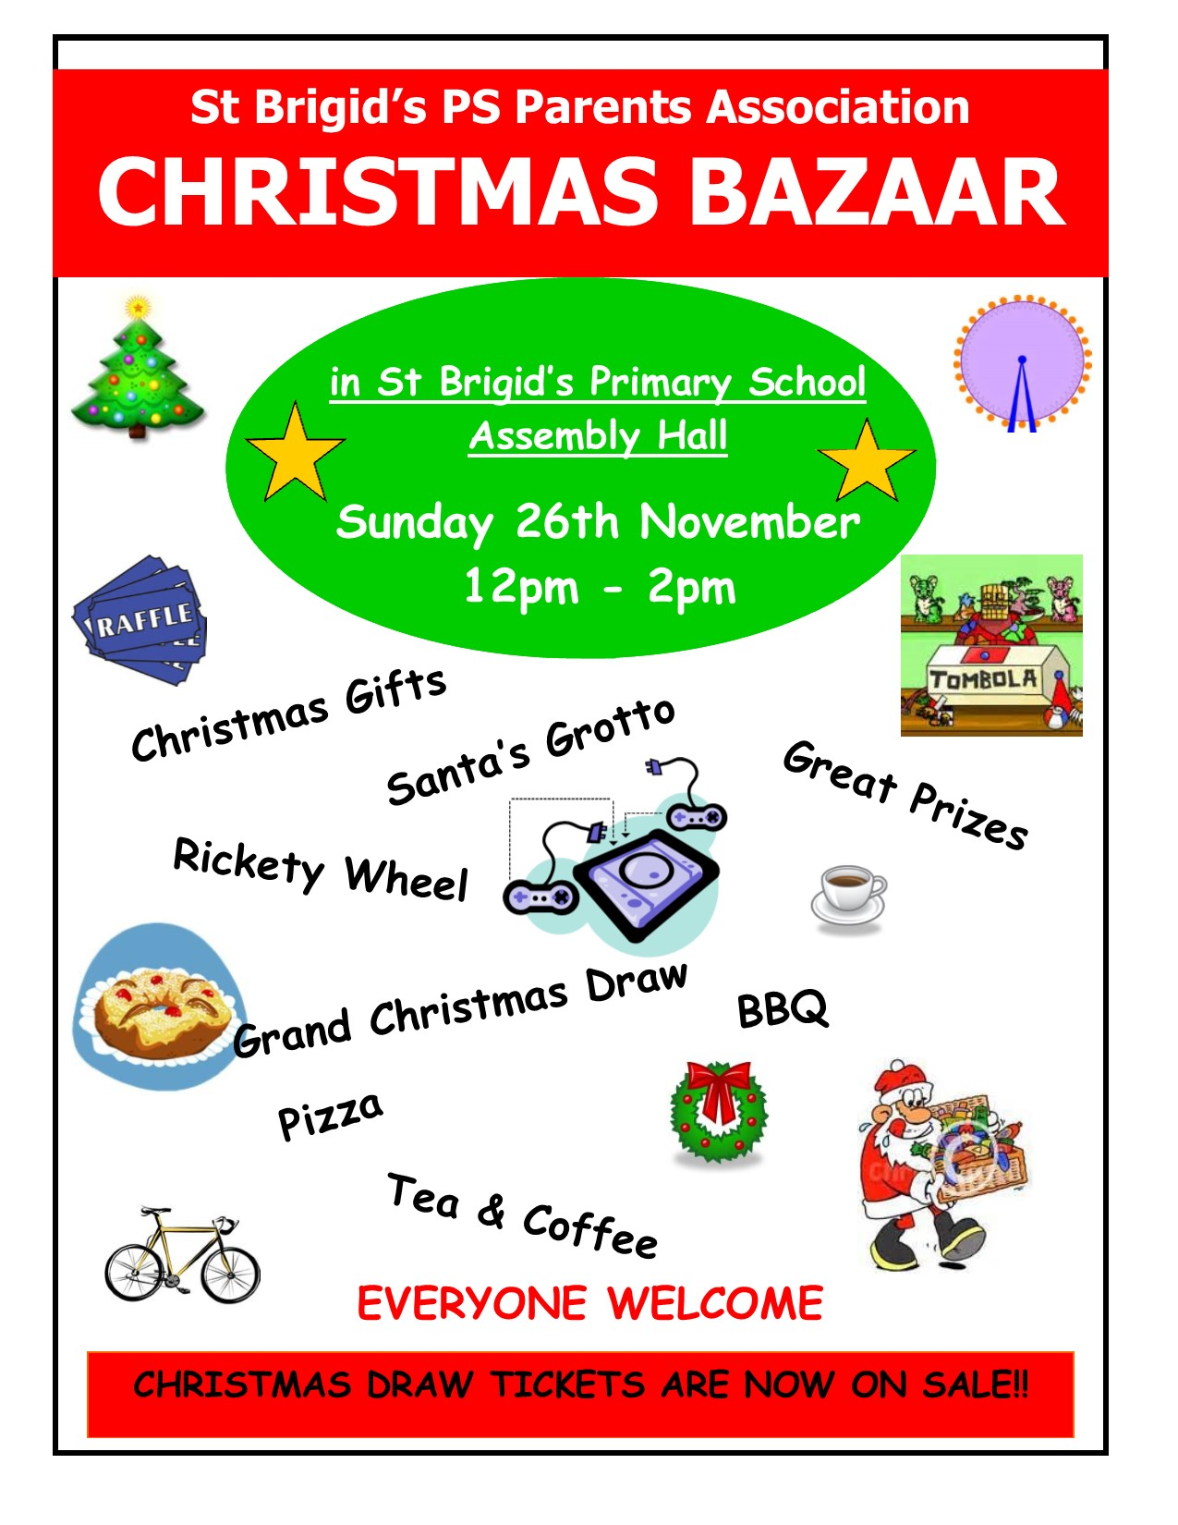

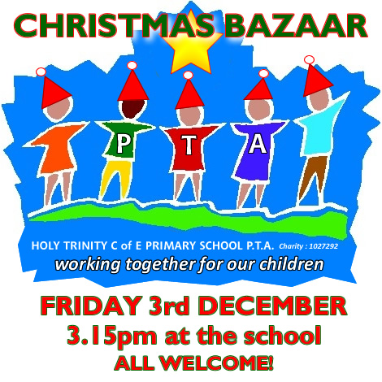

Please return any tickets (sold/unsold) to the school on or before Friday 17 November. We can try to sell any unsold tickets before the 26 November draw.

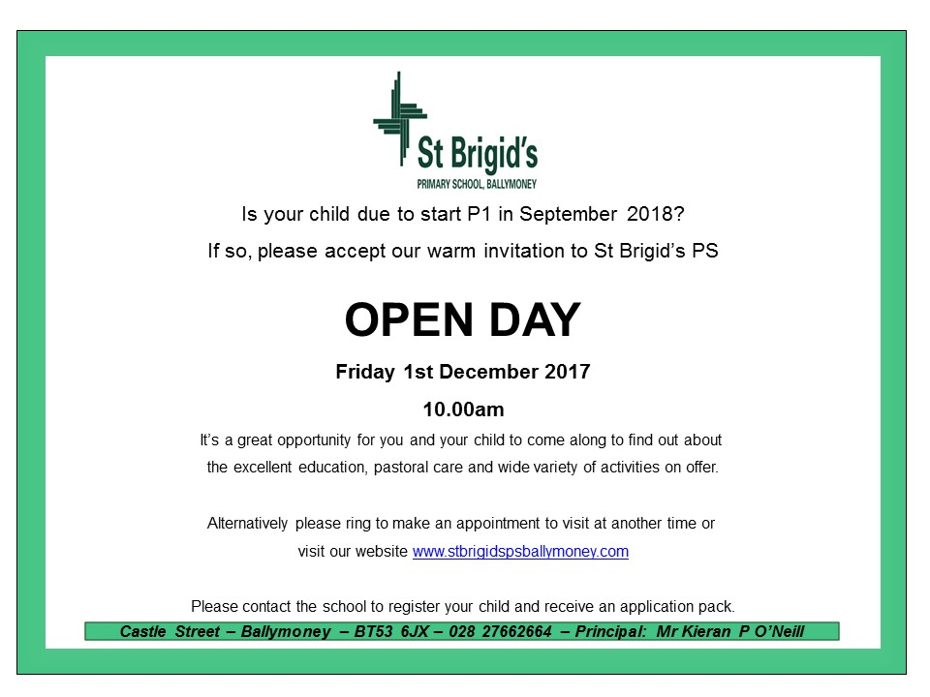
School Choir Carol Singing
Irish Stew
Shoebox Appeal 2017
The annual Road of Hope Shoeboxes was collected on Tuesday 7th November. Thank you for supporting this very worthwhile appeal. Thanks to your great generosity we collected 126 shoeboxes.
If you would still like to fill a shoebox they can be left into the school and we will make sure they are delivered to The Road of Hope Appeal.

Registration P1 September 2017
If you have a child starting school in September or know someone who is, please contact the school to register your interest.
We will send out application packs in December.
The Grand Christmas Draw
Tickets have gone out to every family. If you need any more contact the school.

