

**School Information for Parents/Guardians**

**Monday 15 April 2019**

Follow us now on **the web** for news and updates

**www.stbrigidspsballymoney.com**

**Monday 15 April**

* Guitar Tutor in
* Netball – Boys’ and girls’ teams in OLOL 3.15-415 pm

**Tuesday 16 April**

* **No Swimming**
* Singing tutor in

**Wednesday 17 April**

* Year 6 Healthy Me – Workshop
* Non-Uniform Day – Swimming Unicorns Charities - £1 donation

**Thursday 18 April**

* School Closes 12noon for Easter Holidays

**Friday 19 April**

* School Closed

**Up and coming information & dates for your Diary**

* **Reminder: There is a child in the school with a Nut Allergy – Please do not send in Nuts or Nut Spreads to school.**
* **Term 2 Holidays:**

**Easter: Friday 19 – Fri 26 April 2019**

**School Closes 12noon Thursday 18 April (No Sunshine Club this day) Classes A & B will finish on Wednesday 17 April.**

**School Reopens Monday 29April**

**Car Parking**

**Please use the parking spaces provided in the chapel car park. Driving right up to the gate can be dangerous as when reversing back there will always be children walking towards the gate.**

Have a very enjoyable weekend and thanks for your continued support.

Mr K O’Neill Principal

**St Brigid’s Primary School – Castle Street – Ballymoney – BT53 6JX – 028 27662664**



All of the classes have a Trócaire box and the collection of small change is promoted, given that ‘pennies make pounds’!

**Milk Carton Challenge**

Please bring in any milk cartons on or before Wednesday 17 April.

Thanks to everyone who has supported our annual Trocaire Appeal

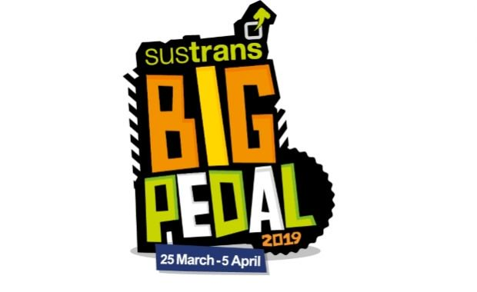

Congratulations to everyone who took part in the Big Pedal 2019.

3rd Overall in Northern Ireland

13th Overall in UK

What a great achievement!!! Again!!

Thanks to all the parents and grandparents for your support in helping the children pedal, scoot and walk to and from school.

**School Closure Advance Notice**

The school will be closed on **Thursday 2 May**

Polling Station for Local Council Elections

**Holiday Dates Term 3**

**Election:** Thursday 2 May

**May Day:**  Monday 6 May

**May Holiday:**  Monday 27 May - Tuesday 28 May

School re-opens Wednesday 29 May

**Summer:** School Closes 12noon Friday 28 June

[](http://www.google.co.uk/url?sa=i&rct=j&q=&esrc=s&source=images&cd=&cad=rja&uact=8&ved=0ahUKEwjLmMe16Y3TAhUpCMAKHSZ0CAAQjRwIBw&url=http://www.geograph.ie/photo/830316&psig=AFQjCNEc5XridgVoh16sBkNi-3Lo3JVR9A&ust=1491499100224848)

EASTER SERVICES

Our Lady and St Patrick’s

Holy Thursday: 7.30 pm

Good Friday: 3.00 pm Solemn Ceremonies

Stations of the Cross

Time TBC

Saturday: 9.00 pm Easter Vigil

Easter Sunday: 11.00 am

**Non-Uniform Day**

A group of children in Year 6 have returned as the ‘Swimming Unicorns’ team and will be completing a 1.5km swim on for Cancer Research, Marie Curie and the Swimathon Foundation.

To support the activity, we will have a **non-uniform day on Wednesday 17 April** with a donation of £1 per child.

[](https://www.google.co.uk/url?sa=i&rct=j&q=&esrc=s&source=images&cd=&ved=2ahUKEwiX2bel1eDgAhX5QxUIHcGyDfEQjRx6BAgBEAU&url=https://store.vitalsd.co.uk/tr014-check-speed-10-miles-per-hour-traffic-signs.html&psig=AOvVaw0cDqxKt7pyPUnGiyTaAhCx&ust=1551520170191550)

**Speed in the Chapel Car Park**

**Please be mindful of your speed in the chapel car park when dropping off and picking up the children. The car park is busy with children moving to and from cars. All drivers must be careful. Speed limit is 10 miles per hour.**