

**School Information for Parents/Guardians**

**Monday 15 October 2018**

Follow us now on **the web** for news updates

**www.stbrigidspsballymoney.com**

**Monday 15 October**

* Dinner menu Week 3
* Guitar Lessons
* After School Drama Club 3-4 pm
* Mix-it-Up Club Yr6 & 7 3-4pm
* Cartoon Drawing Club Yr4 & 5 3-4 pm

**Tuesday 16 October**

* Year 5 & Class B swimming
* Singing Tutor in
* Games Club 3-4 pm

**Wednesday 17 October**

* Yr 7 Trip to Kilrea Lock Gates 9.30 – 1.00 pm
* Year 6 Hockey 11am - 12noon (5 weeks - £5 per child)
* Year 2 & 3 Musical Pathways Programme 1.00-2.00pm (10 weeks- £10 or £1 per week)

**Thursday 18 October**

* Yr 4 Shared Education Session in St Brigid’s PS PS 9.30 – 11.30 am
* Violin tuition

**Friday 19 October**

* Principal Awards
* Piano tuition

**Up and coming information & dates for your Diary**

* **Parent Interviews Mon 22 – Thurs 25 October**. **School will close at 2.00 pm all week.** No casual bookings available for Sunshine Club.
* Sunshine Club: 2.00 – 3.00 pm (£2) 3.00 – 5.30 pm (£2 per hour or part thereof)
* Breakfast Club: 8.00 – 9.00 am (£1 per day)
* **Reminder: There is a child in the school with a Nut Allergy – Please do not send in Nuts or Nut Spreads to school.**
* **PTA Christmas Bazaar Sunday 25 November 12.30 – 2.30 pm**

Have a very enjoyable weekend and thanks for your continued support.

Mr K O’Neill Principal

**St Brigid’s Primary School – Castle Street – Ballymoney – BT53 6JX – 028 27662664**

[](http://www.google.co.uk/url?sa=i&rct=j&q=&esrc=s&source=images&cd=&cad=rja&uact=8&ved=2ahUKEwiEnayCsajdAhXEK8AKHVmtCFUQjRx6BAgBEAU&url=http://www.katyisd.org/campus/HE/Pages/PTA.aspx&psig=AOvVaw2Pet2zGg8sjf3JuWqVy3kD&ust=1536392124057568)

**PTA Update**

**New Playground Equipment**

**Netball, Hockey and Football Equipment**

**New school Sports Kit ordered**

**New Playground markings ordered**

Let’s make a wiser choice – Get the Active Travel Bug!!!

[](https://www.google.co.uk/imgres?imgurl=http://www.healthychildrenliving.com/images/slidenew.jpg&imgrefurl=http://www.healthychildrenliving.com/&docid=d-R0deW7vAlbIM&tbnid=PBmbka2QTttFwM:&w=960&h=331&hl=en&safe=active&bih=674&biw=1024&ved=0ahUKEwjPpMifs5PPAhWnJ8AKHSInCdoQMwgqKA4wDg&iact=mrc&uact=8)

We are a Sustrans School so let’s make

smarter travel choices and walk, cycle or scoot to school.

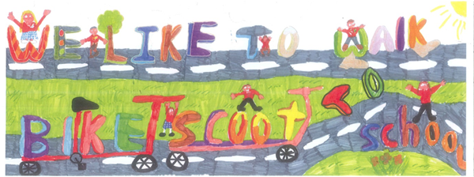

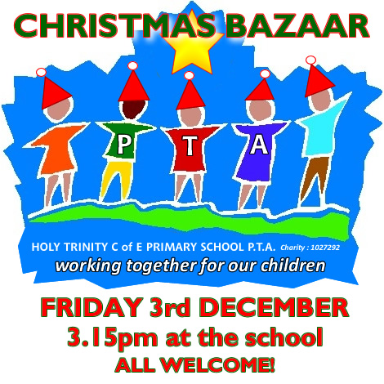

[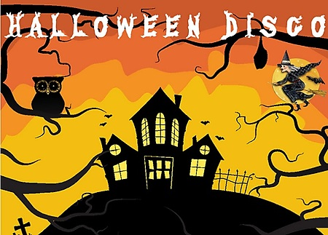](http://www.google.co.uk/url?sa=i&rct=j&q=&esrc=s&source=images&cd=&cad=rja&uact=8&ved=0ahUKEwiR-avVgMrWAhWHJVAKHaKiBXYQjRwIBw&url=http://www.newbridgememo.co.uk/en/whats-on/events/halloween-disco/&psig=AFQjCNHAIMpXn3tG9M1iFa_Wo9qCiUcmyA&ust=1506761094389910)

**Thursday 25 October**

Y1-3 6.30 - 7.30 pm

Yr4-7 7.45 - 8.45 pm



**Halloween Fancy Dress Day**

Friday 26 October 2018

Save the date!!!

**Sunday 25 November 2018**

**Straight after Sunday morning mass**

Loads of Prizes on the Ricketty Wheel

Food served

Choir singing

Grand Christmas Draw

More details to follow

[](https://www.google.co.uk/url?sa=i&rct=j&q=&esrc=s&source=images&cd=&cad=rja&uact=8&ved=0ahUKEwiXjriqhsrWAhVNaVAKHXhhDDQQjRwIBw&url=https://twitter.com/roadofhope44&psig=AFQjCNFEro0zYGQfbOsMoIxtnUWD5sDPRw&ust=1506762605508762)

**Shoebox Appeal 2018**

The annual Road of Hope Shoeboxes will be collected on Tuesday 8th November. Please try to support this very worthwhile appeal.