School Information for Parents/Guardians
Monday 16 October 2017

Follow us now on the web for news updates
www.stbrigidspsballymoney.com
The weekly note is now available on the website and will be uploaded into the downloads section.

Monday 16 October
- RNIB visiting Class A and Year 2 11am
- Year 7 visiting Loreto College to see production of ‘Footloose’ Dep: 8.45am and back for lunch
- Be Unique - After School Drama Club 3-4pm (Payment required as per plan option)
- Guitar Lessons 9.00-4.20 pm (Payment required as per plan option)
- Parent Interview times out today

Tuesday 17 October
- Year 6 Townscape Heritage Project in school
- Year 5 & Class B swimming
- Singing lessons 9.00-3.00 pm (Payment required as per plan option)
- Doherty Cup match v Ballysally PS 2.00pm in University
- Cartoon Drawing Club 3-4 pm

Wednesday 18 October

The old, round £1 coins will no longer be legal tender after Sunday 15 October 2017.
We will no longer be able to accept the round £1 coin after this date.
Thank you.
- Year 6 Hockey 11-12
- Mix it Up Club 3-4 pm
- Netball Club 3-4 pm

Thursday 19 October
- Year 2 and Class A visiting the Causeway Hospital
9.30 – 11.30 am
- Music Lessons: Violins

Friday 20 October
- Principal Assembly
- Football 1.30-3.00 pm
- Music Lessons: Piano
Up and coming information & dates for your Diary
- Parent Interviews Mon 23 – Thurs 26 October. School will close at 2.00 pm for all this week. No drop in club available on these days and sunshine club from 2-5.30 pm must be booked in advance.
- Sunshine Club: 2.00 – 3.00 pm (£2) 3.00 – 5.30 pm (£2 per hour or part thereof)
- Breakfast Club: 8.00 – 9.00 am (£1 per day)
- Reminder: There is a child in the school with a Nut Allergy – Please do not send in Nuts or Nut Spreads to school.

Have a very enjoyable weekend and thanks for your continued support.

Mr K O’Neill Principal
St Brigid’s Primary School – Castle Street – Ballymoney – BT53 6JX – 028 27662664

Save the date!!!
Sunday 26 November 2017
Straight after Sunday morning mass

Loads of Prizes on the Ricketty Wheel
Food served
Choir singing
Grand Christmas Draw
More details to follow

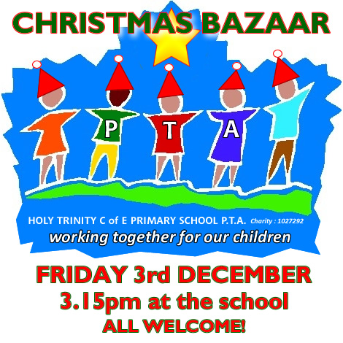

Class B
Faith McNicholl & Micheal Delargy
Year 4
Gracia Kelly/Lucy McLaughlin & Ryan Fleming & Ryan McLaughlin
Year 5
Alice Todd & Katie Ellen McCaw
Year 6
Devyn McAlister & Luke Connor
Year 7
Niamh Harmer & Reece Mitchell
Year1/Class A Rep
Dara Kealey McDonald
Year 2 Rep
Oliwia Ozcerekto
Year 3 Reps
Con McLaughlin & Jay Neely Campbell

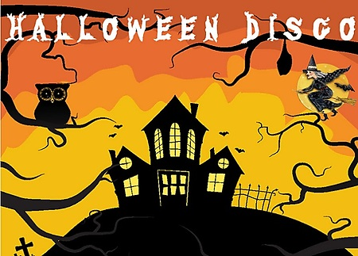
Thursday 26 October

Shoebox Appeal 2017
The annual Road of Hope Shoeboxes will be collected on Tuesday 7th November. Please try to support this very worthwhile appeal.
For details visit the website
http://www.roadofhope.org.uk/

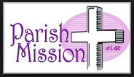
Saturday 21 - Sunday 29 October 2017
Parish Mission - more details to follow soon
Together in Faith - Everyone Welcome

