

**School Information for Parents/Guardians**

**Monday 19 November 2018**

Follow us now on **the web** for news updates

**www.stbrigidspsballymoney.com**

**Monday 19 November**

* Yr6 Library Visit 11-12noon (bring coats)
* Hurling Trials Y6/7 2-3pm
* Be Unique - After School Drama Club 3-4pm **(Payment required as per plan option)**
* Guitar Lessons 9.00-4.20 pm **(Payment required as per plan option)**

**Tuesday 20 November**

* Year 5 and Class B swimming

**Wednesday 21 November**

* People who help us: Visit from Dental Nurse – 9.30-10.30 – Yr2 & 4
* Year 2 & 3 Musical Pathways Programme 1.00-2.00pm (10 weeks- £10 or £1 per week)
* Tag Rugby After School 3-4pm (Year 6 & 7) £2 per week/£10 5 weeks

**Thursday 22 November**

* Year 4 Library visit 11-12noon (bring coats)

DECEMBER MILK £2.94

LAST ORDERS FRIDAY 25TH NOVEMBER

* [](http://www.google.co.uk/url?sa=i&rct=j&q=&esrc=s&source=images&cd=&cad=rja&uact=8&ved=0ahUKEwiznISssqbSAhWDJMAKHXXeDgAQjRwIBw&url=http://www.octoberafternoon.com/line.php?line=DFMM&psig=AFQjCNF2WFP9EeC7h1uRE6Pi4L-OIzj1ig&ust=1487945183162044)Year 2 visit to Causeway Hospital 9.15 am - Lunch
* Music Lessons: Violins

**Friday 23 November**

* Indoor Camogie Blitz in Dunloy (starts 9.30 am)
* Principal’s Assembly
* Football 1.30-3.00 pm
* Music Lessons: Piano

**Sunday 25 November**

* Christmas Bazaar 12.30 – 2.30 pm **School Choir singing at 11am Mass and at opening of Bazaar.**

**Up and coming information & dates for your Diary**

* **Open Day 2018 for children starting school in September 2019 is on Thursday 29 November 2018 at 10.00 am**
* **Reminder: There is a child in the school with a Nut Allergy – Please do not send in Nuts or Nut Spreads to school.**
* **Big Bedtime Read – Y1 & 2 Parents and Children Tuesday 27 November 6.30 –7.30 pm**

**Registration P1 September 2019**

**If you have a child starting school in September or know someone who is, please contact the school to register your interest.**

**Application process is online this year and open during the month of January 2019. Please contact the school if you require any assistance in completing the online application.**

Have a very enjoyable weekend and thanks for your continued support.

Mr K O’Neill Principal

**St Brigid’s Primary School – Castle Street – Ballymoney – BT53 6JX – 028 27662664**

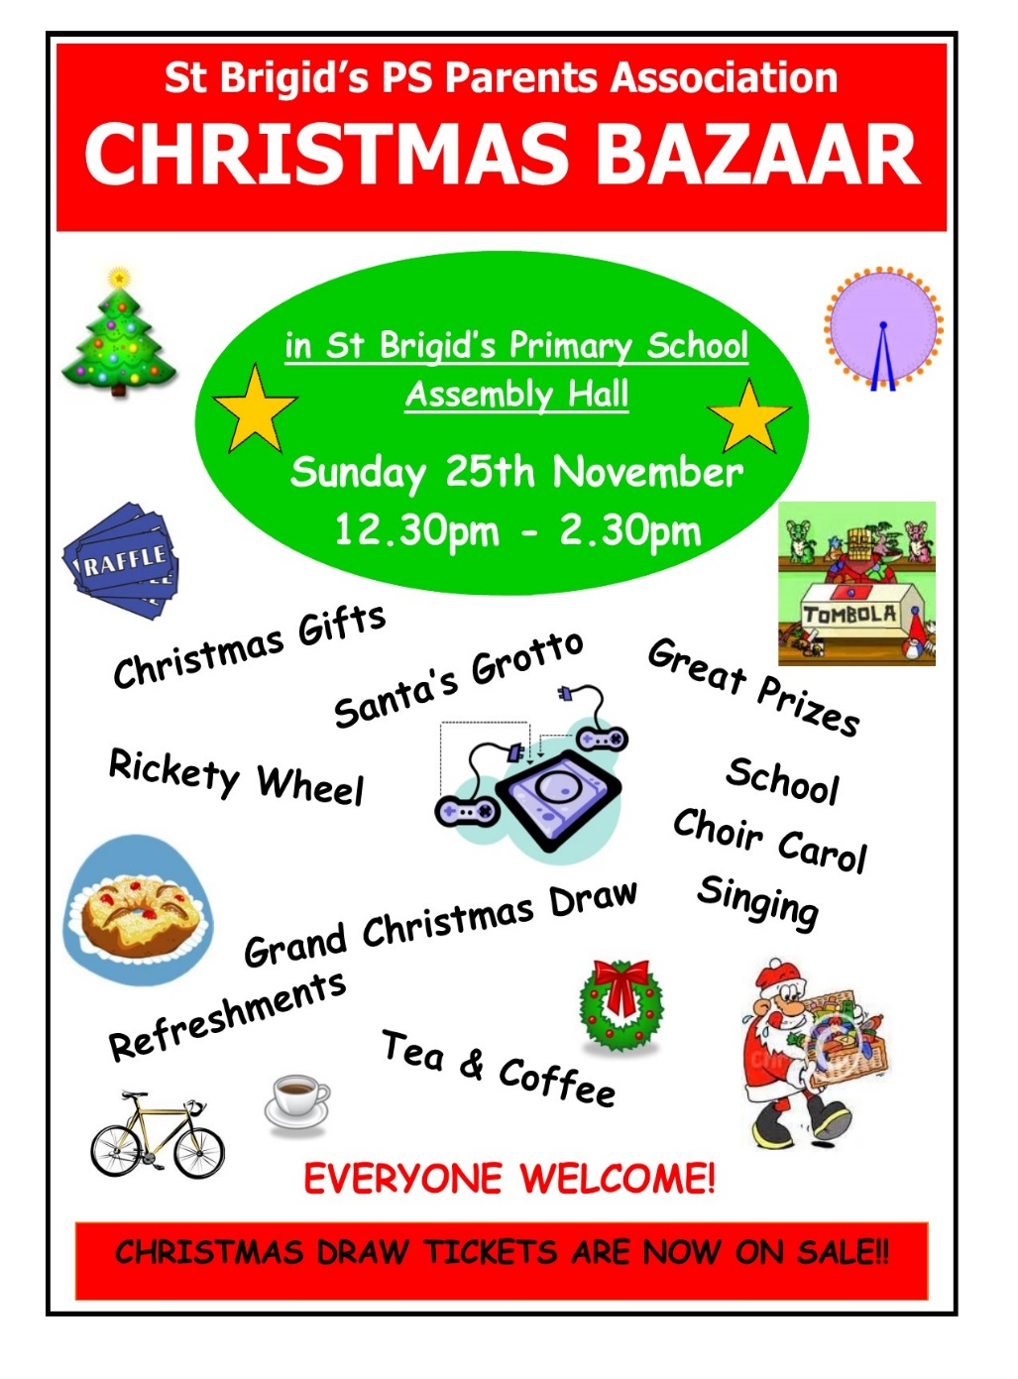

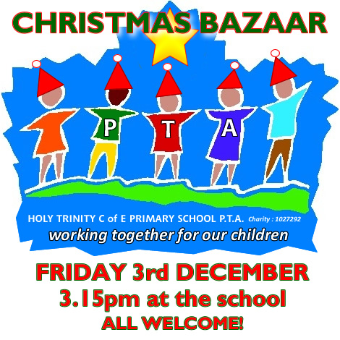

**The Grand Christmas Draw**

Tickets have gone out to every family. If you need any more contact the school.

Please return any tickets (sold/unsold) to the school on or before the end of the week. We can try to sell any unsold tickets before or on the day of the Bazaar.



**Sunshine Club**

In order for the Sunshine Club (3:00 – 5:30pm) to run as efficiently and safely as possible we would ask for your co-operation on the following three issues:

* Contracts need to be completed
* Children must be picked up promptly at the agreed times recorded in contracts
* Booking forms should to be returned on time
* Due to the high demand of places in the Sunshine Club, we apologise that there **cannot** be a ‘drop in’ approach.

[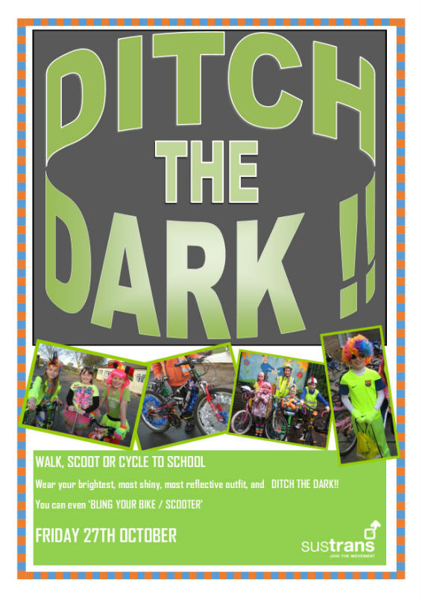](http://www.google.co.uk/url?sa=i&rct=j&q=&esrc=s&source=images&cd=&cad=rja&uact=8&ved=&url=http://www.castlegardens.org.uk/news/friday-27th-october---ditch-the-dark-day/&psig=AOvVaw26Kg3_5Hh2TsxpQz5eATrM&ust=1511000248242140)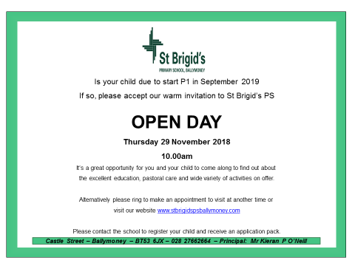

Thursday 6 December

**Be Bright and Be Seen!**

Wear something bright, shiny and reflective.

Walking Bus from Mathewson’s Chemist Car Park and Town Hall Car Park.

Assemble 8.40 am