

**School Information for Parents/Guardians**

**Monday 2 October 2017**

Follow us now on **the web** for news updates

**www.stbrigidspsballymoney.com**

**Monday 2 October**

* After School Club open every day 2.00 - 5.30pm
* Be Unique - After School Drama Club 3-4pm **(Payment required as per plan option)**
* **Final Call** - Recycling clothes, shoes, curtains etc.
* Guitar Lessons 9.00-4.20 pm **(Payment required as per plan option)**

**Tuesday 3 October**

* Year 5 & Class B swimming
* Singing lessons 9.00-3.00 pm **(Payment required as per plan option)**
* Townscape Heritage Initiative Year 6 to Town Hall 9.45 - 11.45 am
* Cartoon Drawing Club 3-4 pm

**Wednesday 4 October**

* Year 6 Hockey 11-12
* Mix it Up Club 3-4 pm
* Netball Club 3-4 pm

**Thursday 5 October**

* Music Lessons: Violins

**Friday 6 October**

* Principal Assembly
* Football 1.30-3.00 pm
* Music Lessons: Piano

**Up and coming information & dates for your Diary**

* Important: Could your child be entitled to free school meals? Did your child receive free school meals last year? Remember you may need to confirm details with the Education Authority. If you think you are entitled but are unsure about what to do please call into the office for advice and a form.
* **Parent Interviews Mon 23 – Thurs 26 October**. School will close at 2.00 pm for all on these days. **No drop in club available on these days and sunshine club from 2-5.30 pm must be booked in advance.**
* Sunshine Club: 2.00 – 3.00 pm (£2) 3.00 – 5.30 pm (£2 per hour or part thereof)
* Breakfast Club: 8.00 – 9.00 am (£1 per day)
* **Reminder: There is a child in the school with a Nut Allergy – Please do not send in Nuts or Nut Spreads to school.**

Have a very enjoyable weekend and thanks for your continued support.

Mr K O’Neill Principal

**St Brigid’s Primary School – Castle Street – Ballymoney – BT53 6JX – 028 27662664**



**All Tex Clothing, Bed Linen, Curtains and Shoes Recycling**:

We are now collecting again for the next two weeks. If you need a Summer clear out please send in any unwanted items. Keep shoes separate.

Final Call this week!!!

[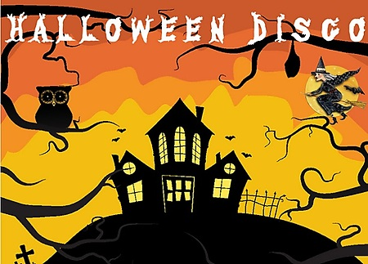](http://www.google.co.uk/url?sa=i&rct=j&q=&esrc=s&source=images&cd=&cad=rja&uact=8&ved=0ahUKEwiR-avVgMrWAhWHJVAKHaKiBXYQjRwIBw&url=http%3A%2F%2Fwww.newbridgememo.co.uk%2Fen%2Fwhats-on%2Fevents%2Fhalloween-disco%2F&psig=AFQjCNHAIMpXn3tG9M1iFa_Wo9qCiUcmyA&ust=1506761094389910)

**Thursday 26 October**

More details and times to follow.

[](http://www.google.co.uk/url?sa=i&rct=j&q=&esrc=s&source=images&cd=&cad=rja&uact=8&ved=0ahUKEwj8qtX9hMrWAhWGbFAKHQA_CfEQjRwIBw&url=http%3A%2F%2Fwww.ourladyofhumility.org%2Fwp-content%2Fuploads%2F2014%2F02%2F&psig=AFQjCNFVWj8hlMmh692ocNOLGNRYcGAN-A&ust=1506762223551175)

**Saturday 21 - Sunday 29 October 2017**  
Parish Mission - more details to follow soon

Together in Faith - Everyone Welcome

[](https://www.google.co.uk/url?sa=i&rct=j&q=&esrc=s&source=images&cd=&cad=rja&uact=8&ved=0ahUKEwiXjriqhsrWAhVNaVAKHXhhDDQQjRwIBw&url=https://twitter.com/roadofhope44&psig=AFQjCNFEro0zYGQfbOsMoIxtnUWD5sDPRw&ust=1506762605508762)

**Shoebox Appeal 2017**

The annual Road of Hope Shoeboxes will be collected on Tuesday 7th November. Please try to support this very worthwhile appeal.

[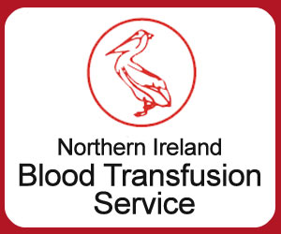](http://www.google.co.uk/url?sa=i&rct=j&q=&esrc=s&source=images&cd=&cad=rja&uact=8&ved=&url=http%3A%2F%2Fwww.highlandradio.com%2F2016%2F09%2F01%2Fnorthern-ireland-eases-restrictions-on-blood-donations-from-gay-men%2F&psig=AFQjCNEF3B3T8UNlHIO8rq5bMVuZRJuUGw&ust=1506762487590852)

**Blood Transfusion Service**

Where: Holmes Memorial Hall

When: 3 & 4 October 2017

Time: 2.00 – 4.00 pm and 5.15 – 8.00 pm

[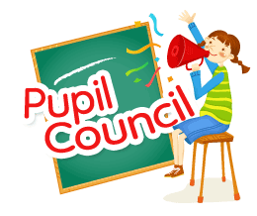](https://www.google.co.uk/url?sa=i&rct=j&q=&esrc=s&source=images&cd=&cad=rja&uact=8&ved=0ahUKEwic757riMrWAhVOJ1AKHebSC3MQjRwIBw&url=https%3A%2F%2Fsciennesnewsflash.blogspot.com%2F2013%2F11%2Fpupil-council-election-2013-2014.html&psig=AFQjCNHHPAJdJeQPcm3mdVymRQw1jMk3dQ&ust=1506763279887635)[](https://www.google.co.uk/url?sa=i&rct=j&q=&esrc=s&source=images&cd=&cad=rja&uact=8&ved=0ahUKEwjc9aL9iMrWAhVBU1AKHTZ0DJ4QjRwIBw&url=https%3A%2F%2Fsites.google.com%2Fa%2Frichland2.org%2Fblazerbattalion%2Fblazer-battalion-news-the-bbn-news-channel%2Fthe-blazer-blog%2Fstudentcouncilelectionresults&psig=AFQjCNErS38igmRflf449D3bqTEFoN9EpQ&ust=1506763313452567)

Class B

Sarah O’Kane & Jake McMullan

Year 4

Lucy Stockman & Turlough Todd

Year 5

Cara Moore & Alan Plotka

Year 6

Addi McGilligan, Alana Coyles & Jerry Kealey McDonald

Year 7

Sinead O’Reilly & Niall Harmer

Year1/Class A Rep

Ben Moore

Year 2 Rep

Riley Hanna

Year 3 Rep

Alix McNeill