School Information for Parents/Guardians
Monday 20 November 2017

Follow us now on the web for news updates
www.stbrigidspsballymoney.com
The weekly note is now available on the website and will be uploaded into the downloads section.

Monday 20 November
- Be Unique - After School Drama Club 3-4pm (Payment required as per plan option)
- Guitar Lessons 9.00-4.20 pm (Payment required as per plan option)

Tuesday 21 November
- Yr6 Town Heritage Project (am)
- Year 5 and Class B swimming
- Singing lessons 9.00-3.00 pm (Payment required as per plan option)

Wednesday 22 November
- Ditch the Dark Day!!
- Individual Active Travel to School Challenge begins (2 weeks)
- Tag Rugby After School 3-4pm (Year 6 & 7) £2 per week

Thursday 23 November
- Music Lessons: Violins

Friday 24 November
- Indoor Hurling Tournament (5-a-side in Dunloy) All day
- Pupil of the Month Awards
- Football 1.30-3.00 pm
- Music Lessons: Piano

Sunday 26 November
- Christmas Bazaar – 12.00 – 2.00 pm

Up and coming information & dates for your Diary

- Sunshine Club: 2.00 – 3.00 pm (£2) 3.00 – 5.30 pm (£2 per hour or part thereof)
- Any pre-payment made for Sunshine Club on Monday 16 & Tuesday 17 October (Storm Closures) will be deducted from the November bill.
- Breakfast Club: 8.00 – 9.00 am (£1 per day)
- Reminder: There is a child in the school with a Nut Allergy – Please do not send in Nuts or Nut Spreads to school.

Have a very enjoyable weekend and thanks for your continued support.

Mr K O’Neill Principal
St Brigid’s Primary School – Castle Street – Ballymoney – BT53 6JX – 028 27662664
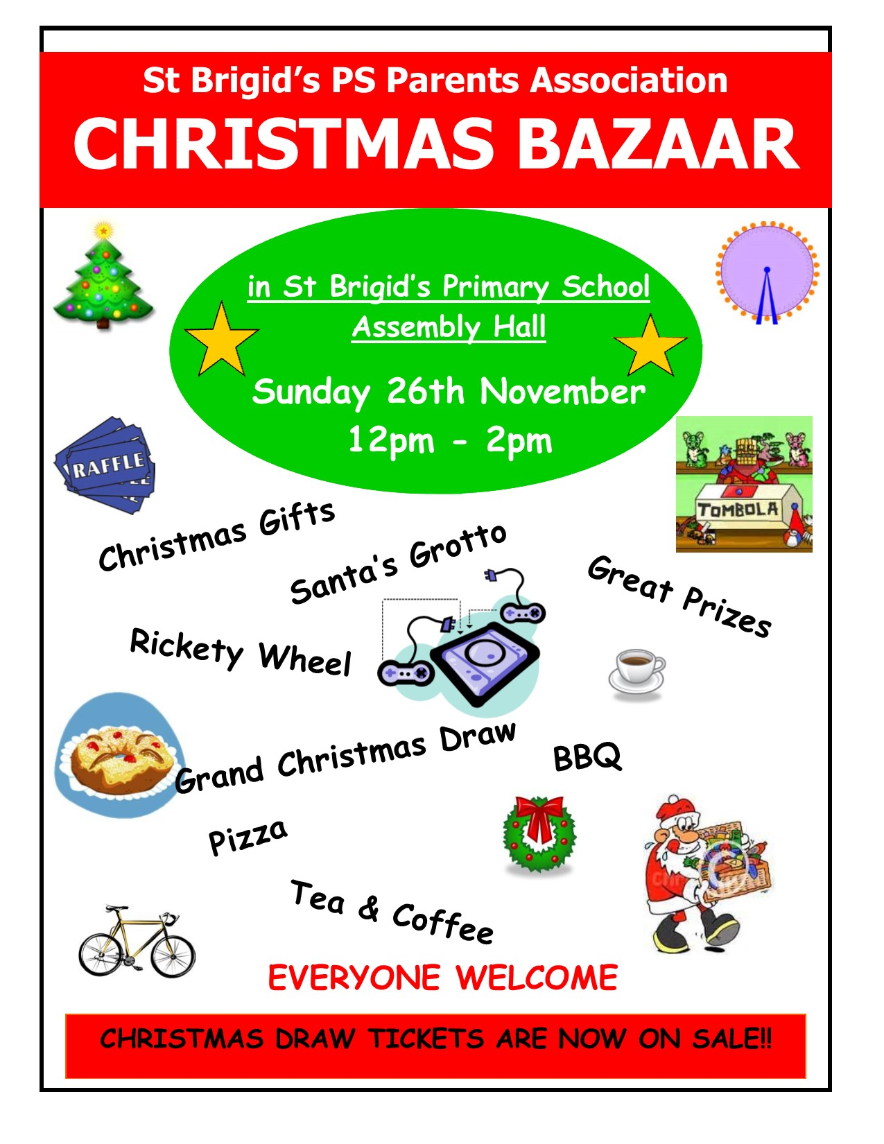

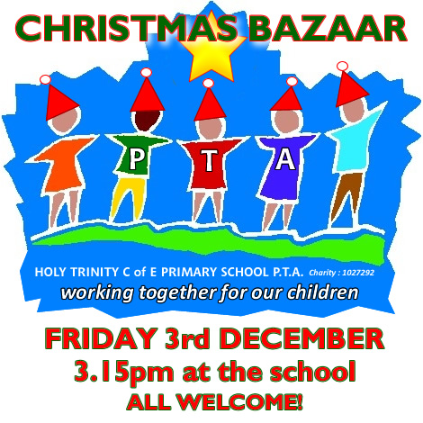

Please return any tickets (sold/unsold) to the school on or before Friday 17 November. We can try to sell any unsold tickets before the 26 November draw.

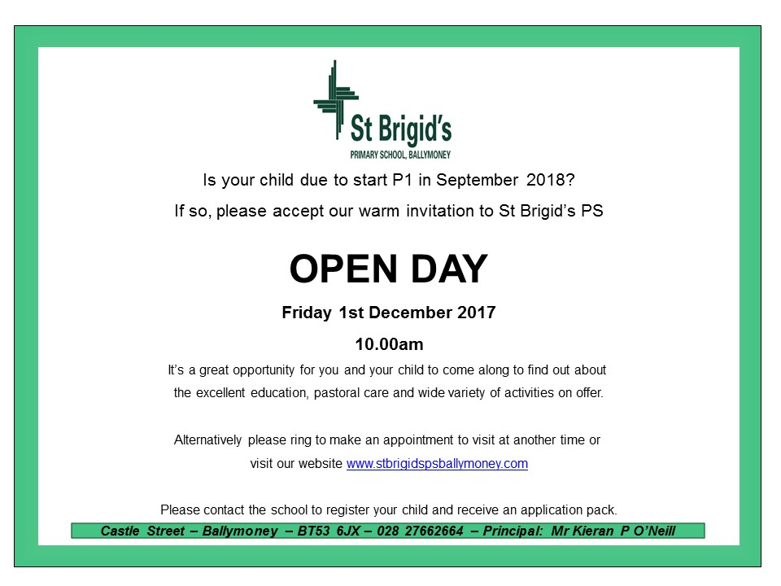
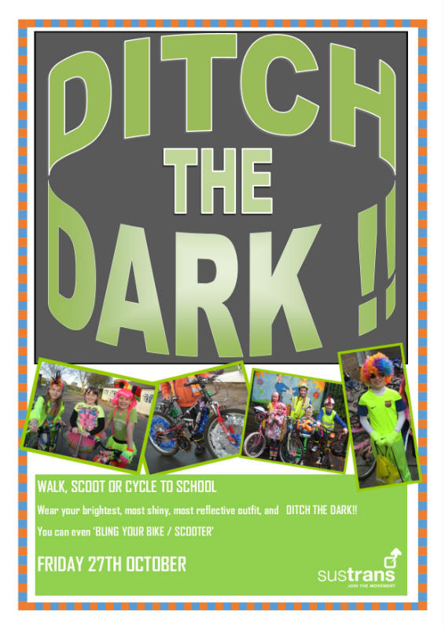
Wednesday 22 November
Be Bright and Be Seen!
Wear something bright, shiny and reflective.
Walking Bus from Mathewson’s Chemist Car Park and V2 Cark Park at Milltown
Assemble 8.40 am
School Choir Carol Singing
Irish Stew
Registration P1 September 2017
If you have a child starting school in September or know someone who is, please contact the school to register your interest.
We will send out application packs in December.
The Grand Christmas Draw
Tickets have gone out to every family. If you need any more contact the school.

