School Information for Parents/Guardians
Monday 23 October 2017

Follow us now on the web for news updates
www.stbrigidspsballymoney.com
The weekly note is now available on the website and will be uploaded into the downloads section.

Monday 23 October
- School Closes 2.00 pm for all children – Parent Interviews
- Be Unique - After School Drama Club 2-3pm (Payment required as per plan option)
- Guitar Lessons 9.00-4.20 pm (Payment required as per plan option)

Tuesday 24 October
- Year 5 swimming
- Singing lessons 9.00-3.00 pm (Payment required as per plan option)
- School Closes 2.00 pm for all children – Parent Interviews

Wednesday 25 October
- Year 6 Hockey 11-12
- School Closes 2.00 pm for all children – Parent Interviews

We no longer accept the round £1 coin.
Thank you.
Thursday 26 October
- Year 4 Class Trip: Hezlett House 9.30-1.30 pm
- School Closes 2.00 pm for all children – Parent Interviews
- Music Lessons: Violins
- Halloween Disco
Year 1-3: 6.00-7.00 pm
Year 4-7:7.00-8.00 pm

Friday 27 October
- Pupil of the Month Assembly
- Football 1.30-3.00 pm
- Music Lessons: Piano

Up and coming information & dates for your Diary
- Mid Term Holiday: School Closed Monday 30 Oct-Friday 3 Nov. School re-opens Monday 6 Nov
- Parent Interviews Mon 23 – Thurs 26 October. School will close at 2.00 pm for all this week. No drop in club available on these days and sunshine club from 2-5.30 pm must be booked in advance.
- Sunshine Club: 2.00 – 3.00 pm (£2) 3.00 – 5.30 pm (£2 per hour or part thereof)
- Breakfast Club: 8.00 – 9.00 am (£1 per day)
- Reminder: There is a child in the school with a Nut Allergy – Please do not send in Nuts or Nut Spreads to school.

Have a very enjoyable weekend and thanks for your continued support.

Mr K O’Neill Principal
St Brigid’s Primary School – Castle Street – Ballymoney – BT53 6JX – 028 27662664

Saturday 21 - Sunday 29 October 2017
Fr O’Brien and the Parish Council would like to extend a warm invitation to you and your family to our Parish Mission.
Together in Faith - Everyone Welcome
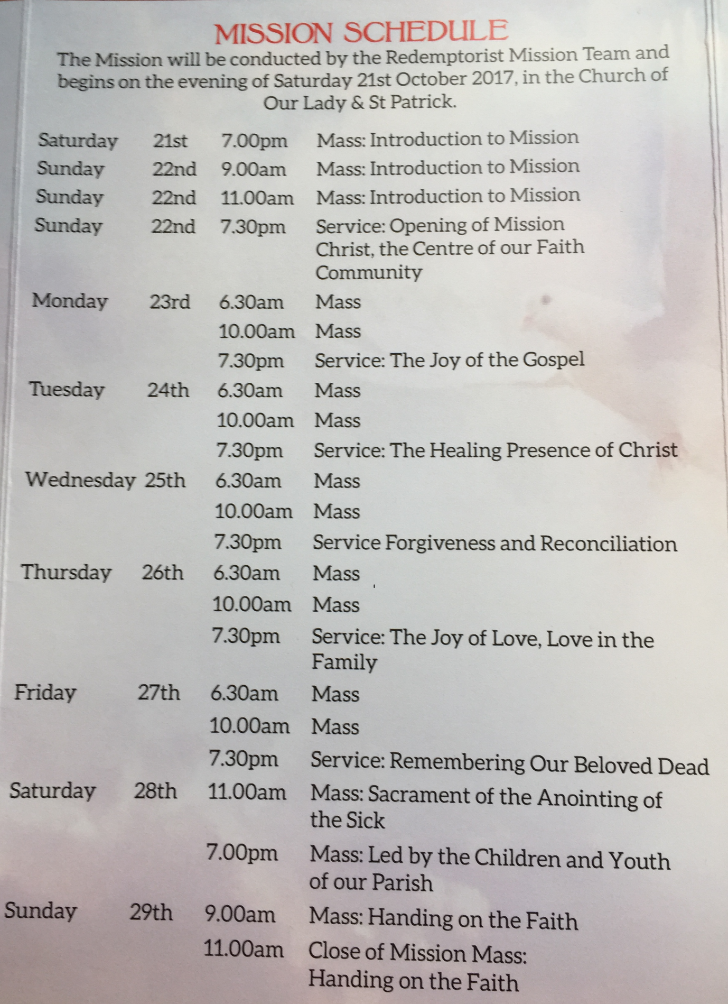

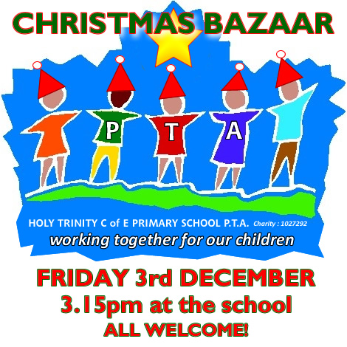

Save the date!!!
Sunday 26 November 2017
Straight after Sunday morning mass

Loads of Prizes on the Ricketty Wheel
Food served
Choir singing
Grand Christmas Draw
It is hoped that tickets for the Christmas Draw will be distributed to all children next week.
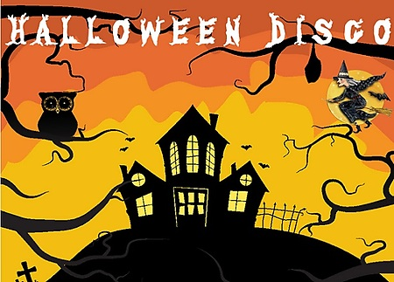
Thursday 26 October

Year 1-3: 6.00-7.00 pm
Year 4-7:7.00-8.00 pm

Shoebox Appeal 2017
The annual Road of Hope Shoeboxes will be collected on Tuesday 7th November. Please try to support this very worthwhile appeal.
For details visit the website
http://www.roadofhope.org.uk/

Halloween Fancy Dress Day
Friday 27 October 2017

