

**School Information for Parents/Guardians**

**Monday 24 September 2018**

Follow us now on **the web** for news updates

**www.stbrigidspsballymoney.com**

**Please return All Data Capture Forms and School Nurse Letters**

**Monday 24 September**

* Dinner menu Week 4
* Guitar Lessons
* After School Drama Club 3-4 pm
* Yr7 Library Visit 11-12 noon
* **Y1 Newspaper photographer in**

**Tuesday 25 September**

* Year 5 & Class B swimming
* Singing Tutor in

**Wednesday 26 September**

* Year 6 Hockey 11am - 12noon (5 weeks - £5 per child)
* PTA Meeting 7pm in St Brigid’s PS

**Thursday 27 September**

* Violin tuition
* Pupil of the Month Awards
* Pupil Council Election Day

**Friday 28 September**

* School Closed

**Up and coming information & dates for your Diary**

* Important: Could your child be entitled to free school meals? Did your child receive free school meals last year? Remember you may need to confirm details with the Education Authority. If you think you are entitled but are unsure about what to do please call into the office for advice and a form.
* **Staff Development Day Friday 28 September – School Closed for all pupils**
* **Parent Interviews Mon 22 – Thurs 25 October**. School will close at 2.00 pm for all on these days.
* Sunshine Club: 2.00 – 3.00 pm (£2) 3.00 – 5.30 pm (£2 per hour or part thereof)
* Breakfast Club: 8.00 – 9.00 am (£1 per day)
* **Reminder: There is a child in the school with a Nut Allergy – Please do not send in Nuts or Nut Spreads to school.**

.

Have a very enjoyable weekend and thanks for your continued support.

Mr K O’Neill Principal

**St Brigid’s Primary School – Castle Street – Ballymoney – BT53 6JX – 028 27662664**

[](http://www.google.co.uk/url?sa=i&rct=j&q=&esrc=s&source=images&cd=&cad=rja&uact=8&ved=2ahUKEwiEnayCsajdAhXEK8AKHVmtCFUQjRx6BAgBEAU&url=http%3A%2F%2Fwww.katyisd.org%2Fcampus%2FHE%2FPages%2FPTA.aspx&psig=AOvVaw2Pet2zGg8sjf3JuWqVy3kD&ust=1536392124057568)

**PTA Meeting**

Wednesday 26th September at 7.00pm in St Brigid’s PS

All new parents welcome.

Let’s make a wiser choice – Get the Active Travel Bug!!!

[](https://www.google.co.uk/imgres?imgurl=http://www.healthychildrenliving.com/images/slidenew.jpg&imgrefurl=http://www.healthychildrenliving.com/&docid=d-R0deW7vAlbIM&tbnid=PBmbka2QTttFwM:&w=960&h=331&hl=en&safe=active&bih=674&biw=1024&ved=0ahUKEwjPpMifs5PPAhWnJ8AKHSInCdoQMwgqKA4wDg&iact=mrc&uact=8)

We are a Sustrans School so let’s make

smarter travel choices and walk, cycle or scoot to school.

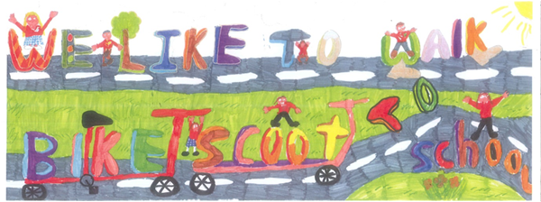

Please return all

School Photograph orders

and

Data Capture forms

ASAP

October Milk

October £4.20

or

Rest of Term 1

£11.34

Orders in by Monday 24 September

Please

Reminder

Staff Development Day

School Closed

**Friday 28th September 2018**