

**School Information for Parents/Guardians**

**Monday 26 November 2018**

Follow us now on **the web** for news updates

**www.stbrigidspsballymoney.com**

**Sunday 25 November**

* Christmas Bazaar 12.30 – 2.30 pm **School Choir singing at 11am Mass and at opening of Bazaar.**

**Monday 26 November**

* Be Unique - After School Drama Club 3-4pm **(Payment required as per plan option)**
* Guitar Lessons 9.00-4.20 pm **(Payment required as per plan option)**

**Tuesday 27 November**

* Year 5 and Class B swimming
* **Big Bedtime Read – Y1 Parents and Children Tuesday 27 November 6.30 –7.30 pm**

**Wednesday 28 November**

* Year 2 & 3 Musical Pathways Programme 1.00-2.00pm (10 weeks- £10 or £1 per week)
* Tag Rugby After School 3-4pm (Year 6 & 7) £2 per week/£10 - 5 weeks

**Thursday 29 November**

* Year 4 Library visit 11-12noon (bring coats)
* Music Lessons: Violins

**Friday 30 November**

* Indoor Hurling Blitz in Dunloy (starts 9.30 am)
* Pupil of the Month
* Music Lessons: Piano

**Up and coming information & dates for your Diary**

* **Open Day 2018 for children starting school in September 2019 is on Thursday 29 November 2018 at 10.00 am.**
* **Reminder: There is a child in the school with a Nut Allergy – Please do not send in Nuts or Nut Spreads to school.**
* **Christmas Dinner Day and Ditch the Dark Event will both be on Friday 7 December.**
* **Choir singing at Castlecroft on Friday 7 December at 1.30 pm.**

**Registration P1 September 2019**

**If you have a child starting school in September or know someone who is, please contact the school to register your interest.**

**Application process is online this year and open during the month of January 2019. Please contact the school if you require any assistance in completing the online application.**

Have a very enjoyable weekend and thanks for your continued support.

Mr K O’Neill Principal

**St Brigid’s Primary School – Castle Street – Ballymoney – BT53 6JX – 028 27662664**

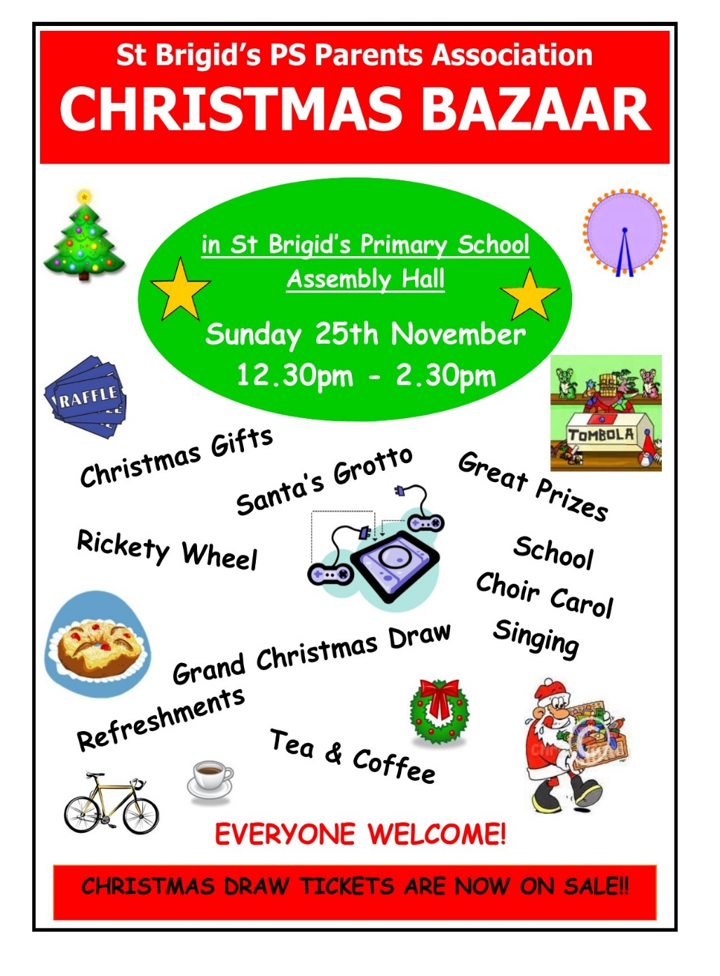

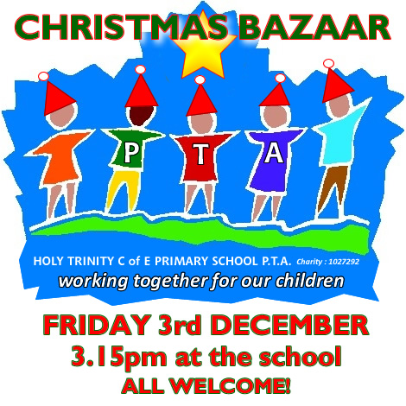

**The Grand Christmas Draw**

Tickets have gone out to every family. If you need any more contact the school.

Please return any tickets (sold/unsold) to any member of the PTA or to the Bazaar on Sunday. We can try to sell any unsold tickets before or on the day of the Bazaar.



**Sunshine Club**

In order for the Sunshine Club (3:00 – 5:30pm) to run as efficiently and safely as possible we would ask for your co-operation on the following three issues:

* Contracts need to be completed
* Children must be picked up promptly at the agreed times recorded in contracts
* Booking forms should to be returned on time
* Due to the high demand of places in the Sunshine Club, we apologise that there **cannot** be a ‘drop in’ approach.

[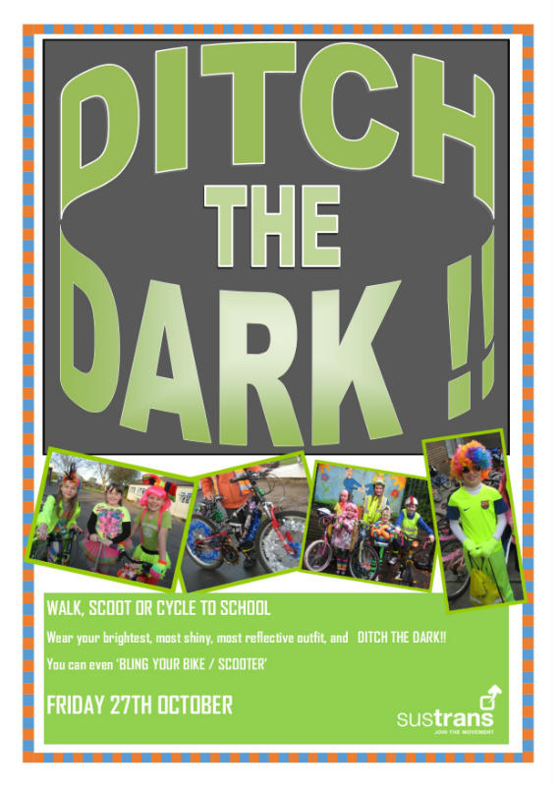](http://www.google.co.uk/url?sa=i&rct=j&q=&esrc=s&source=images&cd=&cad=rja&uact=8&ved=&url=http://www.castlegardens.org.uk/news/friday-27th-october---ditch-the-dark-day/&psig=AOvVaw26Kg3_5Hh2TsxpQz5eATrM&ust=1511000248242140)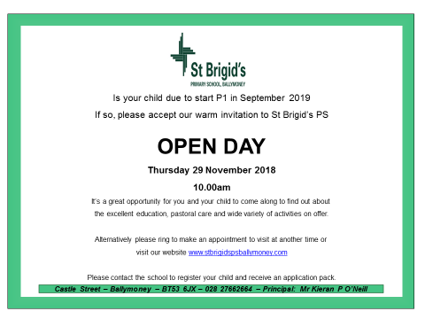

Friday 7 December

**Be Bright and Be Seen!**

Wear something bright, shiny and reflective.

Walking Bus from Mathewson’s Chemist Car Park and Town Hall Car Park.

Assemble 8.40 am