

**School Information for Parents/Guardians**

**Monday 3 December 2018**

Follow us now on **the web** for news updates

**www.stbrigidspsballymoney.com**

**Monday 3 December**

* Be Unique - After School Drama Club 3-4pm **(Payment required as per plan option)**
* Guitar Lessons 9.00-4.20 pm **(Payment required as per plan option)**

**Christmas Dinner Money**

Due Monday 3 December

£2.60

* Yr5 Bridge Building Workshop in St Brigid’s PS

**Tuesday 4 December**

* Year 5 and Class B swimming
* Deadline for Christmas Card Order Forms

**Wednesday 5 December**

* Cross Country Competition – Roe Valley Leisure Centre Limavady am - £2 per child to include transport and lunch.
* Year 2 & 3 Musical Pathways Programme 1.00-2.00pm (10 weeks- £10 or £1 per week)
* Tag Rugby After School 3-4pm (Year 6 & 7) £2 per week/£10 - 5 weeks

**Thursday 6 December**

* Music Lessons: Violins

**Friday 7 December**

* Ditch the Dark Day (for details see over page)
* Christmas Dinner and Jumper Day
* Choir singing in Castlecroft at 1.30pm
* Principal Awards
* Music Lessons: Piano

**Up and coming information & dates for your Diary**

* **Reminder: There is a child in the school with a Nut Allergy – Please do not send in Nuts or Nut Spreads to school.**

**Registration P1 September 2019**

**If you have a child starting school in September or know someone who is, please contact the school to register your interest.**

**Application process is online this year and open during the month of January 2019. Please contact the school if you require any assistance in completing the online application.**

Have a very enjoyable weekend and thanks for your continued support.

Mr K O’Neill Principal

**St Brigid’s Primary School – Castle Street – Ballymoney – BT53 6JX – 028 27662664**

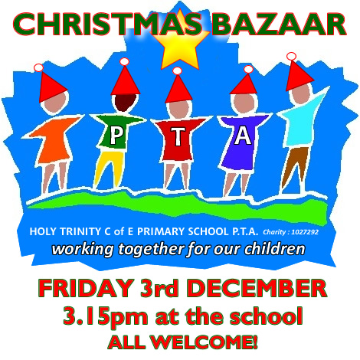

Thank you to everyone who helped make the Annual Christmas Bazaar so successful this year. Through all your help and support we were able to raise **£3600**. All of this money will be reinvested in many ways to enhance the learning opportunities for all the children. We are so grateful for your generosity and kindness. It was a wonderful occasion and great to see so many families and parishioners coming along to enjoy the afternoon events.

The event was such a success because of the great work of St Brigid’s PTA. I would like to thank all involved in the planning and those who helped on the day in making the event so successful.

**The Grand Christmas Draw Winners**

1st Prize: Pele Reid

2nd Prize: Kaitlyn McErlain

3rd Prize: Siobhan McMullan

4th Prize: Cara Moore

**Reminder**

**Anyone wishing to place an order for a set of personally designed Christmas Cards by your child/children please send in the card design on or before Tuesday 4 December.**

[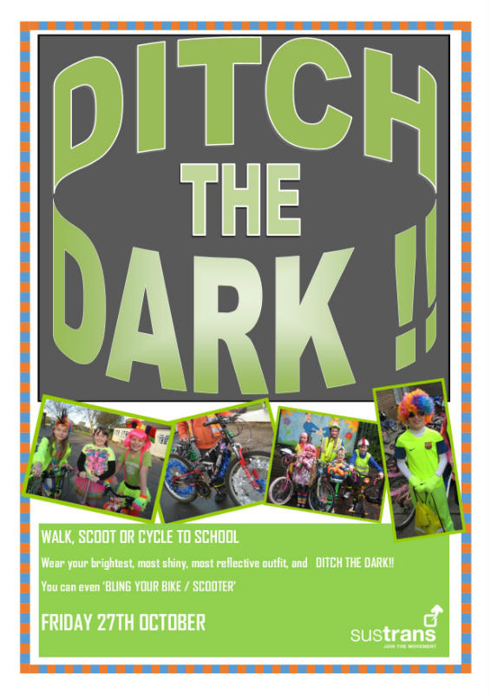](http://www.google.co.uk/url?sa=i&rct=j&q=&esrc=s&source=images&cd=&cad=rja&uact=8&ved=&url=http://www.castlegardens.org.uk/news/friday-27th-october---ditch-the-dark-day/&psig=AOvVaw26Kg3_5Hh2TsxpQz5eATrM&ust=1511000248242140)



**Sunshine Club**

In order for the Sunshine Club (3:00 – 5:30pm) to run as efficiently and safely as possible we would ask for your co-operation on the following three issues:

* Contracts need to be completed
* Children must be picked up promptly at the agreed times recorded in contracts
* Booking forms should to be returned on time
* Due to the high demand of places in the Sunshine Club, we apologise that there **cannot** be a ‘drop in’ approach.

Friday 7 December

**Be Bright and Be Seen!**

Wear something bright, shiny and reflective.

Walking Bus from Mathewson’s Chemist Car Park and Town Hall Car Park.

Assemble 8.40 am