

**School Information for Parents/Guardians**

**Monday 4 December 2017**

Follow us now on **the web** for news updates

**www.stbrigidspsballymoney.com**

The weekly note is now available on the website and will be uploaded into the downloads section.

**Monday 4 December**

* Year 7 Science morning in OLOL
* Be Unique - After School Drama Club 3-4pm **(Payment required as per plan option)**
* Guitar Lessons today **(Payment required as per plan option)**
* Individual Active Travel to School Challenge (All Week)

**Tuesday 5 December**

* Year 5 and Class B swimming
* Singing lessons 9.00-3.00 pm **(Payment required as per plan option)**

**Wednesday 6 December**

* Tag Rugby After School 3-4pm (Year 6 & 7) £2 per week

**Thursday 7 December**

* Christmas Dinner Day – Children can wear Christmas Jumper/Hat
* Music Lessons: Violins

**Friday 8 December**

* Whole School going to Mass – 10am – Everyone welcome
* Principal Awards
* Last day of Superhero Active Travel to School Challenge
* Music Lessons: Piano

**Up and coming information & dates for your Diary**

* Sunshine Club: 2.00 – 3.00 pm (£2) 3.00 – 5.30 pm (£2 per hour or part thereof)
* Breakfast Club: 8.00 – 9.00 am (£1 per day)
* **Reminder: There is a child in the school with a Nut Allergy – Please do not send in Nuts or Nut Spreads to school.**
* **Christmas Show:** Tuesday 19 December 1.00pm and Wednesday 20 December 7.00pm
* School Closes 12.00 noon 22 December for Christmas Holidays
* School reopens Monday 8 January

Have a very enjoyable weekend and thanks for your continued support.

Mr K O’Neill Principal

**St Brigid’s Primary School – Castle Street – Ballymoney – BT53 6JX – 028 27662664**

A big thank you to everyone who supported the Annual Bazaar last Sunday. It was a wonderful occasion and great to see so many families and parishioners coming along to enjoy the afternoon events.

The event was such a success because of the great work of St Brigid’s PTA. I would like to thank all involved in the planning and those who helped on the day in making the event so successful.

The total amount raised was an outstanding **£4400.**

**The Grand Christmas Draw Winners**

1st Prize: Estelle Mulgrew

2nd Prize: Sorcha Jennings

3rd Prize: Rob McCullagh

4th Prize: Katie McBride

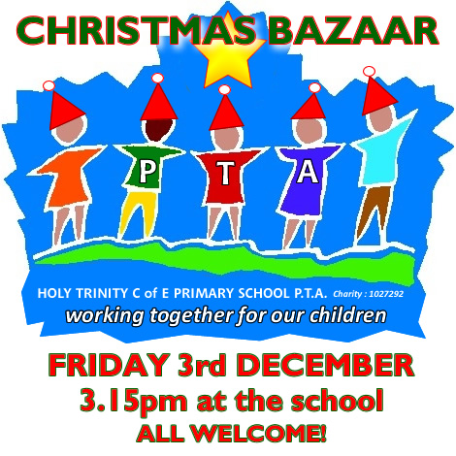



**Registration P1 September 2017**

**If you have a child starting school in September or know someone who is, please contact the school to register your interest.**

**Application forms are now available from Susan.**