

**School Information for Parents/Guardians**

**Monday 5 November 2018**

Follow us now on **the web** for news updates

**www.stbrigidspsballymoney.com**

**Reminder School Closed 29 Oct – 2 Nov.**

**Reopens Mon 5 Nov.**

**Monday 5 November**

* Yr6 Library Visit 11-12noon (bring coats)
* Be Unique - After School Drama Club 3-4pm **(Payment required as per plan option)**
* Guitar Lessons 9.00-4.20 pm **(Payment required as per plan option)**
* PTA Grand Christmas Draw tickets will be distributed to all families.

**Tuesday 6 November**

* Yr 4 Shared Education Session in Leaney PS 9.30 – 11.30 am
* Year 5 and Class B swimming

**Wednesday 7 November**

* Tag Rugby After School 3-4pm (Year 6 & 7) £2 per week

**Thursday 8 November**

* Yr 5 Shared Education Session in Joey Dunlop Leisure Centre 9.30am – 12noon
* Music Lessons: Violins
* PTA Meeting 7pm

**Friday 9 November**

* Dairy Council Food and Fitness Workshop Yr5-7 (11-11.45am/bring trainers)
* Principal’s Assembly
* Football 1.30-3.00 pm
* Music Lessons: Piano

**Up and coming information & dates for your Diary**

* **Open Day 2018 for children starting school in September 2019 is on Thursday 29 November 2018 at 10.00 am**
* **If you cannot make the general Open Day, please contact the school to arrange a suitable date and time at your convenience to get a tour of the school.**
* **Reminder: There is a child in the school with a Nut Allergy – Please do not send in Nuts or Nut Spreads to school.**
* **PTA Christmas Bazaar Sunday 25 November 12.30 – 2.30 pm**

**Registration P1 September 2017**

**If you have a child starting school in September or know someone who is, please contact the school to register your interest.**

**We will send out application packs in December.**

Have a very enjoyable weekend and thanks for your continued support.

Mr K O’Neill Principal

**St Brigid’s Primary School – Castle Street – Ballymoney – BT53 6JX – 028 27662664**

[](http://www.google.co.uk/url?sa=i&rct=j&q=&esrc=s&source=images&cd=&cad=rja&uact=8&ved=2ahUKEwiEnayCsajdAhXEK8AKHVmtCFUQjRx6BAgBEAU&url=http://www.katyisd.org/campus/HE/Pages/PTA.aspx&psig=AOvVaw2Pet2zGg8sjf3JuWqVy3kD&ust=1536392124057568)

**PTA Update**

**Meeting on Thursday 8 November**

**7pm**

**In School to plan the Christmas Bazaar**

**Please try to attend**

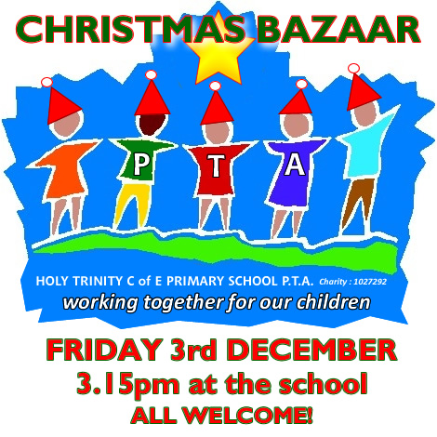

**Sunday 25 November 2018**

**Dear Parents**

**If you have, know or work in a business that may be able to donate a prize or support our Christmas Bazaar in any way please contact the school and speak to Mr O’Neill or Mrs Campbell**

**Many thanks.**



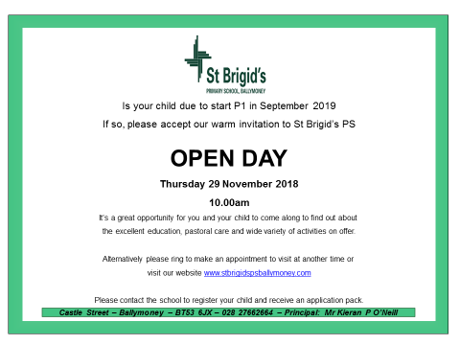

Save the date!!!

**Sunday 25 November 2018**

**Straight after Sunday morning mass**

Loads of Prizes on the Ricketty Wheel

Food served

Choir singing

Grand Christmas Draw

More details to follow

[](https://www.google.co.uk/url?sa=i&rct=j&q=&esrc=s&source=images&cd=&cad=rja&uact=8&ved=0ahUKEwiXjriqhsrWAhVNaVAKHXhhDDQQjRwIBw&url=https://twitter.com/roadofhope44&psig=AFQjCNFEro0zYGQfbOsMoIxtnUWD5sDPRw&ust=1506762605508762)

**Shoebox Appeal 2018**

The annual Road of Hope Shoeboxes will be collected on Tuesday 8th November. Please try to support this very worthwhile appeal.