School Information for Parents/Guardians
Monday 6 November 2017

Follow us now on the web for news updates
www.stbrigidspsballymoney.com
The weekly note is now available on the website and will be uploaded into the downloads section.

Monday 6 November
- Be Unique - After School Drama Club 2-3pm (Payment required as per plan option)
- Guitar Lessons 9.00-4.20 pm (Payment required as per plan option)

Tuesday 7 November
- Doherty Cup Match v Ballsally PS @ University 2.15pm
- Year 5 and Class B swimming
- Singing lessons 9.00-3.00 pm (Payment required as per plan option)

We no longer accept the round £1 coin.
Thank you.
Wednesday 8 November
- Tag Rugby After School 3-4pm (Year 6 & 7)
(Registration letter out Monday 6 November)

Thursday 9 November
- Music Lessons: Violins

Friday 10 November
- Principal’s Assembly
- Football 1.30-3.00 pm
- Music Lessons: Piano

Up and coming information & dates for your Diary

- Sunshine Club: 2.00 – 3.00 pm (£2) 3.00 – 5.30 pm (£2 per hour or part thereof)
- Any pre-payment made for Sunshine Club on Monday 16 & Tuesday 17 October (Storm Closures) will be deducted from the November bill.
- Breakfast Club: 8.00 – 9.00 am (£1 per day)
- Reminder: There is a child in the school with a Nut Allergy – Please do not send in Nuts or Nut Spreads to school.
- Tickets for the Grand Christmas Draw can be returned at any time to the school office.

Have a very enjoyable Halloween break and thanks for your continued support.

Mr K O’Neill Principal
St Brigid’s Primary School – Castle Street – Ballymoney – BT53 6JX – 028 27662664
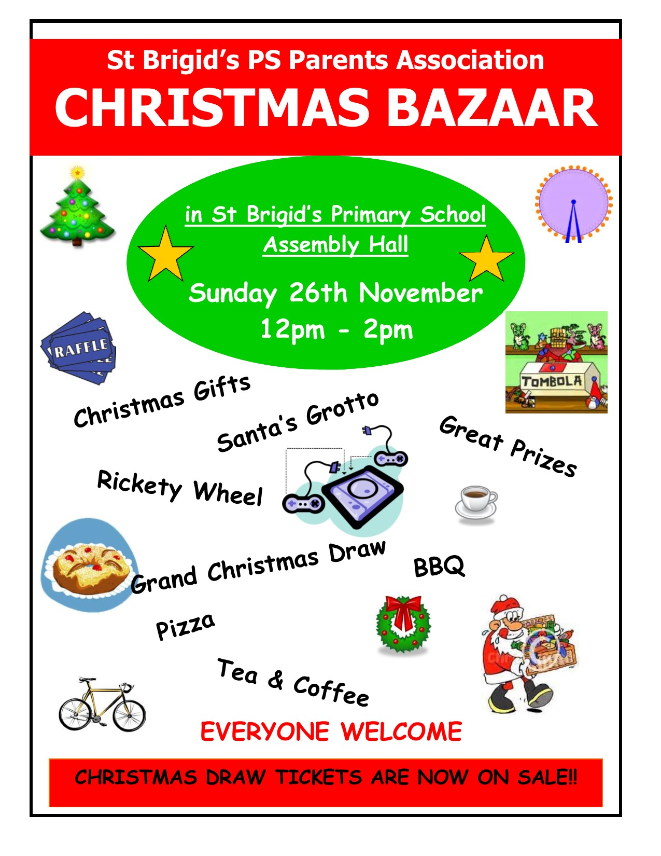
Shoebox Appeal 2017
The annual Road of Hope Shoeboxes will be collected on Tuesday 7th November. Please try to support this very worthwhile appeal.
For details visit the website
http://www.roadofhope.org.uk/

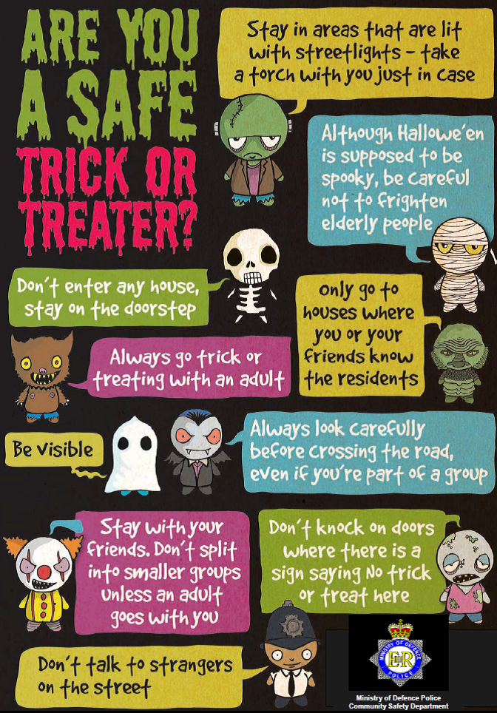
The Grand Christmas Draw
Tickets have gone out to every family. If you need any more contact the school.

