

**School Information for Parents/Guardians**

**Monday 8 April 2019**

Follow us now on **the web** for news and updates

**www.stbrigidspsballymoney.com**

**Monday 8 April**

* After School Drama 3-4 pm. Parents welcome at 3.30 pm for a drama showcase.
* Guitar Tutor in
* Netball – Boys’ and girls’ teams in OLOL 3.15-415 pm

**Tuesday 9 April**

* Swimming Year 7 & CB
* Singing tutor in

**Wednesday 10 April**

* Netball (Year 4 & 5) 3-4pm

**Thursday 11 April**

* Mental Health Workshop – Year 7
* Netball match v Hezlett in St Brigid’s – 1.30 pm
* Violin Tutor in

**Friday 12 April**

* Outrageous Outfits Day – Fundraiser for Trocaire
* Piano tutor in
* Principal Awards

**Up and coming information & dates for your Diary**

* **Reminder: There is a child in the school with a Nut Allergy – Please do not send in Nuts or Nut Spreads to school.**
* **Term 2 Holidays:**

**Easter: Friday 19 – Fri 26 April 2019**

**School Closes 12noon Thursday 18 April (No Sunshine Club this day) Classes A & B will finish on Wednesday 17 April.**

**Car Parking**

**Please use the parking spaces provided in the chapel car park. Driving right up to the gate can be dangerous as when reversing back there will always be children walking towards the gate.**

Have a very enjoyable weekend and thanks for your continued support.

Mr K O’Neill Principal

**St Brigid’s Primary School – Castle Street – Ballymoney – BT53 6JX – 028 27662664**

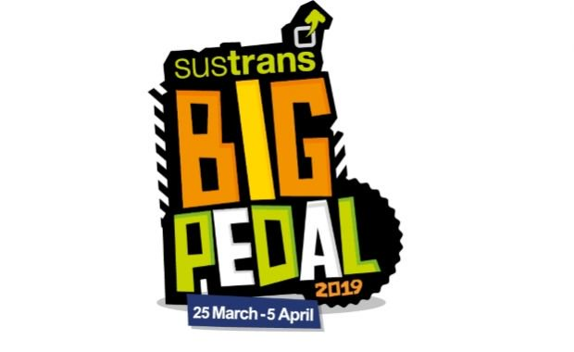

Congratulations to everyone who took part in the Big Pedal 2019.

It was a great success again this year and hopefully St Brigid’s will feature high on the list of schools in terms of participation. The final results should be known next week.

Thanks to all the parents and grandparents for your support in helping the children pedal, scoot and walk to and from school.

**Sacraments of Confirmation and First Penance**

The sacraments of Confirmation and Reconciliation took place during the last week. Both services were lovely occasions and the children were a real credit to the school. Bishop Treanor was very complimentary about the children and their participation during the Confirmation Ceremony.

Holy Communion Saturday 18th May at 11.00am. Year 4 children celebrate their special day.

**Trocaire Fundraiser**

**‘Outrageous Outfits’**

**Anything Goes!**

**As bright as you can!**

**Friday 12 April 2019**

**£1 donation for Trocaire**

**Holiday Dates Term 3**

**Election:** Thursday 2 May

**May Day:**  Monday 6 May

**May Holiday:**  Monday 27 May - Tuesday 28 May

School re-opens Wednesday 29 May

**Summer:** School Closes 12noon Friday 28 June

**Non-Uniform Day**

A group of children in Year 6 have returned as the ‘Swimming Unicorns’ team and will be completing a 1.5km swim on for Cancer Research, Marie Curie and the Swimathon Foundation.

To support the activity, we will have a **non-uniform day on Wednesday 17 April** with a donation of £1 per child.

[](https://www.google.co.uk/url?sa=i&rct=j&q=&esrc=s&source=images&cd=&ved=2ahUKEwiX2bel1eDgAhX5QxUIHcGyDfEQjRx6BAgBEAU&url=https://store.vitalsd.co.uk/tr014-check-speed-10-miles-per-hour-traffic-signs.html&psig=AOvVaw0cDqxKt7pyPUnGiyTaAhCx&ust=1551520170191550)

**Speed in the Chapel Car Park**

**Please be mindful of your speed in the chapel car park when dropping off and picking up the children. The car park is busy with children moving to and from cars. All drivers must be careful. Speed limit is 10 miles per hour.**

**School Closure Advance Notice**

The school will be closed on **Thursday 2 May**

Polling Station for Local Council Elections