

**School Information for Parents/Guardians**

**Monday 9 September 2019**

Follow us now on **the web** for news updates

**www.stbrigidspsballymoney.com**

**Whole school and Class Term 1 Newsletters out this week!**

**Monday 9 September**

* Breakfast Club open every day 8.00 – 9.00 am
* After School Club open every day 2.00 - 5.30pm
* Dinner menu Week 2

**Homework Diaries**

**Year 3 – 7**

The Homework diaries for 2019-20 will be available soon.

Unfortunately, the cost this year has risen to **£6.00** from the supplier.

* Guitar tuition restarts - some places available please contact office.
* After school drama 3-4pm

**Tuesday 10 September**

* Year 5 & Class B swimming
* Musical Pathways Programme (Year2 & 3) 1-2pm

**Wednesday 11 September**

* Year 6 Hockey starts 11am - 12noon (5 weeks - £5 per child)
* Violin tuition

**Thursday 12 September**

**Friday 13 September**

* Piano tuition restarts – some places available please contact the office.
* Assembly and Principal Awards

**Up and coming information & dates for your Diary**

* Important: Could your child be entitled to free school meals? Did your child receive free school meals last year? Remember you may need to confirm details with the Education Authority. If you think you are entitled but are unsure about what to do please call into the office for advice and a form.
* **School Photographer in Tuesday 24 September**
* **Parent Interviews Mon 21 – Fri 25 October**. School will close at 1.00 pm for all on these days. (Parent Interviews will scheduled between 1.00 – 3.00 pm each day)
* Sunshine Club: 2.00 – 3.00 pm (£2) 3.00 – 5.30 pm (£2 per hour or part thereof)
* Breakfast Club: 8.00 – 9.00 am (£1 per day)
* **Reminder: There is a child in the school with a Nut Allergy – Please do not send in Nuts or Nut Spreads to school.**

.

Have a very enjoyable weekend and thanks for your continued support.

Mr K O’Neill Principal

**St Brigid’s Primary School – Castle Street – Ballymoney – BT53 6JX – 028 27662664**

Let’s make a wiser choice – Get the Active Travel Bug!!!

[](https://www.google.co.uk/imgres?imgurl=http://www.healthychildrenliving.com/images/slidenew.jpg&imgrefurl=http://www.healthychildrenliving.com/&docid=d-R0deW7vAlbIM&tbnid=PBmbka2QTttFwM:&w=960&h=331&hl=en&safe=active&bih=674&biw=1024&ved=0ahUKEwjPpMifs5PPAhWnJ8AKHSInCdoQMwgqKA4wDg&iact=mrc&uact=8)

We are a Sustrans School so let’s make

smarter travel choices and walk, cycle or scoot to school.

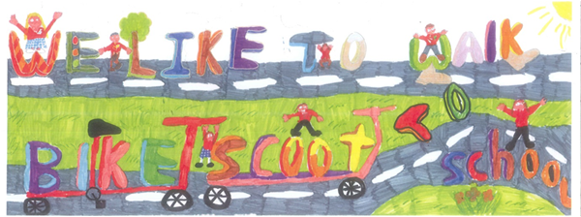

[](http://www.google.co.uk/url?sa=i&rct=j&q=&esrc=s&source=images&cd=&cad=rja&uact=8&ved=2ahUKEwiEnayCsajdAhXEK8AKHVmtCFUQjRx6BAgBEAU&url=http://www.katyisd.org/campus/HE/Pages/PTA.aspx&psig=AOvVaw2Pet2zGg8sjf3JuWqVy3kD&ust=1536392124057568)

**PTA Meeting**

Thursday 26th September at 7.00pm in St Brigid’s PS

All new parents welcome.

[](https://www.google.co.uk/url?sa=i&rct=j&q=&esrc=s&source=images&cd=&ved=2ahUKEwiX2bel1eDgAhX5QxUIHcGyDfEQjRx6BAgBEAU&url=https://store.vitalsd.co.uk/tr014-check-speed-10-miles-per-hour-traffic-signs.html&psig=AOvVaw0cDqxKt7pyPUnGiyTaAhCx&ust=1551520170191550)**Speed in the Chapel Car Park**

Please be mindful of your speed in the chapel car park when dropping off and picking up the children. The car park is busy with children moving to and from cars. All drivers must be careful. Speed limit is 10 miles per hour.

**A New School Year Underway!!**

It is great to see the children back at school full of excitement and eager to do well in their new school year. Let’s hope that this year we can build upon the successes of last year and make it an even better one for the children. They are a credit to you all and a great advertisement for St Brigid’s PS.

I would like to wish you the children good luck and success throughout the year in whatever you do.

Sponsored Event

**Not Half Right!!!**

[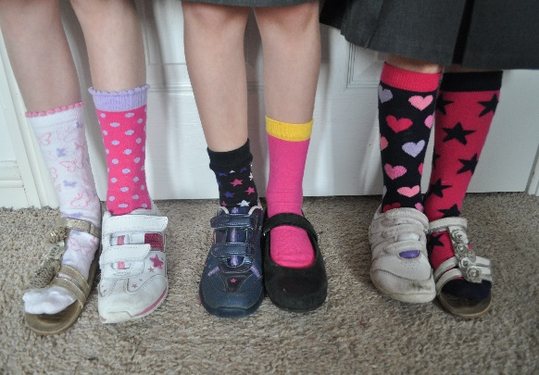](http://www.google.co.uk/url?sa=i&rct=j&q=&esrc=s&source=images&cd=&ved=2ahUKEwip_4WJ1LvkAhURiFwKHSpEA7EQjRx6BAgBEAQ&url=http%3A%2F%2Fopenmindhypnotherapy.co.uk%2Fwhat-makes-you-smile%2F&psig=AOvVaw0C3-MauqTjRw28i8EbzXRo&ust=1567840729072299)

Odd, unusual and crazy trousers, socks and shoes

Friday 20 September 2019

**Important Notice**

When using the car park at the chapel and in the front playground please do not park in front of the gates as they are emergency exits and must be kept clear at all times for access. There are a good number of spaces to park in so please use the designated parking spaces. The front car park is very busy and apart from children arriving by bus, taxi or for the Learning Support Centre the front car park is for **drop off only** using the turning system.