



**School Information for Parents/Guardians**

**Monday 16th March 2020**

Follow us now on **the web** for news and updates

**www.stbrigidspsballymoney.com**

**Contact Details**

Please make sure we have up to date contact details for all parents.

If you have changed your number recently, please inform Susan.

**Monday 16 March**

* Green Day – Non-Uniform Day children can come to school dressed in green (£1 donation for Trocaire) There will be no whole school celebration just individual class activities)
* Drama 3-4pm
* Guitar Lessons
* Netball 3-4 Yr6 & 7

**Tuesday 17 March**

* School Closed

**Wednesday 18 March**

* Year 6 Shared Education in Leaney PS (morning)
* After School Hockey 3-4pm (£10 for 5 weeks)
* Musical Pathways Programme 1-2 pm (Yr1 & Yr4) (£1 per week/£12 for 12 weeks)
* Violin tuition
* Culture Club 3-4 pm

**Thursday 19 March**

* Boys’ Hockey @ Rugby Avenue (morning)

**Friday 20 March**

* Netball Blitz – Coleraine Leisure Centre
* Principal Awards

**Up and coming information & dates for your Diary**

* **Important Reminder! There is a child in the school with an immune deficiency disease. Please remember to contact school if your child or children are unwell. Even if they are in school.**
* Reminder: There is a child in the school with a Nut Allergy – Please do not send in Nuts or Nut Spreads to school.
* **Term 2 Holidays:**

**St Patrick’s Day: Tuesday 17 March 2020**

**Easter: Friday 10– Fri 17 April 2020**

**School Closes 12noon Thursday 9 April (No Sunshine Club this day)**

Have a very enjoyable weekend and thanks for your continued support.

Mr K O’Neill Principal

**St Brigid’s Primary School – Castle Street – Ballymoney – BT53 6JX – 028 27662664**



**CORONAVIRUS (COVID-19)**

**St Brigid’s PS Update for Parents/Guardians**

**If any child is unwell with a cough, cold etc. please do not send them to school.**

If you are worried about your symptoms or those of a child or colleague, please call NHS 111.

In addition to the information sent out via the letter on Wednesday we in school will continue to be proactive in minimising contact between large numbers of children.

To enable this in school:

* All avoidable whole school gatherings e.g. assemblies, Green Day celebrations, attendance at Mass during Lent, The Bun Sale etc. **will NOT** take place.
* For as long as we are expected to remain open we will continue to monitor all events on a weekly basis and will inform children and parents with regards to postponement and cancellation of other events.

**Hand washing is and will be a high priority in school throughout the school day. The children have been great in this regard.**

**Parents/Guardians/Escorts**

Unless it is necessary to come into the school with your child/children – please remain with the children in the playground in the morning and wait for them outside at 2.00/3.00 pm. If you need to pass information on to the school, please ring the main office.

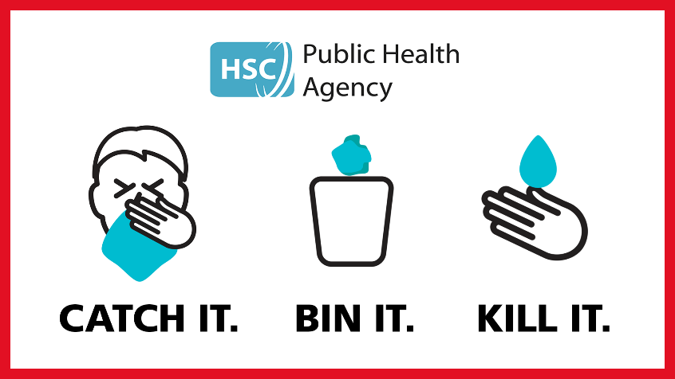

**Preventing spread of any infection.**

**What can we do?**

• washing your hands often - **with soap and water**, or use alcohol sanitiser if handwashing facilities are not available.

• covering your cough or sneeze with a tissue, then throwing the tissue in a bin.

• people who feel unwell should stay at home and should not attend work or any education or early years/youth setting

• children, pupils, students, staff and visitors should wash their hands:

o before leaving home

o on arrival at school

o after using the toilet

o after breaks and sporting activities

o before food preparation

o before eating any food, including snacks

o before leaving school

• avoid touching your eyes, nose, and mouth with unwashed hands

• avoid close contact with people who are unwell

• clean and disinfect frequently touched objects and surfaces

• if you are worried about your symptoms or those of a child or colleague, please call NHS 111.

Do not go directly to your GP or other healthcare environment but phone.