

**School Information for Parents/Guardians**

**Monday 2 December**

Follow us now on **the web** for news updates

**www.stbrigidspsballymoney.com**

**Sunday 1 December**

* Choir singing at end of Mass and at beginning of the Christmas Bazaar.
* Christmas Bazaar 12.30 – 2.30 pm

**Monday 2 December**

* Dinner menu Week 1
* Year 6 Shared Education in St Brigid’s PS (morning)
* Guitar Tuition
* After School Drama 3-4 pm

**Tuesday**

* Y6/7/CB Science Workshop in OLOL (morning)
* No Swimming

**Wednesday**

* Cross Country event in Coleraine (morning)
* Musical Pathways Programme (Year2 & 3) 1-2pm
* Violin Tuition
* Tag Rugby After School 3-4pm (Year 6 & 7) £2 per week/£10 5 weeks

**Thursday**

* Christmas Dinner Day
* Christmas jumper or hat day - £1 donation to St Vincent de Paul Christmas Appeal.

**Friday**

* Girls’ Hockey at Rugby Avenue, Coleraine (9.00 am – 12.30 pm)
* Piano tuition
* Principal Awards

**Winter is coming! Please ensure your child brings a coat to school every day.**

**Up and coming information & dates for your Diary**

* School Closure: Thursday 12 December – Election Polling Station
* Sunshine Club: 2.00 – 3.00 pm (£2) 3.00 – 5.30 pm (£2 per hour or part thereof)
* Breakfast Club: 8.00 – 9.00 am (£1 per day)
* **Allergy – Please do not send in Nuts or Nut Spreads to school.**

Have a very enjoyable weekend and thanks for your continued support.

Mr K O’Neill Principal

**St Brigid’s Primary School – Castle Street – Ballymoney – BT53 6JX – 028 27662664**



**Important Reminder!**

There is a child in the school with an immune deficiency disease.

Please remember to contact school if your child or children are unwell. Even if they are in school.

**The Grand Christmas Draw**

**The draw will take place during the Christmas Bazaar**.

If you have any tickets sold/unsold please bring along to the Bazaar on Sunday between 12.30 and 2.30 pm.

**Registration P1 September 2020**

**If you have a child starting school in September or know someone who is, please contact the school to register your interest.**

**Application process is online this year and open during the month of January 2020. Please contact the school if you require any assistance in completing the online application. A date and time for the Open Day will follow shortly.**

**&**

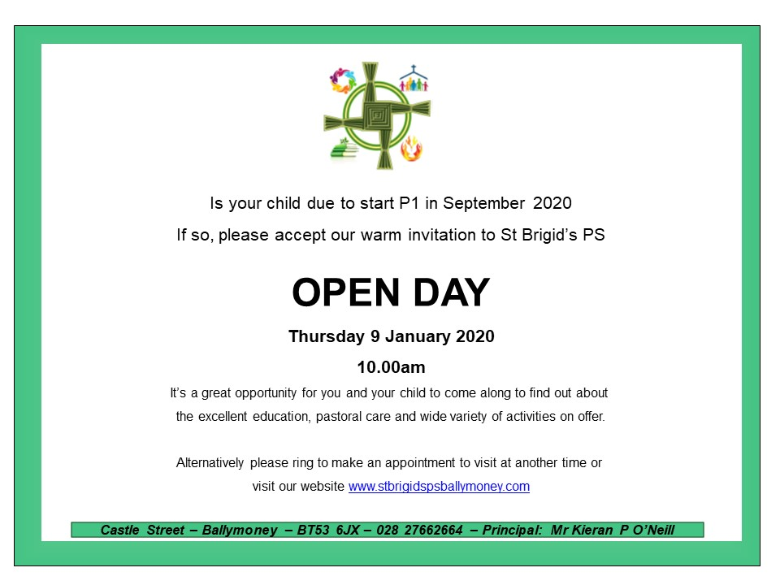

**Christmas Countdown**

**Our countdown to Christmas begins on Monday 2nd December (weather permitting.) Join us in the playground at 9am to enjoy daily singing and dancing performances as we get in to the Christmas spirit. **