

**School Information for Parents/Guardians**

**Monday 25 November 2019**

Follow us now on **the web** for news updates

**www.stbrigidspsballymoney.com**

**Monday 25 November**

**December Milk**

£2.94

Orders in by Wednesday 27 November please.

* Dinner menu Week 4
* Guitar Tuition
* After School Drama 3-4 pm

**Tuesday 26 November**

* Year 4 Library visit 10.45-11.45 am
* No Swimming

**Wednesday 27 November**

* Musical Pathways Programme (Year2 & 3) 1-2pm
* Violin Tuition
* Tag Rugby After School 3-4pm (Year 6 & 7) £2 per week/£10 5 weeks

**Thursday 28 November**

Please return all Grand Christmas Draw tickets sold or unsold before the end of the week.

* Year 6 Library visit 10.45-11.45 am
* Yr 3 Shared Education Session in St Brigid’s PS 9.30am – 12noon

**Friday 29 November**

* Indoor Hurling Blitz in Dunloy (10 am start)
* Piano tuition
* Principal Awards

**Sunday 1 December**

* Choir singing at end of Mass and at beginning of the Christmas Bazaar.
* Christmas Bazaar 12.30 – 2.30 pm

**Winter is coming! Please ensure your child brings a coat to school every day.**

**Up and coming information & dates for your Diary**

* School Closure: Thursday 12 December – Election Polling Station
* Sunshine Club: 2.00 – 3.00 pm (£2) 3.00 – 5.30 pm (£2 per hour or part thereof)
* Breakfast Club: 8.00 – 9.00 am (£1 per day)
* **Allergy – Please do not send in Nuts or Nut Spreads to school.**

Have a very enjoyable weekend and thanks for your continued support.

Mr K O’Neill Principal

**St Brigid’s Primary School – Castle Street – Ballymoney – BT53 6JX – 028 27662664**

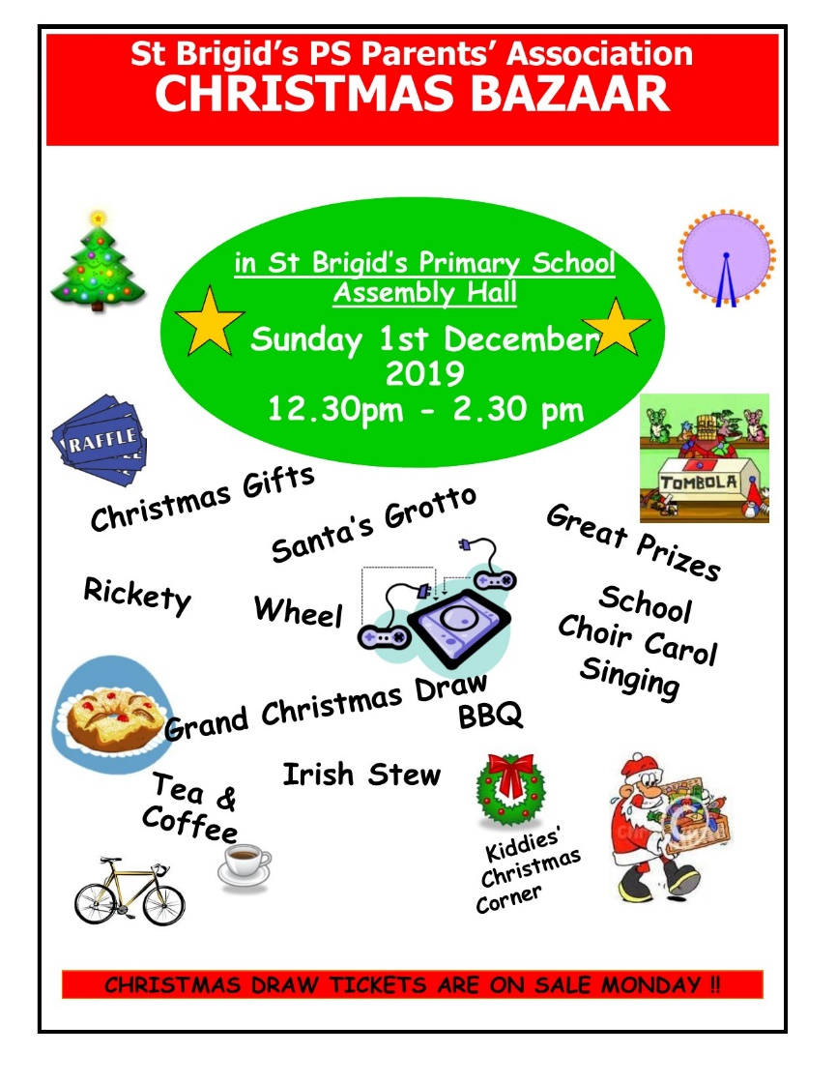

**Reminder**

There is a child in the school with an immune deficiency disease.

Please remember to contact school if your child or children are unwell. Even if they are in school.

**On sale next week in school :**

**Christmas Bazaar Competitions**

Name the Christmas Teddy - 50p

Name the Christmas Elf - 50p

Guess the number of sweets in jar - 20p

Lucky Lapland & Winning

Winter Wonderland Squares

£1 each - to win £10 prize

**&**

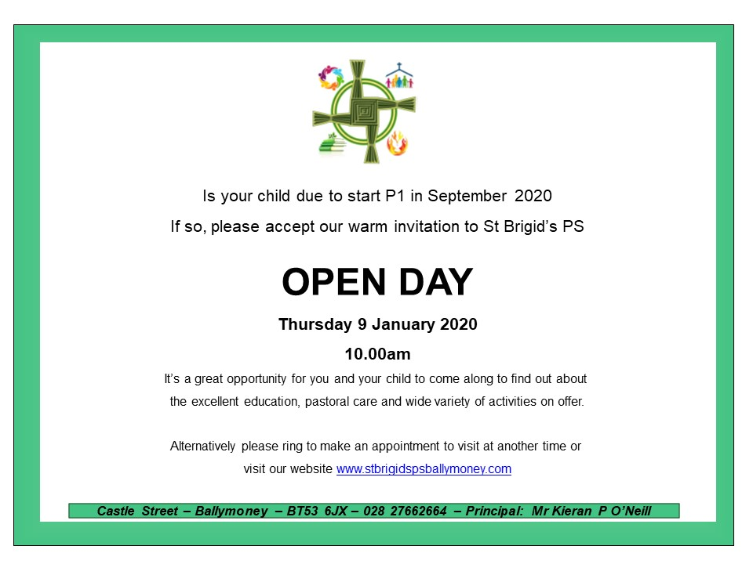

**Registration P1 September 2020**

**If you have a child starting school in September or know someone who is, please contact the school to register your interest.**

**Application process is online this year and open during the month of January 2020. Please contact the school if you require any assistance in completing the online application. A date and time for the Open Day will follow shortly.**

**The Grand Christmas Draw**

Tickets have gone out to every family on this week

If you would like any more contact the school.

Please return any tickets (sold/unsold) to the school asap. We can try to sell any unsold tickets before the 1 December draw.