

**School Information for Parents/Guardians**

**Monday 4 November 2019**

Follow us now on **the web** for news updates

**www.stbrigidspsballymoney.com**

**REMINDER: Half Term: Monday 28 October – Friday 1 November.**

**School Reopens Monday 4 November.**

**Monday 4 November**

* Dinner menu Week 1
* Guitar Tuition
* After School Drama 3-4 pm

[](https://www.google.co.uk/url?sa=i&rct=j&q=&esrc=s&source=images&cd=&cad=rja&uact=8&ved=0ahUKEwiXjriqhsrWAhVNaVAKHXhhDDQQjRwIBw&url=https://twitter.com/roadofhope44&psig=AFQjCNFEro0zYGQfbOsMoIxtnUWD5sDPRw&ust=1506762605508762)

The annual Road of Hope Shoeboxes will be collected on Wednesday 6th November.

Please try to support this very worthwhile appeal.

**Tuesday 5 November**

* No Swimming
* Boys’ Hockey (morning)

**Wednesday 6 November**

* Road of Hope Shoebox Collection
* Yr 5 Shared Education Session in Leaney PS 9.30am – 12noon
* Musical Pathways Programme (Year2 & 3) 1-2pm
* Violin Tuition
* PTA Meeting 7.00pm

**Thursday 7 November**

* Fashion Club – Year 4 & 5 3-4pm
* Yr 4 Shared Education Session in Leaney PS 9.30 – 11.30 am

**Friday 8 November**

* Piano tuition
* Principal Awards

**Up and coming information & dates for your Diary**

* Sunshine Club: 2.00 – 3.00 pm (£2) 3.00 – 5.30 pm (£2 per hour or part thereof)
* Breakfast Club: 8.00 – 9.00 am (£1 per day)
* **Allergy – Please do not send in Nuts or Nut Spreads to school.**

.

Have a very enjoyable weekend and thanks for your continued support.

Mr K O’Neill Principal

**St Brigid’s Primary School – Castle Street – Ballymoney – BT53 6JX – 028 27662664**

**PTA News**

**Save the Date**

**Christmas Bazaar Sunday 1 December**

[](http://www.google.co.uk/url?sa=i&rct=j&q=&esrc=s&source=images&cd=&cad=rja&uact=8&ved=2ahUKEwiEnayCsajdAhXEK8AKHVmtCFUQjRx6BAgBEAU&url=http://www.katyisd.org/campus/HE/Pages/PTA.aspx&psig=AOvVaw2Pet2zGg8sjf3JuWqVy3kD&ust=1536392124057568)

**PTA Meeting**

Wednesday 6 November at 7.00pm in St Brigid’s PS

All new parents welcome.

**Reminder**

There is a child in the school with an immune deficiency disease.

Please remember to contact school if your child or children are unwell. Even if they are in school.

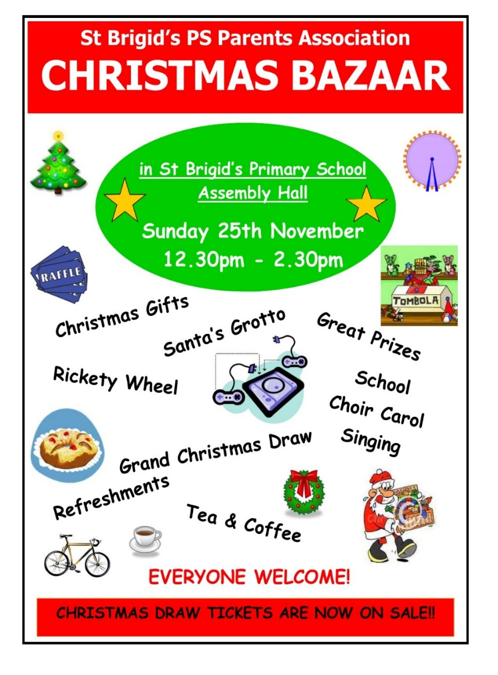

**Homework Diaries Year 3 – 7**

The Homework diaries for 2019-20 are now available.

**£6.00**

**Sunday 1st December**

**12.30 – 2.30 pm**

**The Grand Christmas Draw**

Tickets will go out to every family on the week beginning 11 November. If you would like any more contact the school.

Please return any tickets (sold/unsold) to the school on or before Friday 22 November. We can try to sell any unsold tickets before the 1 December draw.

**Christmas Draw Tickets will be on sale from 11th November**

**Not Half Right Day**

A massive thank you to everyone who collected sponsorship for the school annual fundraising day at the end of September.

**A massive £1530 was raised.**

Thanks for all your support.