



**School Information for Parents/Guardians**

**Monday 9th March 2020**

Follow us now on **the web** for news and updates

**www.stbrigidspsballymoney.com**

**Christmas Show DVD 2019**

The Christmas DVD is now available to order.

Cost £10

Orders extended to Wednesday 11 March

**Monday 9 March**

* Drama 3-4pm
* Guitar Lessons
* Netball 3-4 Yr6 & 7

**Tuesday 10 March**

* Yr6 & CB Swimming
* Year 4 & 5 Gaelic football pm in St Brigid’s
* Games Club 3-4 pm (Yr4 & 5)

**Wednesday 11 March**

* Year 3 Shared Education in Leaney PS (morning)
* After School Hockey 3-4pm (£10 for 5 weeks)
* Musical Pathways Programme 1-2 pm (Yr1 & Yr4) (£1 per week/£12 for 12 weeks)
* Violin tuition
* Culture Club 3-4 pm
* **First Confession Parent Information Evening (Yr3) 7.00 pm**

**Thursday 12 March**

* Hockey 2-3 (school teams only Boys and Girls)

**Friday 13 March**

* Year 5 Shared Education in Joey Dunlop Leisure Centre (morning)
* Principal Awards

**Up and coming information & dates for your Diary**

* **Important Reminder! There is a child in the school with an immune deficiency disease. Please remember to contact school if your child or children are unwell. Even if they are in school.**
* Reminder: There is a child in the school with a Nut Allergy – Please do not send in Nuts or Nut Spreads to school.
* **Term 2 Holidays:**

**St Patrick’s Day: Tuesday 17 March 2020**

**Easter: Friday 10– Fri 17 April 2020**

**School Closes 12noon Thursday 9 April (No Sunshine Club this day)**

Have a very enjoyable weekend and thanks for your continued support.

Mr K O’Neill Principal

**St Brigid’s Primary School – Castle Street – Ballymoney – BT53 6JX – 028 27662664**

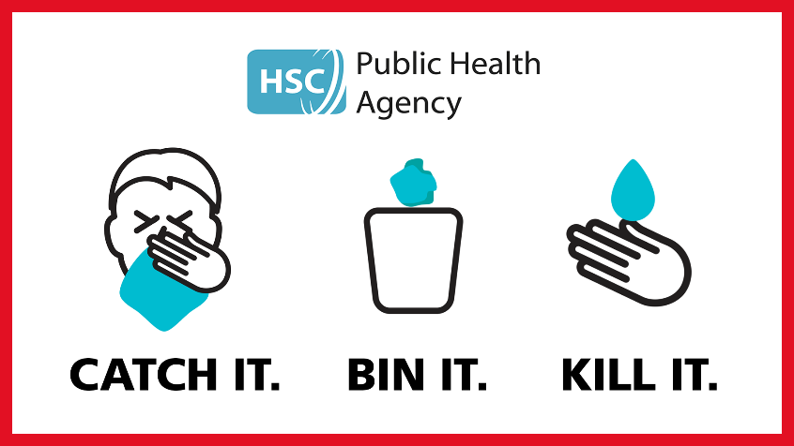

**Sacrament Dates 2020**

Year 3 **First Confession** Thursday 26th March

Our Lady and St Patrick’s 11.00 am

Year 7 **Confirmation**  Monday 4th May

Our Lady and St Patrick’s 11.00 am

Year 4 **Holy Communion** Saturday 16th May

Our Lady and St Patrick’s 11.00 am



All of the classes have a Trócaire box and the collection of small change is promoted, given that ‘pennies make pounds’!

**Milk Carton Challenge**

This year each child will again receive an empty milk carton to collect change.

We will also have a designated Fund Raising Day for Trocaire later on in April. More details to follow!

The annual **Green Day** will be held on **Monday 16 March** in conjunction with our St Patrick’s Day Céilí and Concert. Each child will dress in green and donate £1 to Trócaire. We will also have a bun sale on this day!

During the Lenten season, the classes will attend mass and confessions in preparation for Easter.

**Preventing spread of any infection.**

**What can we do?**

• washing your hands often - **with soap and water**, or use alcohol sanitiser if handwashing facilities are not available.

• covering your cough or sneeze with a tissue, then throwing the tissue in a bin.

• people who feel unwell should stay at home and should not attend work or any education or early years/youth setting

• children, pupils, students, staff and visitors should wash their hands:

o before leaving home

o on arrival at school

o after using the toilet

o after breaks and sporting activities

o before food preparation

o before eating any food, including snacks

o before leaving school

• avoid touching your eyes, nose, and mouth with unwashed hands

• avoid close contact with people who are unwell

• clean and disinfect frequently touched objects and surfaces

• if you are worried about your symptoms or those of a child or colleague, please call NHS 111.

Do not go directly to your GP or other healthcare environment but phone.