

**School Information for Parents/Guardians**

**Monday 9 November 2020**

Follow us now on **the web** for news updates

**www.stbrigidspsballymoney.com**

**Stop COVID-19**

**If you have symptoms you must stay at home and book a test.**

**You must isolate as a family bubble until the result of the test has been received.**

**Please keep school well informed.**

**Monday 9 November**

**Shoebox Appeal 2020**

**A huge thank you to everyone who contributed this year.**

**Your donations amounted to a massive £808.**

**A wonderful response to those who need our help.**

* Breakfast Club open every day 8.00 – 9.00 am
* After School Club open every day 2.00 - 5.30pm
* Dinner menu Week 1

**Tuesday 10 November**

**Wednesday 11 November**

* **First Confession** Year 4

10.30 am in Our Lady and St Patrick’s Chapel

* Violin Tutor in

**Thursday 12 November**

**Friday 13 November**

* Ditch the Dark and Crazy Hair Day
* Principal Awards

**Up and coming information & dates for your Diary**

* **Reminder: St Brigid’s PS is a Nut Free School. Please do not send in Nuts or Nut Spreads to school.**
* Important: Could your child be entitled to free school meals? Did your child receive free school meals last year? Remember you may need to confirm details with the Education Authority. If you think you are entitled but are unsure about what to do please call the office for advice.
* **Odd Socks Day** – Friday 20 November

**After School Childcare – Spaces available!!!**

* One Stop: 2.00 – 3.00 pm (£2) Sunshine Club: 3.00 – 5.30 pm (£2 per hour or part thereof)
* Breakfast Club: 8.00 – 9.00 am (£2 per day)

**Christmas Break 2020:**

12 noon Friday 18 December – Wednesday 6 January (inclusive).

Have a very enjoyable weekend and thanks for your continued support. Mr K O’Neill Principal

**St Brigid’s Primary School – Castle Street – Ballymoney – BT53 6JX – 028 27662664**

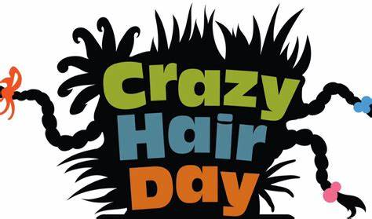

**Parent Interviews**

The parent interviews normally scheduled for the end of October will take place in Jan/Feb 2021. Current restrictions make the number of face to face interviews difficult to manage. If you have any worries or concerns, you can still contact the school to arrange to speak to the class teacher and they will get back to you.

**Important Notice**

When using the car park at the chapel, please do not park in front of the gates as they are emergency exits and must be kept clear at all times for access. There is a good number of spaces to park in so please use the designated parking spaces. The front car park is very busy and only for children arriving by bus or taxi. Please be careful when reversing out of spaces

**Ditch the Dark Day!!**

**Social Distancing and Wearing a Face Covering at Drop off and Pick up times**

* **Please respect social distance (2m between adults).**
* **Please spread out and use all of the area available.**
* **If you can, please wear a face covering.**
* **Limit the no. of adults on the playground to 1 per family if possible.**

**Nut Allergy - St Brigid’s a Nut Free School**

As there is a child in school with a Nut Allergy, please do not send in nuts or nut based products e.g. spreads into school.

**Reminder**

There is a child in the school with an immune deficiency disease. Please remember to contact school if your child or children are unwell. Even if they are in school.



Crazy Hair and Bright Clothes Day

Friday 13 November 2020

**Ditch the Dark Day with a difference.**

* Crazy Hair (spikes, colours, bobbles etc.)
* Non-Uniform Day
* Wear bright, luminous clothes to celebrate Ditch the Dark day