MC900232110[1]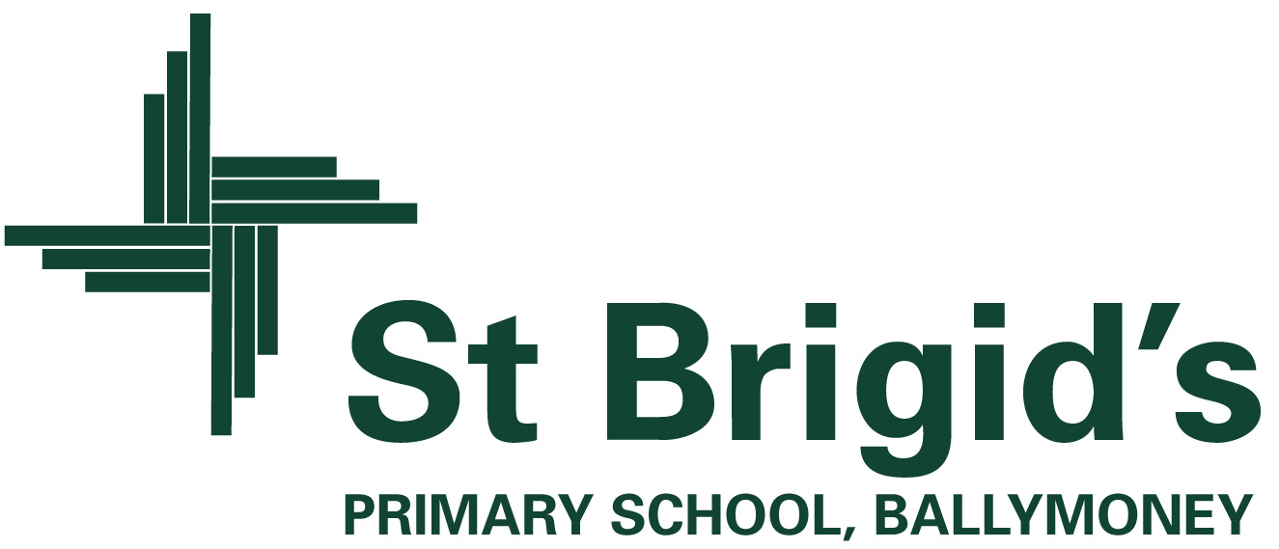

**Curriculum Newsletter P2 Term 1 2020**

The World Around Us

(Science, Technology, Geography and History)

The theme we are studying this term is ‘**Wonderful Me’.**

The focus of this topic in September is to help the children gain a greater understanding of ‘Ourselves’, our bodies and how to care for them. We have an exciting few weeks ahead of us in P.2! We will be busy learning about our senses, carrying out experiments based on investigating the role they play in our daily lives. This topic has already led us to looking at our unique characteristics e.g. hair colour and eye colour. We will write facts about our body and will discuss our uniqueness by looking at our fingerprints. We will be considering adjectives to describe ourselves and will discuss what makes us special. We will have hospital role play equipment set up in the classroom for play based learning and we will be re-enacting the roles of patients, doctors and nurses. Any parent who works in the healthcare profession who would like to talk to the class about what they do would be very welcome to even share their knowledge via video chat.

Our Topic will change to “**Yum, Yum**” in the second half of the term. The children will investigate the importance of having a healthy and balanced diet. We will look at different types of food, sorting them into what we think we should eat most or least often and we will be investigating the hidden sugar content in foods and drinks. This topic will allow huge potential for investigation and research. For example, we will be looking at the importance of storing food in the correct place and we will be studying food labels to discover where in the world our food comes from and mapping the journey it makes before arriving on our plates!

***We will be really busy bees!***

Included in themed work are creative activities, simple science investigations, activities which explore our environment and activities which use information technology.

***What else is happening in the curriculum?***

Homework: This will hopefully start at the end of September. We may use the Seesaw App to assign homework activities to your child. New reading books will be given twice a week and a library book will not be sent home at present. When spellings are eventually sent home the spelling and recognition of rhyming words and tricky words will be tested each Friday.

ICT: Children will programme the Beebot robot to move around the supermarket mat, using a series of instructions. They will use Activ Inspire to draw a portrait of themselves and will use the ipad to engage in Literacy and Numeracy activities on a daily basis.

Numeracy: We will be working on identifying numbers 1-20 and beyond as well as beginning to look at adding and subtracting. This will lead us onto exploring number stories and bonds to 10. We will also be naming odd/even numbers and using money to 20p: 1p, 2p, 5p, 10p, 20p. Pattern, sorting, shape and data handling work will be revisited throughout the term also.

P.E: Children will enjoy P.E on Tuesday and Thursday. On these days, please send your child to school wearing their PE shoes.

**What’s going on this term?**

P.2 will be getting busy inside and outside the classroom! We will use our Nature trail to explore the changes in ‘Autumn’ as well as going on adventures in order to use each of our 5 senses in our surroundings. We will be grasping opportunities to use the outdoor classroom for play based learning.

**Class Contract**

In order to secure a happy and safe learning environment P.2 have agreed upon the rules (overleaf) which we have devised together. You will notice that these are presented in a positive ‘We can’ way. We will achieve them and can succeed in keeping them. Children will be awarded ‘Green Cards’ when they work well and conscientiously adhere to the rules. There will also be ‘Superstar Points’ awarded to each table whenever they work well together as a team. At the end of each week, the ‘Green Card Winner’ will be rewarded as well as ‘Table of the Week’ too. The children are already enjoying watching their green cards accumulate! Another lovely surprise at the end of each week will be our Principal’s Award. This child’s achievements and positive character will be recognised each Friday as their success will be celebrated by their classmates. and they will be awarded a certificate too.

MC900250922[1]

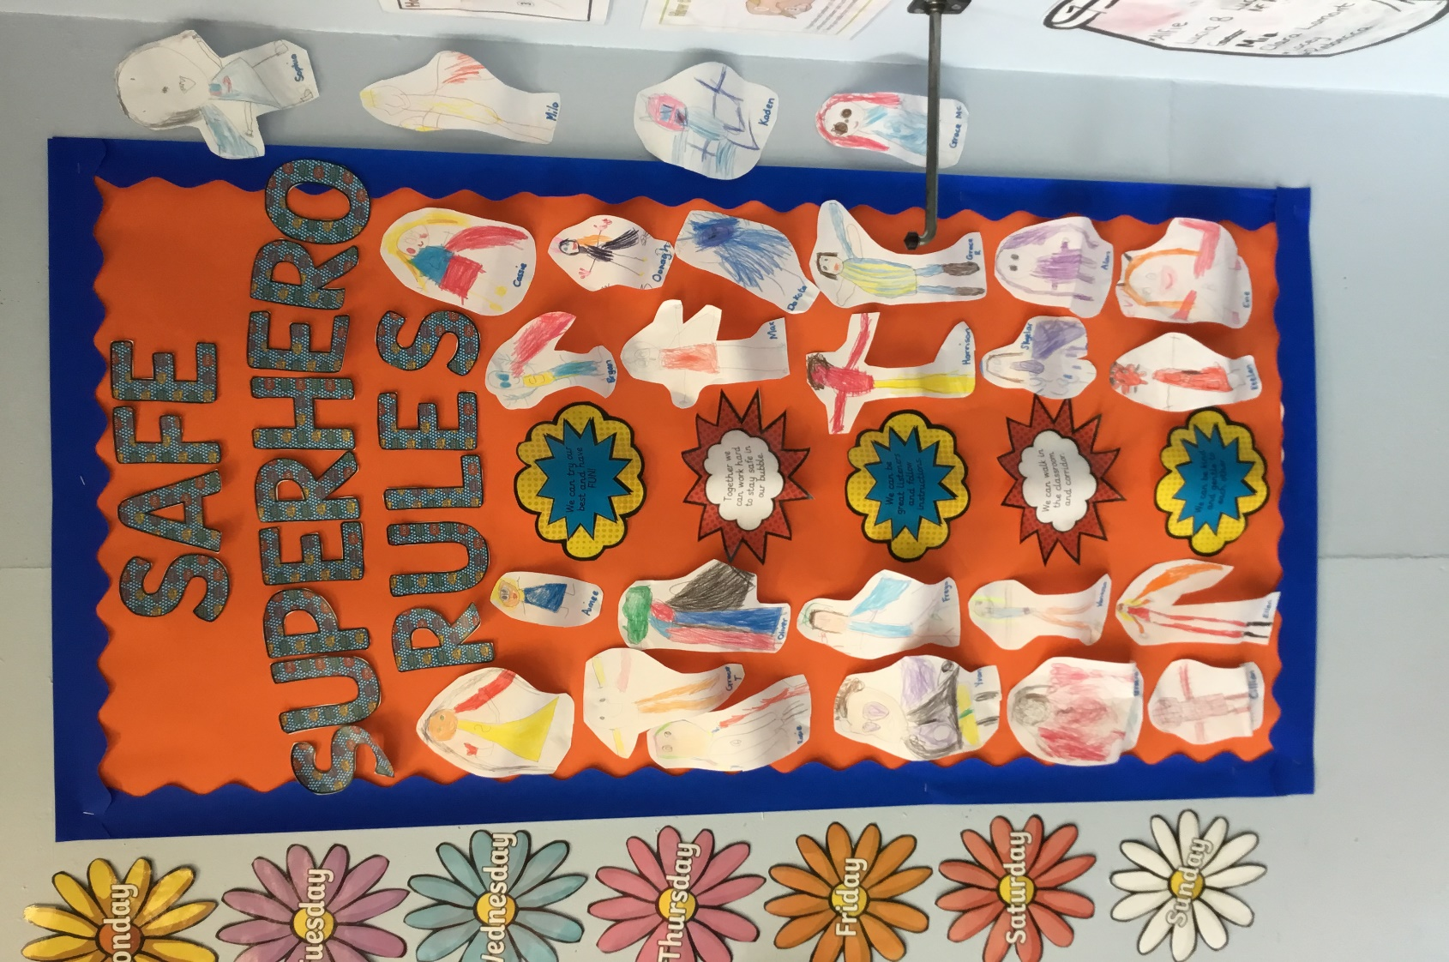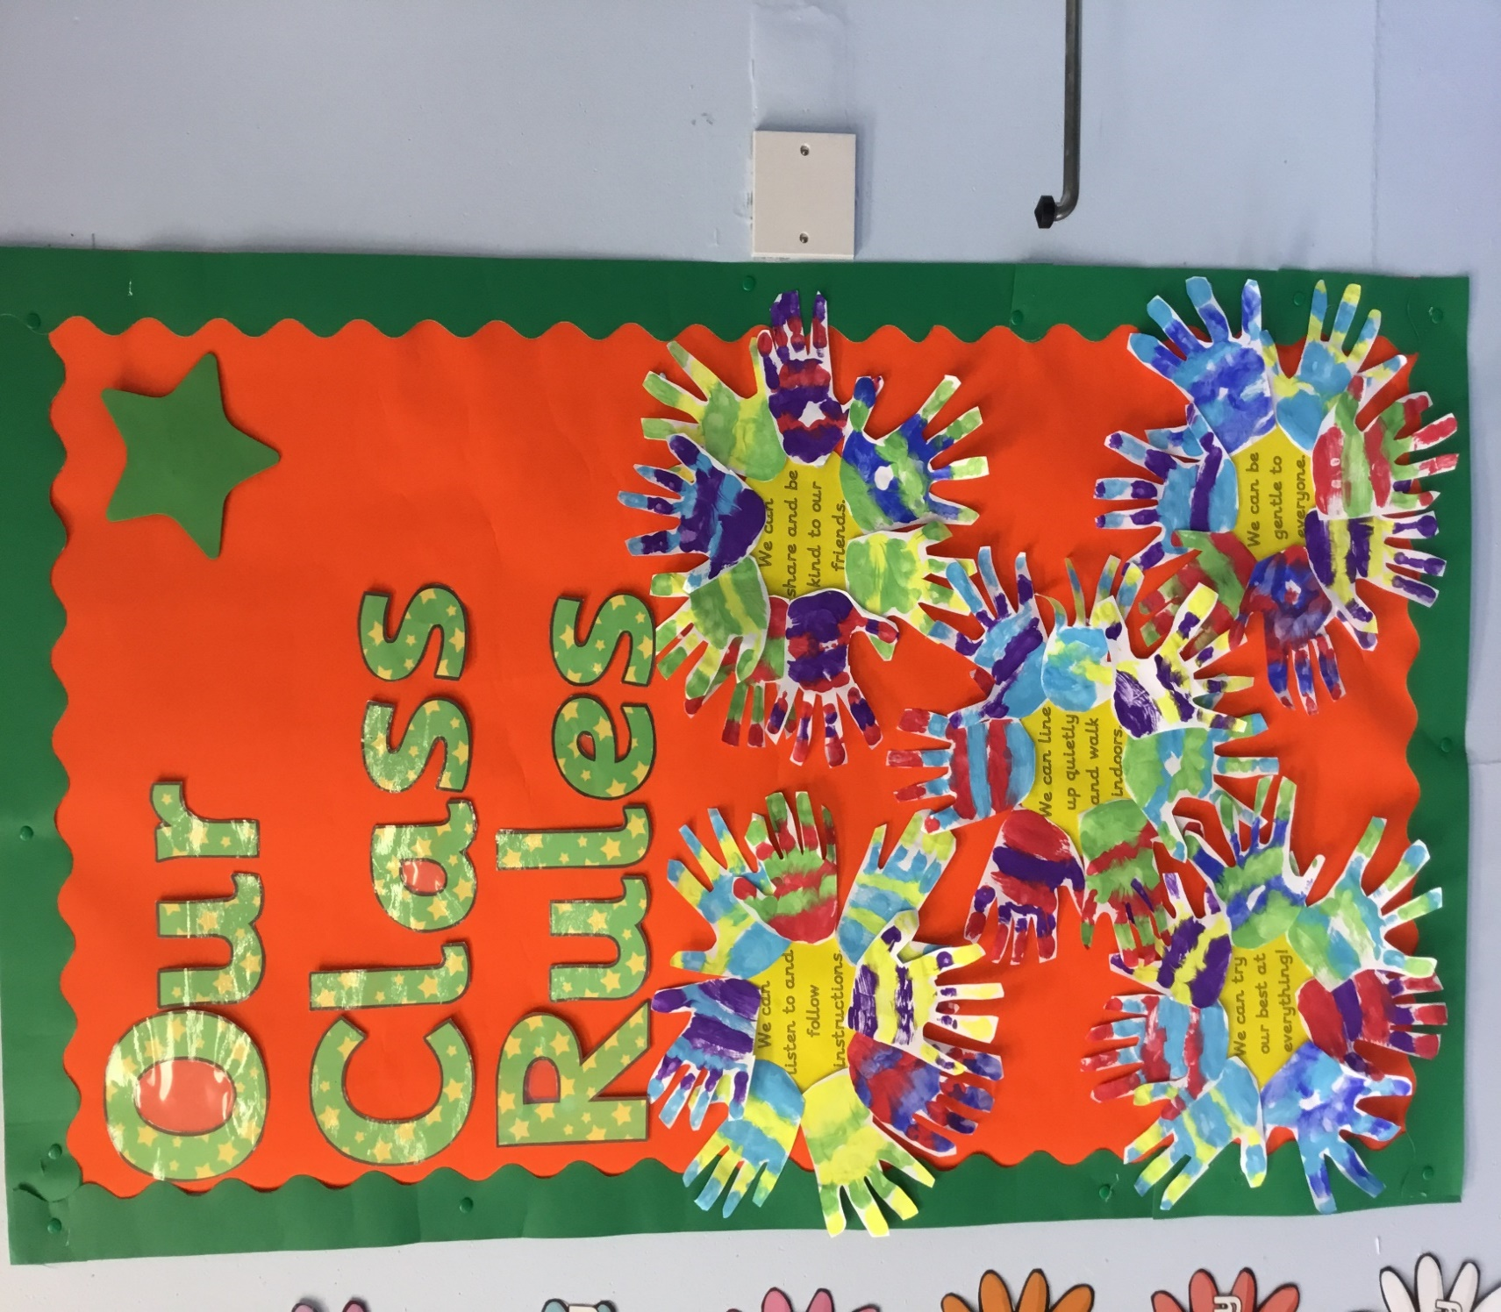

* Together we can work hard to stay safe in our bubble.
* We can be great listeners and follow instructions.
* We can walk in the classroom and corridors.
* We can be kind and gentle to each other.
* We can try our best and have FUN!

***OUR PLAYGROUND RULES***

* We can be a good friend.
* We can be gentle.
* We can follow instructions.
* We can play nicely.
* We can line up quietly.

MC900250922[1]

In the playground, we will make a special effort to include everyone in our games and will always aim to be kind and gentle to those around us.

*[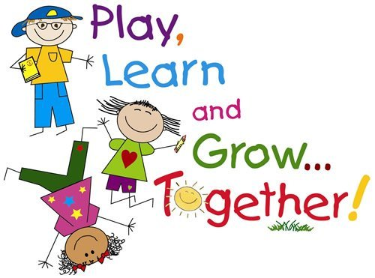](http://www.google.co.uk/url?sa=i&rct=j&q=&esrc=s&source=images&cd=&cad=rja&uact=8&ved=0CAcQjRxqFQoTCIv7tO6vjcgCFSGt2woddogPIA&url=http://www.mpsaz.org/sirrine/educational_links/&psig=AFQjCNEs3_Wd2RgLYl-A9R6eLV6cPXDzBQ&ust=1443105165988514)*

**Our class motto in P2 is: “We can!”**

MC900250922[1]