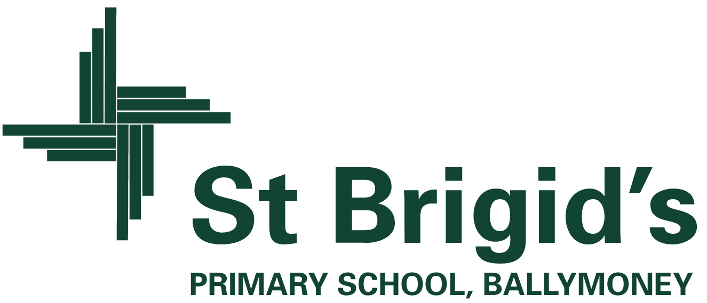

**Curriculum Newsletter P4 Term 1**

The World Around Us

(Science, Technology, Geography and History.)

During **September**, the topic for P.4 is called “Wonderful Me.” 

We will be looking at the area of healthy eating, good hand washing and hygiene habits, the importance of exercise in our lives and having a balanced diet. Activities will involve sorting food items into different food groups and playing ICT games in ABL to investigate and reinforce the importance of keeping our bodies healthy and having a balanced and varied diet.

Science experiments will be carried out to help the children explore their senses and we will be discussing and celebrating how we are all unique and special. Using ink blocks, we will capture our fingerprints and use our knowledge of the different line patterns to ‘solve a serious crime’ within the P4 classroom!



From **October to December**, the P.4 topic will be “My Place and Yours.”

This topic will include a detailed study of Ballymoney Town.

We will be looking at the position of our school and town in relation to the world, the U.K and within Ireland.

The children will produce a video advertisement to promote life in Ballymoney which they will then share with their peers in class.

In their WAU project they will include information and pictures about their local area and design factual travel brochures advertising local buildings and areas of interest in the town. To aid this work, the children will go on a ‘trail’ around the town, where they will take photographs and record short video clips.

Included in themed work are creative activities, simple science investigations, activities which explore our environment and activities which use information technology.

What’s going on?

**Seesaw:** Over the next few weeks, your child will be issued with a password to access the Seesaw learning app from home. Seesaw will be used in P4 to help manage distance-learning should the need arise but also as a way to communicate with parents and to keep you up to date with what is happening in P4.

Further details on Seesaw will be issued shortly.

**P.E** – Sessions will be on a Tuesday and Friday.

Children will not be changing for P.E and are therefore permitted to wear P.E trainers to school on both these days. As our PE sessions will be outside, please ensure your child comes to school with a coat each day. Some children may wish to leave their trainers and coats in school permanently and this is not a problem. Items should be clearly marked with your child’s name.

Break: We are a ‘Healthy school’ and we operate a healthy break policy. Pupils are asked to have a healthy break each day e.g a piece of fruit or a pancake.



Changes within the Curriculum.

**Homework:** There will be no formal homework for the month of September with reading and spellings covered weekly in class.

Homework will recommence in October and further guidance will be provided on this nearer the time.

**Guided Reading:** The children are being given their own reading books every Monday which they store in their personal trays for the week. These books will be collected on a Friday, wiped down and quarantined before another group will be permitted to use them.

**Classroom routine:** Although very different from other years, the children have adapted very well to the new systems and sanitising measures introduced within the classroom. Considering the threat from the current pandemic and taking into account the views of the staff, parents and school community, pupils have the option of wearing a visor, a face cover or neither. The decision is being left in the hands of the parent and no child will be made to wear PPE.

