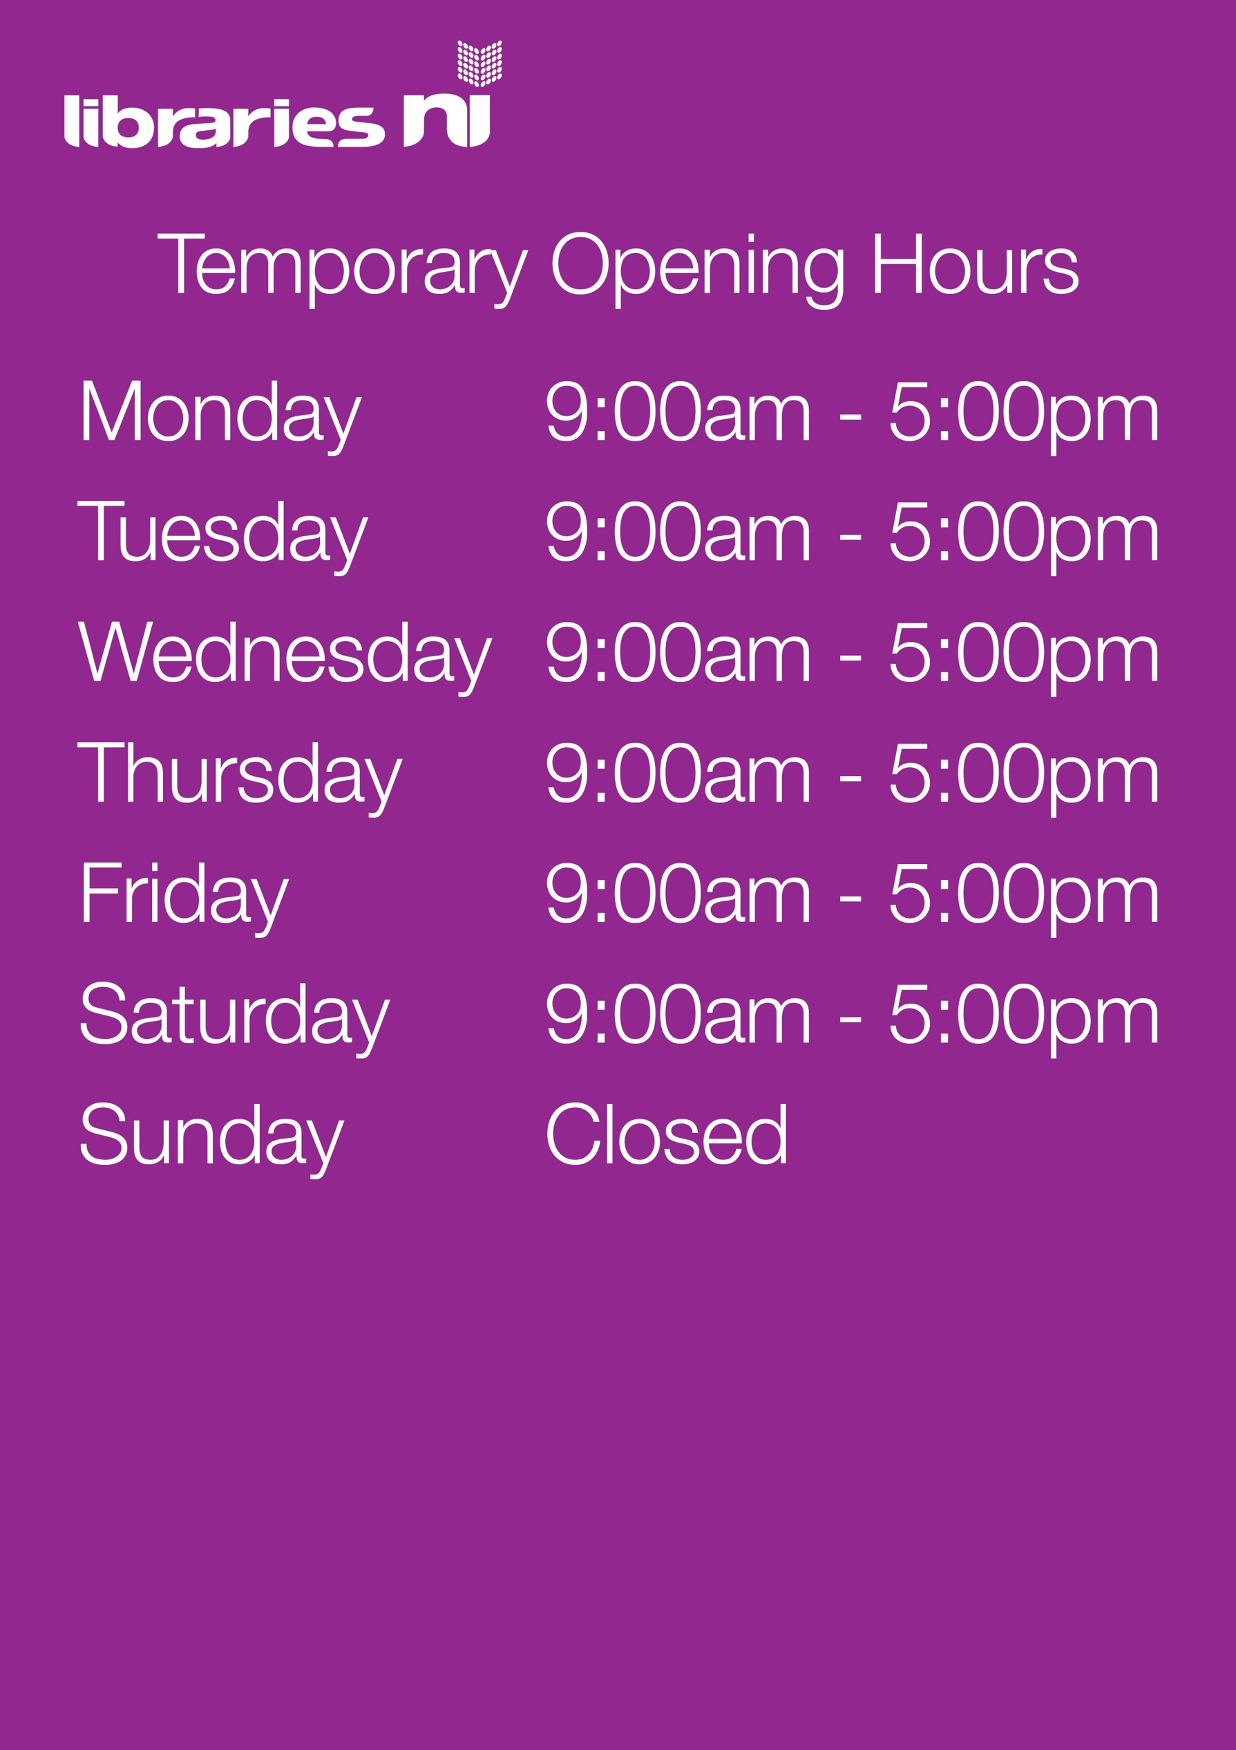

Book and Collect only

Ballymoney Library

This service allows customers to phone their local library to request a selection of books and then arrange a contactless collection. Details of when you can phone your local library to arrange a collection are listed below.

t: 028 2766 3589

Monday 10am-1pm 2pm-4pm

Tuesday 10am-1pm 2pm-4pm

Wednesday 10am-1pm 2pm-4pm

Thursday 10am-1pm 2pm-4pm

Friday 10am-1pm 2pm-4pm

Saturday 10am-1pm 2pm-4pm

Sunday CLOSED