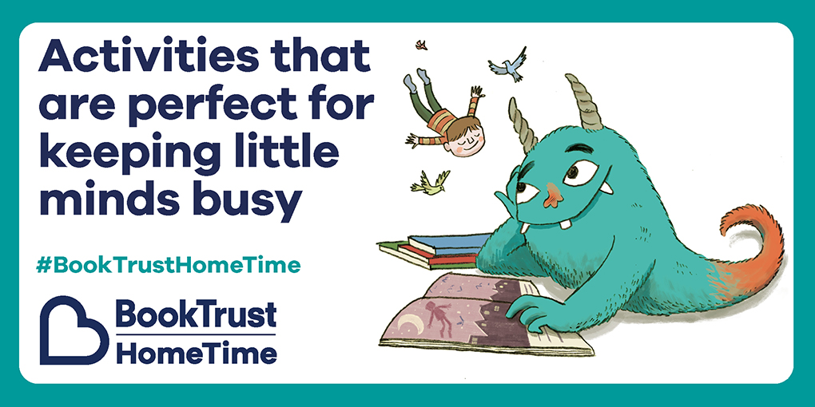
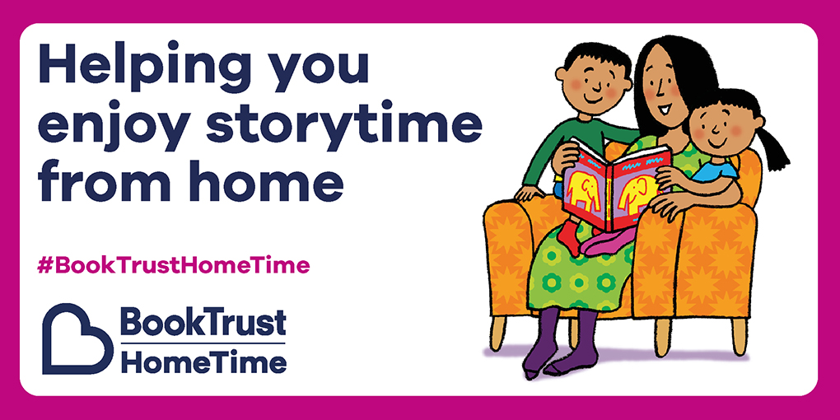
BookTrust have launched a new digital hub, www.booktrust.org.uk/hometime which is packed with reading advice, ideas, activities and resources.
On Monday 6 April we launched a Northern Ireland page, where we feature local authors, illustrators and initiatives. We will use this portal to highlight the amazing talent we have and share what other organisations are doing to support families across Northern Ireland.
The BookTrust NI facebook page allows us to connect with families and share the work that authors and illustrators post on Facebook. We will be able to share your organisations content there too www.facebook.com/booktrustni

