Term 3: Year 2 Numeracy Pack

Within this pack I will provide more information on:
- Numbers 1-100- Counting, Forming and ordering numbers
- Skip counting in 2s, 5s and 10s
- Odd and Even Numbers
- Number bonds to 10
- Addition and subtraction sums
- Making number families
- Finding 10 more/10 less
- Counting tens and ones
- Doubling and Halving
- Money
- Time
- 2D/3D Shape
- Data Handling
- Measure- Length, weight and Capacity
Similar to my explanation in the Literacy pack I have tried to source a variation of ways in which these tasks can be completed. Some pages will contain a photo collage of different ideas that you and your child may find useful and hopefully you may have the appropriate materials needed at home. I have also included links to videos and games in some areas. I understand that not every child may have access to a printer so if you are unable to print the tasks then I would encourage your child to record the assigned task in a book.
Adaptions can be made according to the resources you have available to you as well as your child’s ability. For example, you can choose to make the sums more challenging or easier depending on the efforts of your child. I’ve purposely kept the worksheets small so that each concept is on one page and easier to follow. This would make sure you aren’t scrolling for a long time down through these documents but rather if you wish to print it out and have it much bigger then it should be easily enlarged as this is an editable word document.
I urge you to work through this Numeracy pack at a suitable pace. Please note that I do not expect anyone to do all the things shown on a single page in one day but rather you can be selective and maybe focus on 10 more/10 less for a few days at a time or at random.
A Mental maths workout (see previous pack for details) and one completed task per day is enough and will be beneficial for your child. Revisiting concepts and revising them is necessary in order to consolidate learning.

Numbers 1-100

- Choose any number to start on and choose to count forwards or backwards with and without looking at your number square.
- You can do a counting pattern- ‘heads, shoulders, heads, shoulders’ as you count or even ‘whisper, shout, whisper, shout’ similar to what we would have been doing in class.
- Form the numbers as high as you can possibly go- check that your numbers make sense. For example making sure when writing 38 than you haven’t written 83
- Write the numbers using the sensory ideas listed in your Literacy Pack.
- Order numbers from smallest to biggest and biggest to smallest too.
45, 67, 78, 31 ordered ‘biggest to smallest’ 78, 67, 45, 31
- Identify numbers, before, after and ‘in between’ as well as using which is more/less, smaller/larger questions too.

The Big Numbers Song: https://www.youtube.com/watch?v=e0dJWfQHF8Y
We loved doing this one in class It will help to identify number words too.

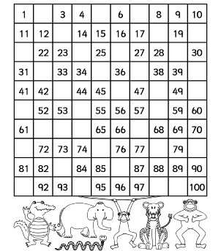
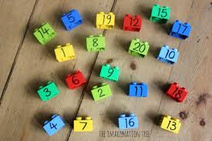
Complete the missing numbers in the 100 square

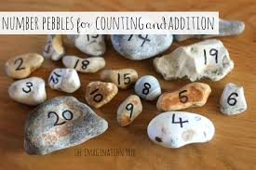

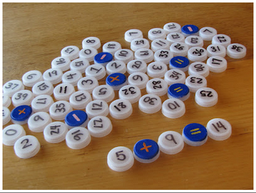

SKIP COUNTING

- Use the 100 square, 2p coins or even pairs of socks to skip count in 2s as high as you can go.
- Skip count in 5s as high as you can go (waving one hand out at a time or 5p coins)
- Skip count in 10s as high as you can go (doing ‘high ten’ movements or 10p coins as you count)

Paint the Squares- https://www.topmarks.co.uk/learning-to-count/paint-the-squares
Use the link above to access the Topmarks 100 square and take part in splat counting in 2s, 5s and 10s. This can also be used to identify and splat any random numbers to 100 for example, ‘Splat the number that comes after 89’ or ‘Splat the number in between 17 and 19’.

There are lots of songs on You tube for skip counting in 2s, 5s and 10s- too many to choose from so I’ll let P2 decide for themselves!
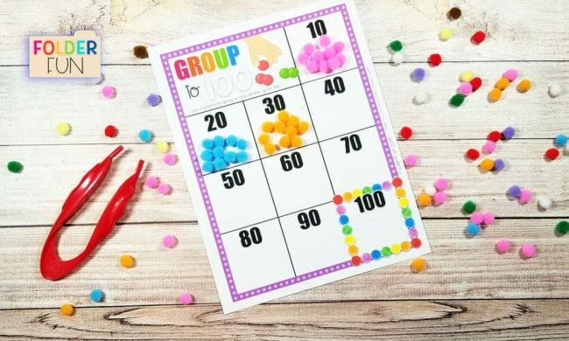
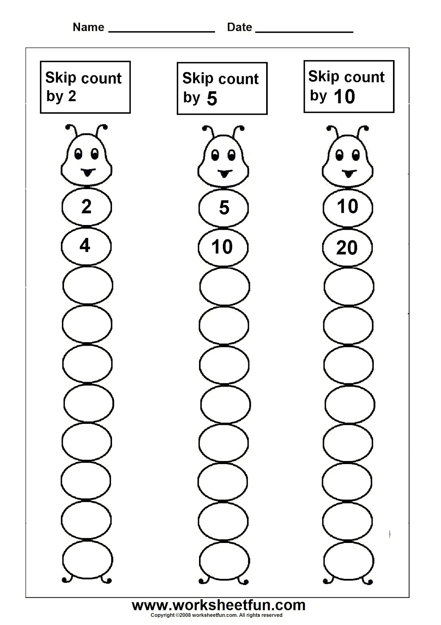
Finish the number patterns below.

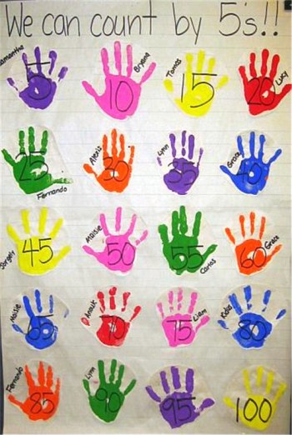
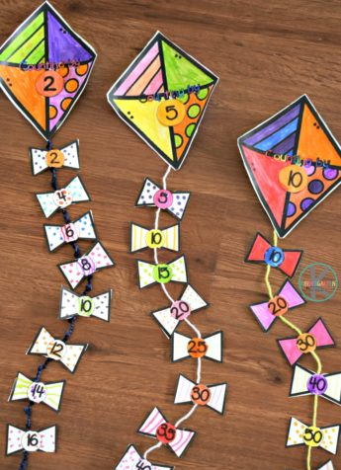

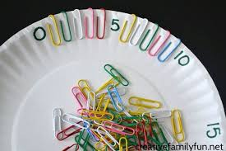

ODD AND EVEN NUMBERS
- Use the 100 square splat online or even using your 100 square sent home in the first pack to colour even numbers yellow and odd numbers purple or any stated colours.
- Sing the Even Number Song https://www.youtube.com/watch?v=Ei19HMn1BxM
- Say the odd numbers to 50 really quietly and slowly
- Say the even numbers to 50 as loudly and quickly as you can

Play this Topmarks game to quickly identify and sort odd and even numbers. You can select how high your numbers go for that extra challenge https://www.topmarks.co.uk/learning-to-count/coconut-odd-or-even
Another game for sorting odd and even numbers including ladybirds and door numbers. https://www.doorwayonline.org.uk/number/oddandeven/

You could attempt a number hunt around your house or in your garden to find and record as many odd or as many even numbers as you can. You may need to use Post it notes for this. You could even order the numbers by size to tie in a little ordering too.

You could even use chalk to record odd numbers and even numbers on the ground and ask a family member to run and stomp on an odd number. If this proves too easy you could be challenged further by being asked to stomp on an even number less than 30 but more than 20 to really get your brain working hard!

ADDITION: ODD OR EVEN ANSWERS?

You could write your own addition sums
which give an even answer.

You could write subtraction sums which
give an odd answer.

Remember even numbers always end in

0, 2, 4, 6, 8

Odd numbers always end in

1, 3, 5, 7, 9

NUMBER BONDS TO 10

- Work on quick recall of ways of number pairs that make 5, 6, 7, 8, 9 and 10.
For example, ‘8 and blank make 9’, ‘4 and blank make 7’ Fill in the blank.
- Jack Hartmann Kids Music Channel has a song for the bonds of each number.
https://www.youtube.com/watch?v=GyK8iEO5-GI Sing/rap along with him
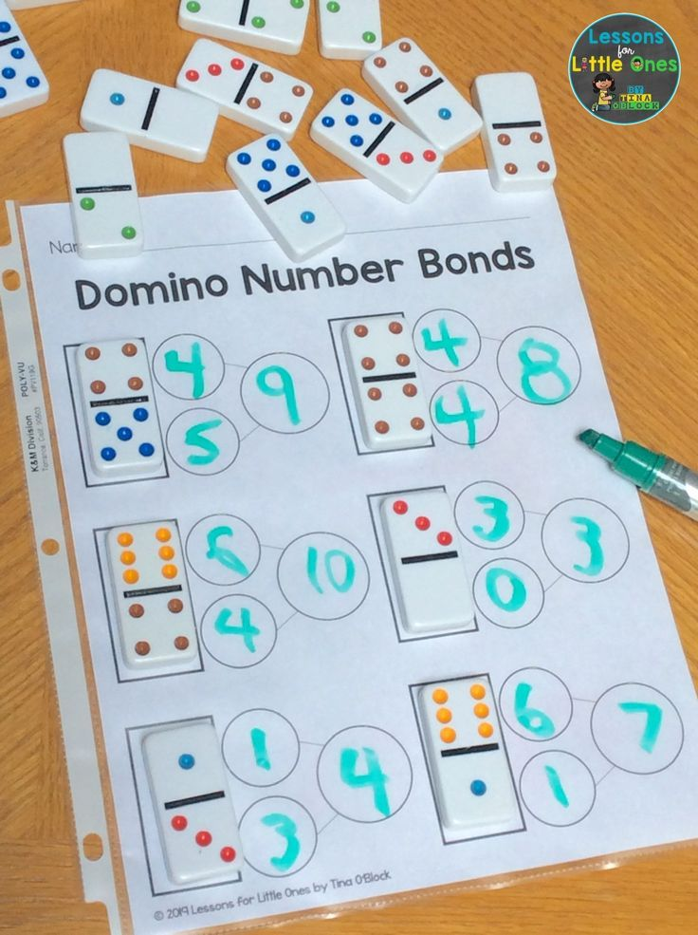
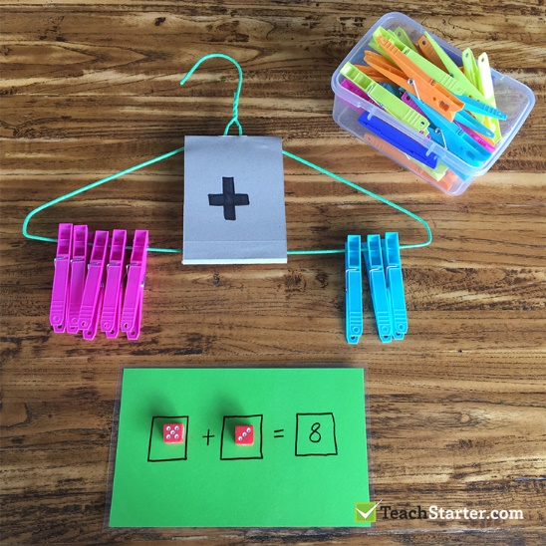
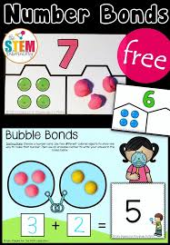

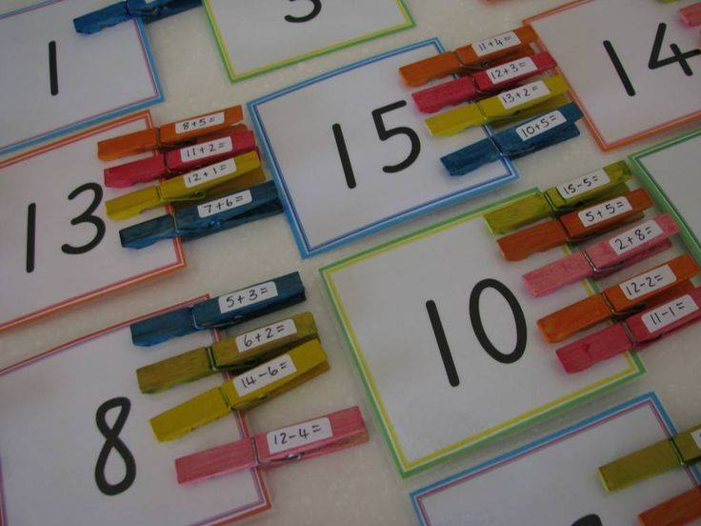
This game encourages quick recall of number bonds of 10.
http://www.snappymaths.com/addition/make10/interactive/make10totc.htm

This game can be changed to focus on bonds of 5, 6, 7, 8, 9 or 10
http://www.ictgames.com/saveTheWhale/index.html

Have a go at making this Bonds of 10 Poster
Learn this really short song to help you remember the bonds of 10
https://www.youtube.com/watch?v=jZi-6_-Uhwc

ADDITION AND SUBTRACTION SUMS

- Always remember when you are adding you count forward and when subtracting you count back.
- Always check your sums are written correctly.
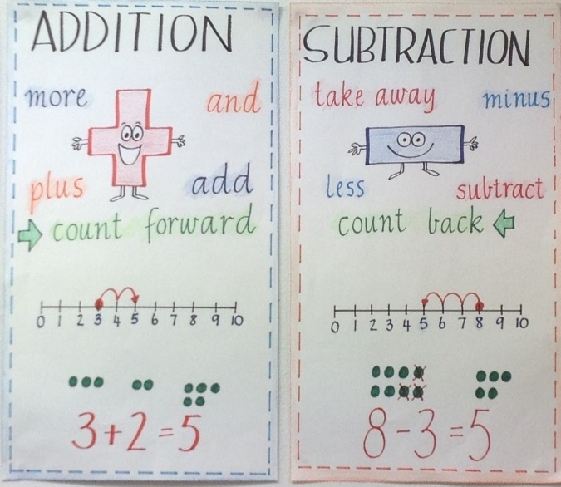
When thinking of addition and subtraction sums try and talk your way through the sum in order to solve it.
What is 6 more than 1? This means 1+6
Start at 9, count forward 3. This means 9+3
What is 7 and 2 altogether? This means 7 +2

Find the difference between 10 and 4. This means 10-4
What is 20 minus 8? This means 20-8
What is 5 less than 17? This means 17-5

You can use a numberline or the 100 square to help you if you need them as a visual aid.
You can use 100 square splat to paint the number that is ‘3 less than 77’.

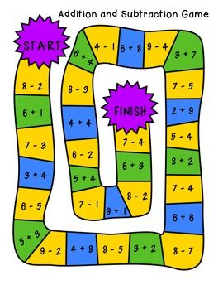
Use toys, food items, buttons, outdoor objects to help you create your own addition and subtraction sums. For example, 8 markers and 7 crayons altogether there is a total of 15 objects.
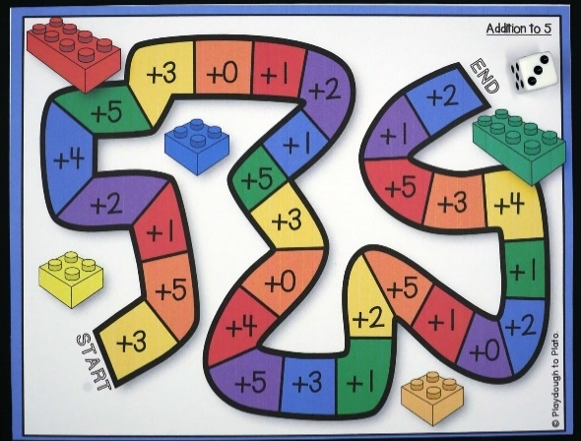
CHALLENGE
Make your own addition
and subtraction board game

You could get creative and
think of ways to make it
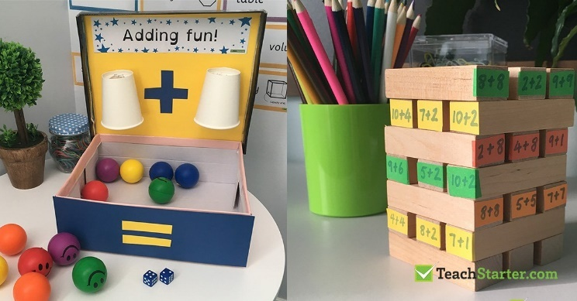
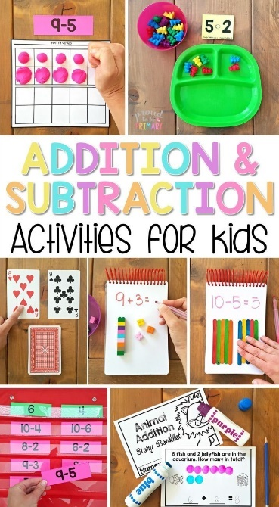
extra cool and imaginative!

https://www.topmarks.co.uk/maths-games/mental-maths-train
A really super train game for addition and subtraction sums!

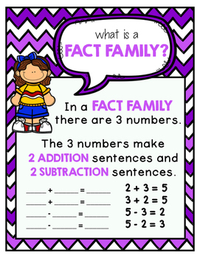
NUMBER FACT FAMILIES
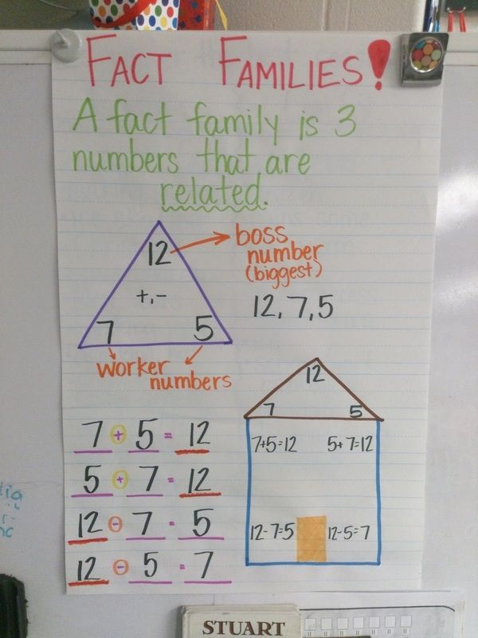
- This will show the link between
addition and subtraction.

- You can use a variety of practical
materials to work through the
number facts for example, cones,
beanbags or cars.

The two You tube links below provide you with animated videos to give further information on fact families.

https://www.youtube.com/watch?v=_2ma8v1GFV0
https://www.youtube.com/watch?v=9IhZDEffyTk
https://www.youtube.com/watch?v=eHb0xKitL40

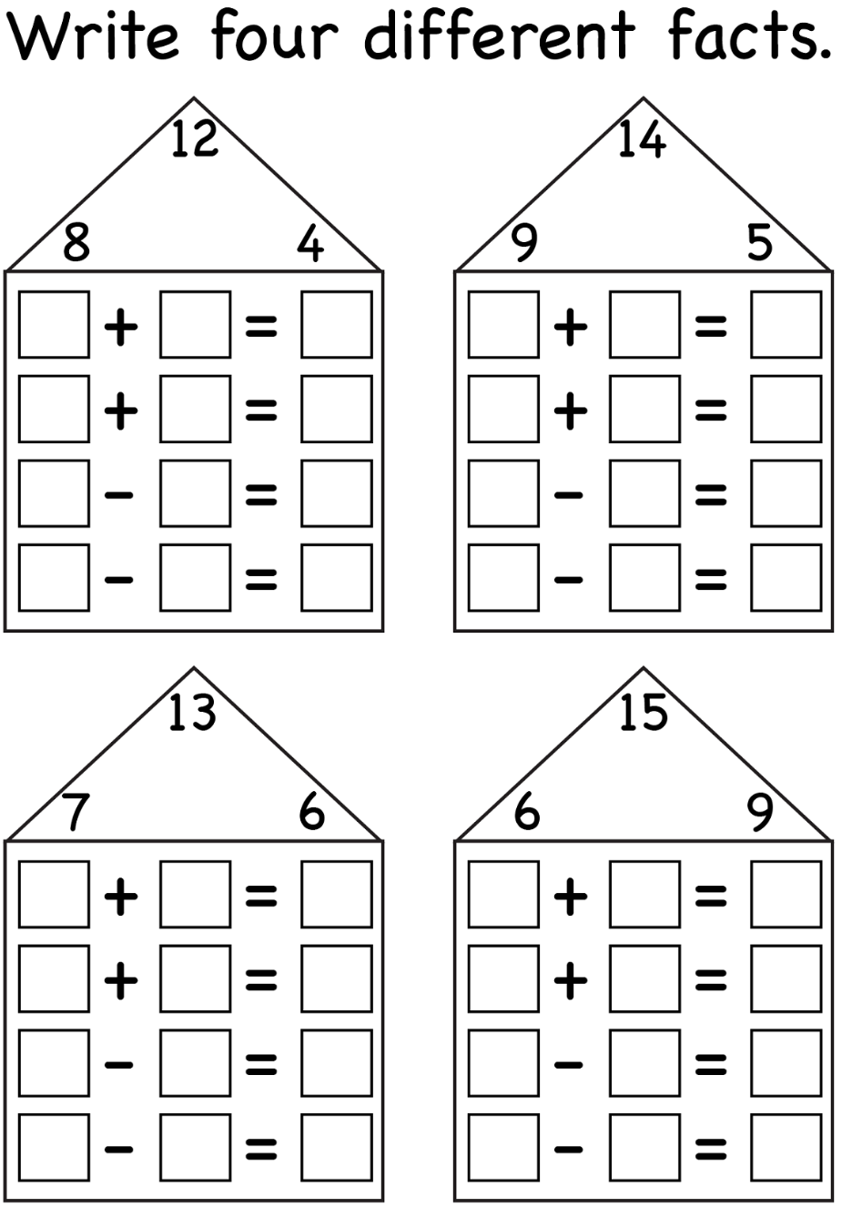

The following game is extremely useful for problem solving as well as ‘trial and error’ to work out the fact family

https://www.topmarks.co.uk/number-facts/number-fact-families

Finding 10 More or 10 Less
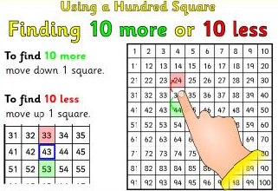
Practice counting up in 10s from 0 and backwards from 100 to 0.

Try counting in 10s from a variety of different places e.g 2, 12, 22, 32, 42.
Talk about the pattern that you see.
Identify 10 less than 20 and 10 more than 20. What do you notice?

Watch the Youtube videos below to help aid your understanding of this.
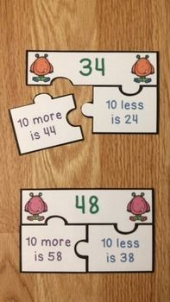
https://www.youtube.com/watch?v=9NRdxc0XjOg

Use the 100 square to find 1 more/1 less and
10 more/10 less than a given number.
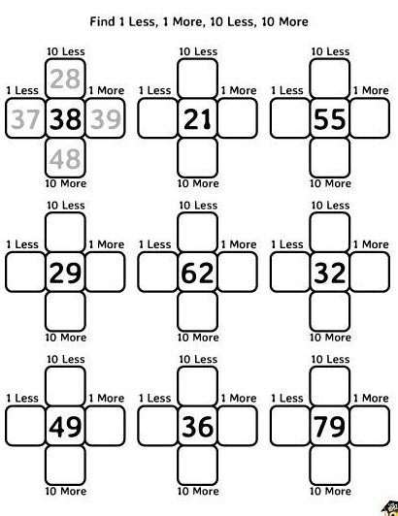

https://www.topmarks.co.uk/learning-to-count/chopper-squad - A listening game to test your knowledge of 10 more/10 less than.

COUNTING TENS AND ONES

Make a number by counting in 10s and 1s orally.
A ‘high 10’ counts as 10 and a finger tap counts as 1.
For example making the number 66 you would have 6 high 10s- 10, 20, 30, 40, 50, 60 followed by 6 finger taps- 61, 62, 63, 64, 65, 66. Try a variety of numbers to encourage physical counting.

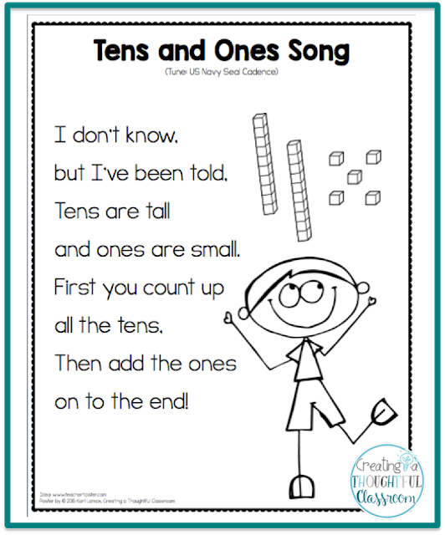
Watch the following video: https://www.youtube.com/watch?v=1F3AycEDksY
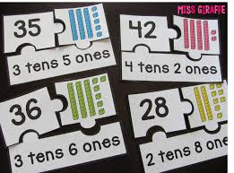
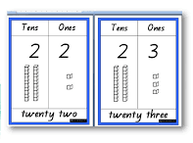

Create your own number using objects at home to represent ‘tens’ and ‘ones’. For example, breadsticks could be tens and cheerios could represent ones. Make the numbers 22, 34, 55, 67, 44.

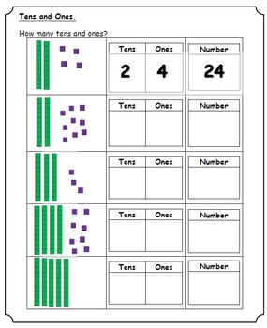
https://www.topmarks.co.uk/learning-to-count/place-value-basketball
Count the tens and ones to identify the number.

Take your time when counting the tens and ones to ensure you arrive at the correct answer each time.
Practice chanting the tens and ones song to help you!

DOUBLING AND HALVING

ALWAYS REMEMBER THAT WHEN YOU ARE DOUBLING NUMBERS THE ANSWER IS ALWAYS EVEN!

Record double number sums as quickly as you can

SONGS: https://www.youtube.com/watch?v=e-KTHfrFit0
https://www.youtube.com/watch?v=4U2QLjqripY

ALL ABOUT HALVING

Listen to the story ‘Give Me Half’ by Stuart J. Murphy on Youtube
Watch: https://www.bbc.co.uk/programmes/p017kztf

Think of lots of ‘real life’ halving situations e.g. a football team and think of times when you have had to split something in half in order to share it with someone else.
Halve a selection of food- For example split an apple in 2 and share it with a family member.

Applying halving to number: Build a tower of 3 cubes and split it in half into 2 equal parts? Can it be done? Now try building a tower of 10 and splitting it into 2 equal parts? Can you split 10 equally?
Spot the link between doubling numbers and halving numbers.
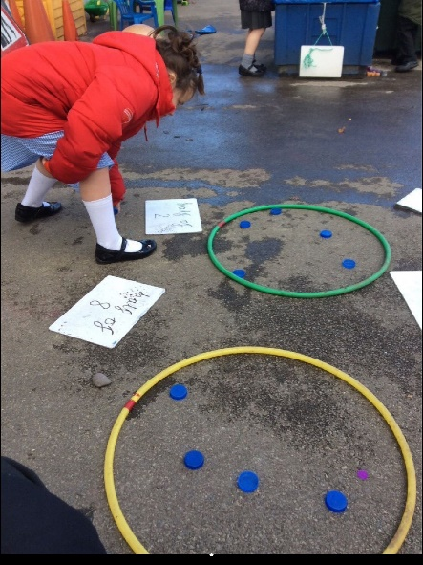
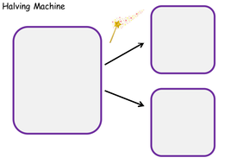
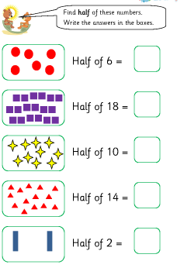
A game for quick recall of doubles and halves: https://www.topmarks.co.uk/maths-games/hit-the-button

MONEY

Continue work on counting a selection of coins, ordering coins by value as well as sorting coins or use coins to create 2 step, 3 or 4 step patterns.

Record different ways of making 25p, 32p, 16p, 20p, 10p, 70p etc.
For example, 10p + 5p + 2p + 1p = 18p and 10p + 2p + 2p + 2p + 2p= 18p
Put a price on several items from your house and role play paying for an item as well as giving the correct change too. Try within 20p, 50p and £1.
Have a go at the game shown below
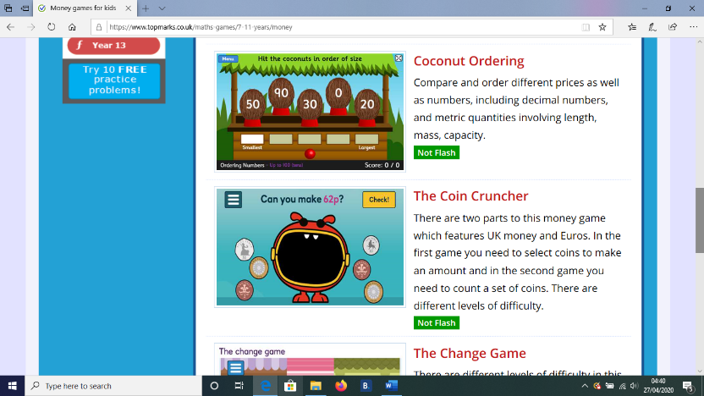
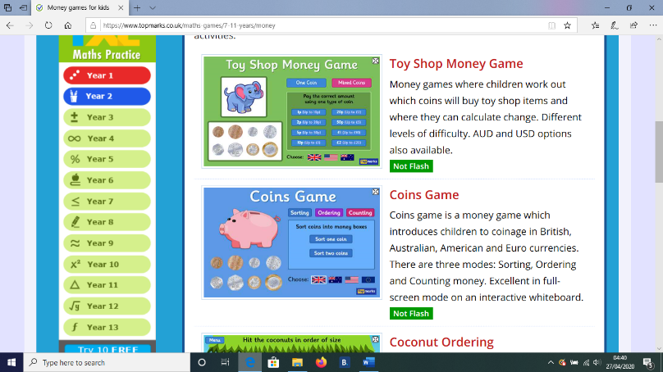

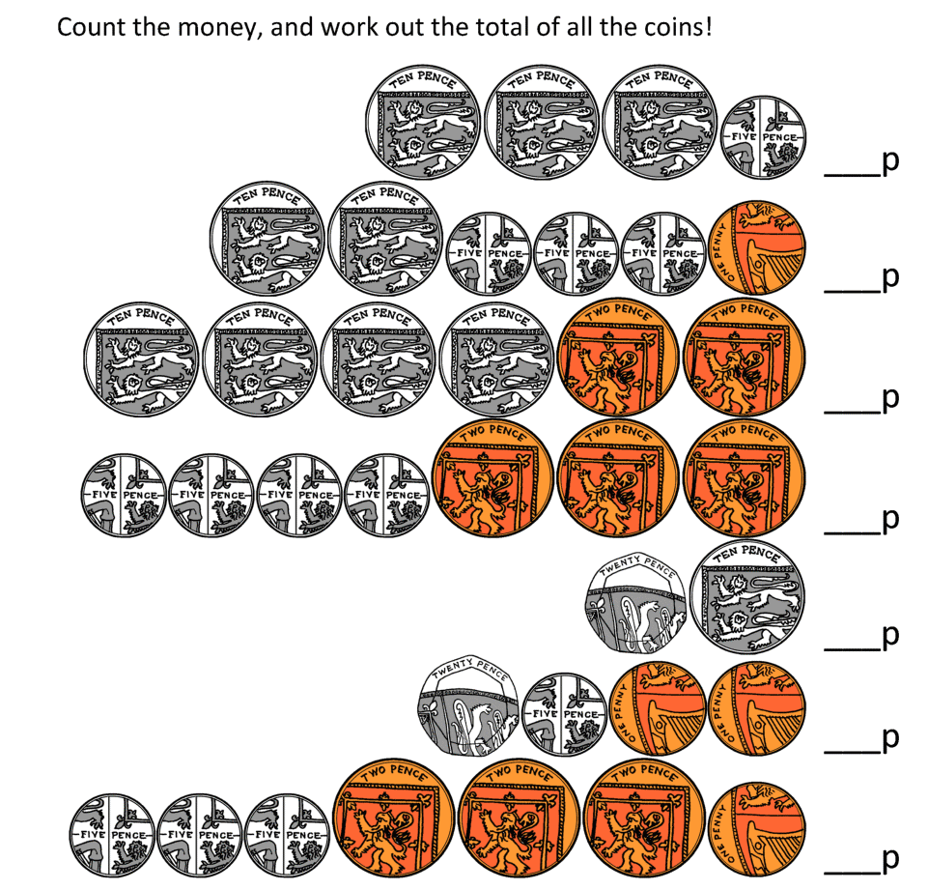

Always remember to start with the coin that has the highest value.

TIME

How many Seasons in a year? How many months in the year?
How many days in a week? How many days in a year?
Practice writing these in the correct order.
Make flashcards to order them.
https://www.roythezebra.com/reading-games/high-frequency-words-days.html
Talk about the morning, afternoon, evening and nighttime and discuss things you would do together as a family at these times.
Make your own clock
Identify o’ clock times and half past times on an analogue clock within your house. Continue to practice telling the time.
https://www.topmarks.co.uk/Flash.aspx?f=matchingpairstimev3
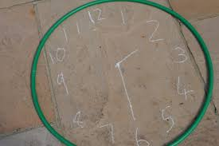
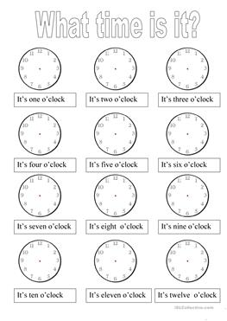

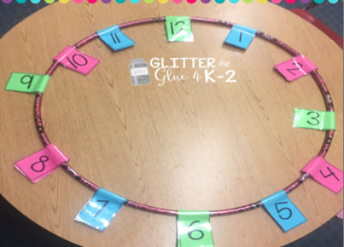

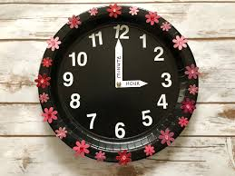

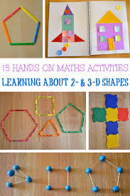
2D/3D SHAPE
Name 2D and 3D shapes.
Talk about their properties.
Find 2D and 3D shapes around your house.
Use a variety of shapes to build structures.
Sort 2D and 3D shapes.
https://www.ictgames.com/mobilePage/shiftingShapes/index.html
https://www.starfall.com/h/geometry/enviro-shapes/?t=292890663
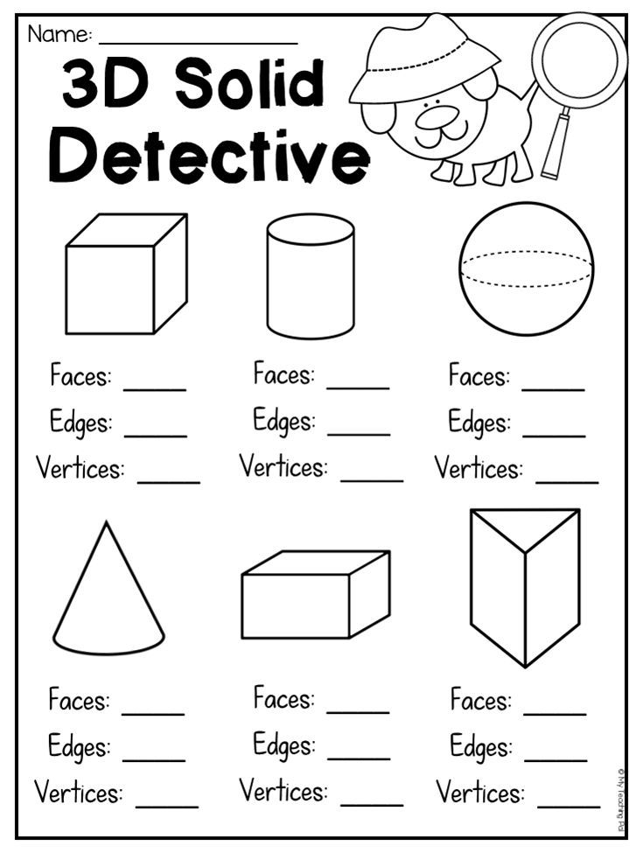
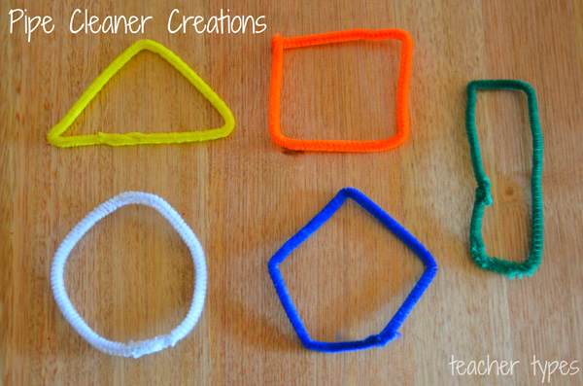

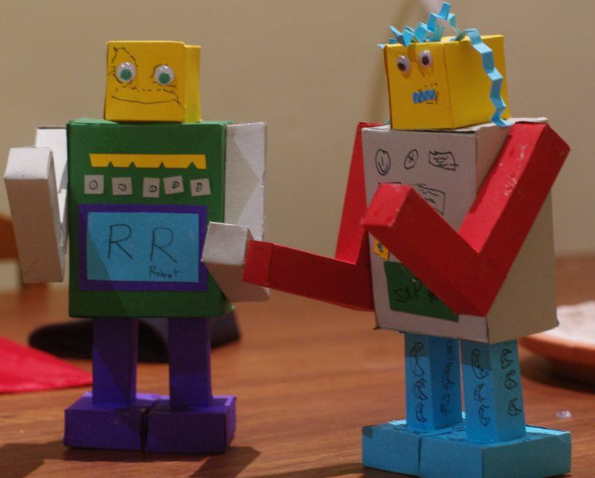

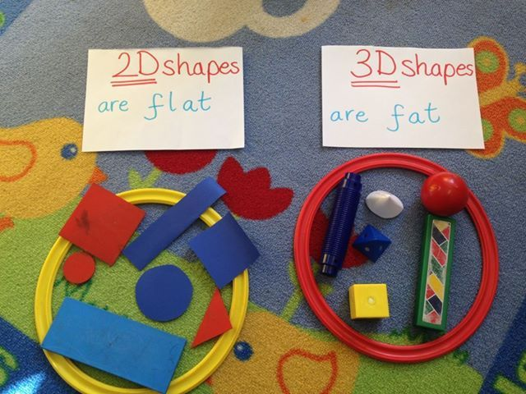

DATA HANDLING

Think of 3 Jungle animals and record them in a table. Find out the most favourite Jungle animal in your family. You can find collect data from extended family too in order to produce a tally chart.

Using the information produce a block chart to show your data.
Share this information with a friend.
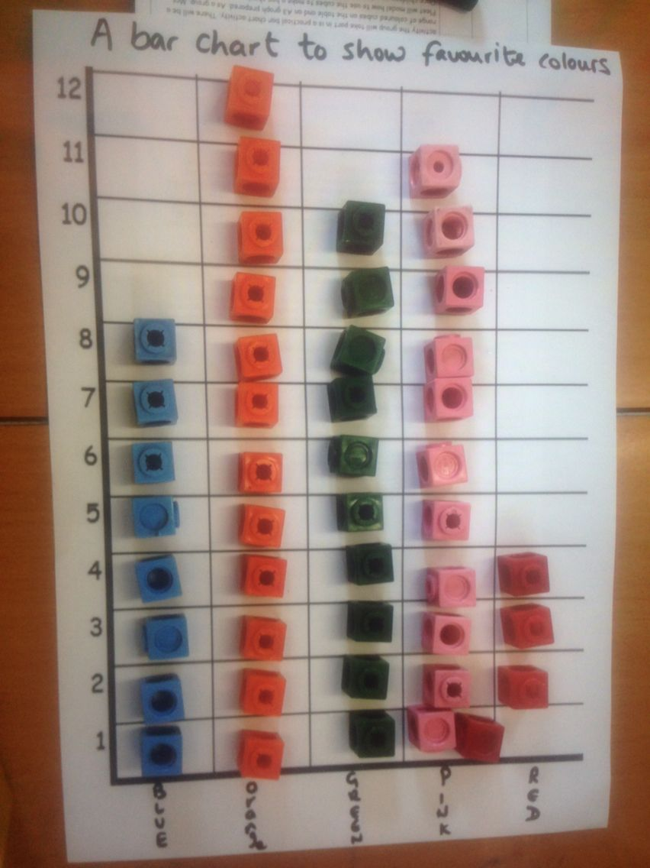
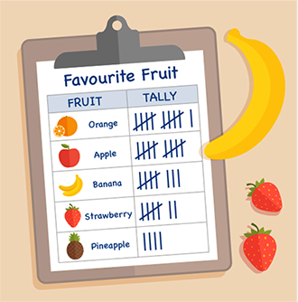

You can produce a block chart for eye colour, favourite hobby in your house or whatever you decide.

Suggested games below:

http://toytheater.com/fishing/

https://www.softschools.com/math/data_analysis/pictograph/games/

http://toytheater.com/fruit-fall/

MEASURES: LENGTH
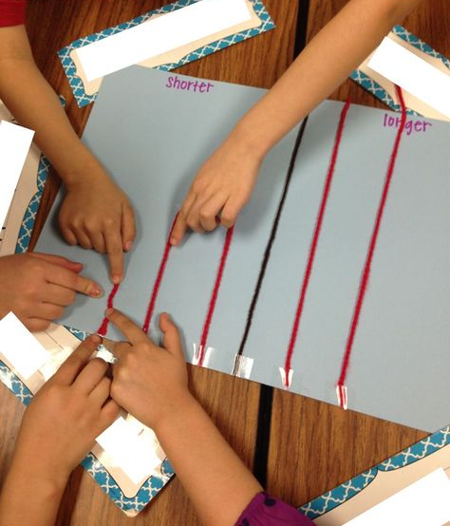
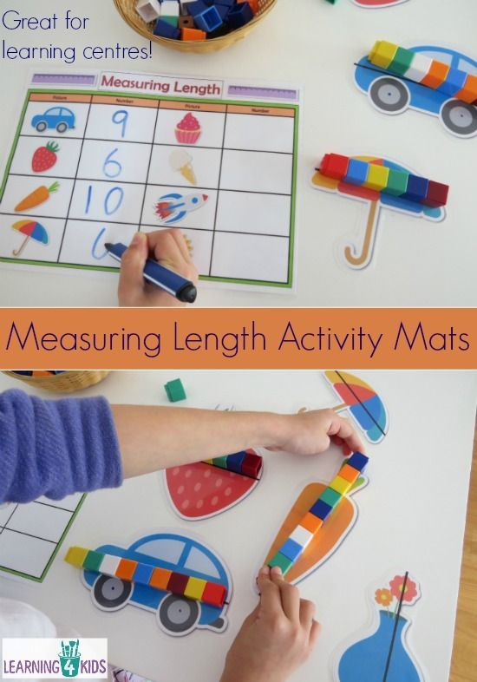
Compare lengths of different objects around your house.

Can you find 10 things shorter than your shoe?

Use pasta, cheerios or buttons to measure items. How many buttons long is a tub of butter?
Order leaves smallest to tallest.

Complete the challenge cards below.

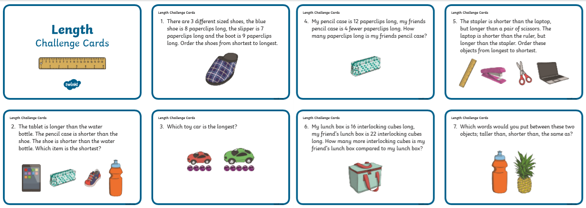

https://www.topmarks.co.uk/early-years/lets-compare

WEIGHT
Compare weights of different objects around the house.
What is the lightest object you can find? What is the heaviest?
https://pbskids.org/peg/games/happy-camel
https://www.kidsmathgamesonline.com/logic/scalesweight.html
Complete the challenge cards below.

CAPACITY
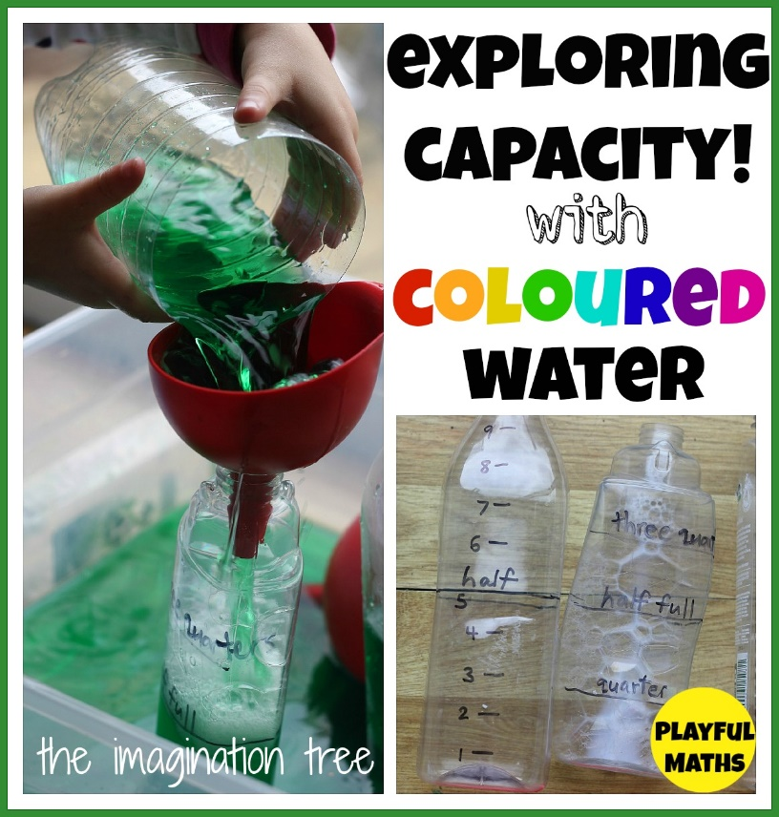
Use water, sand, pom poms, cotton wool balls, to fill a small bucket or cup to full capacity.
Empty the container.
Pour liquid into bottles (same size)
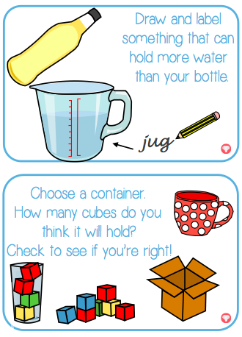
Order various containers from empty to full.

