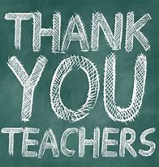
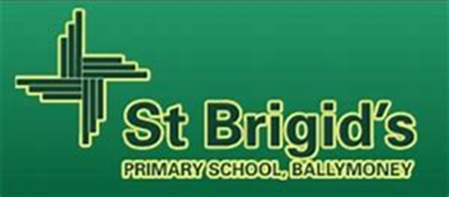
St. Brigid’s thank you for my memories………..
My best memory is the time we won the hockey tournament in Coleraine and we ran on the pitch cheering!
My second best memory is my last school play I played a fireman and my line was “Did anyone call a fireman, a good looking fireman” everyone laughed.
Another memory is the first time Don gave me my first letter to go and represent our school playing football. All the mad hair days, and bring a bike to school weeks.
My best school trip was in P6 when we went to Carrowmena and I did the leap of faith. I was the first person to complete it in our class and I felt proud of myself.
Finally I am grateful for the friends I made the fun times we have had and I am grateful for all the nice teachers that have gave me extra attention and extra fun sports actives and trips.
