Term 3 Topic ‘Are You Wise? Week beg 11th May Healthwise
TASK 1: Create a food diary for this week using the template below. Include all food and drinks consumed.
 | Monday | Tuesday | Wednesday | Thursday | Friday
Breakfast

Snacks

Lunch

Snacks

Dinner

Snacks

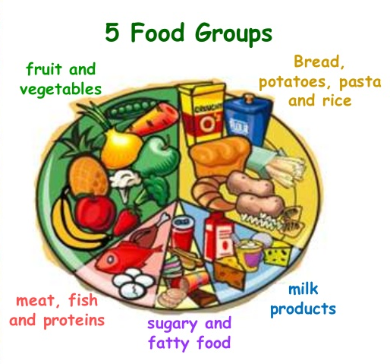
TASK 2: Now, choose one day and using all the food and drinks you have consumed in that day, sort them into each of the 5 food groups, include number of portions. The diagrams will help you.

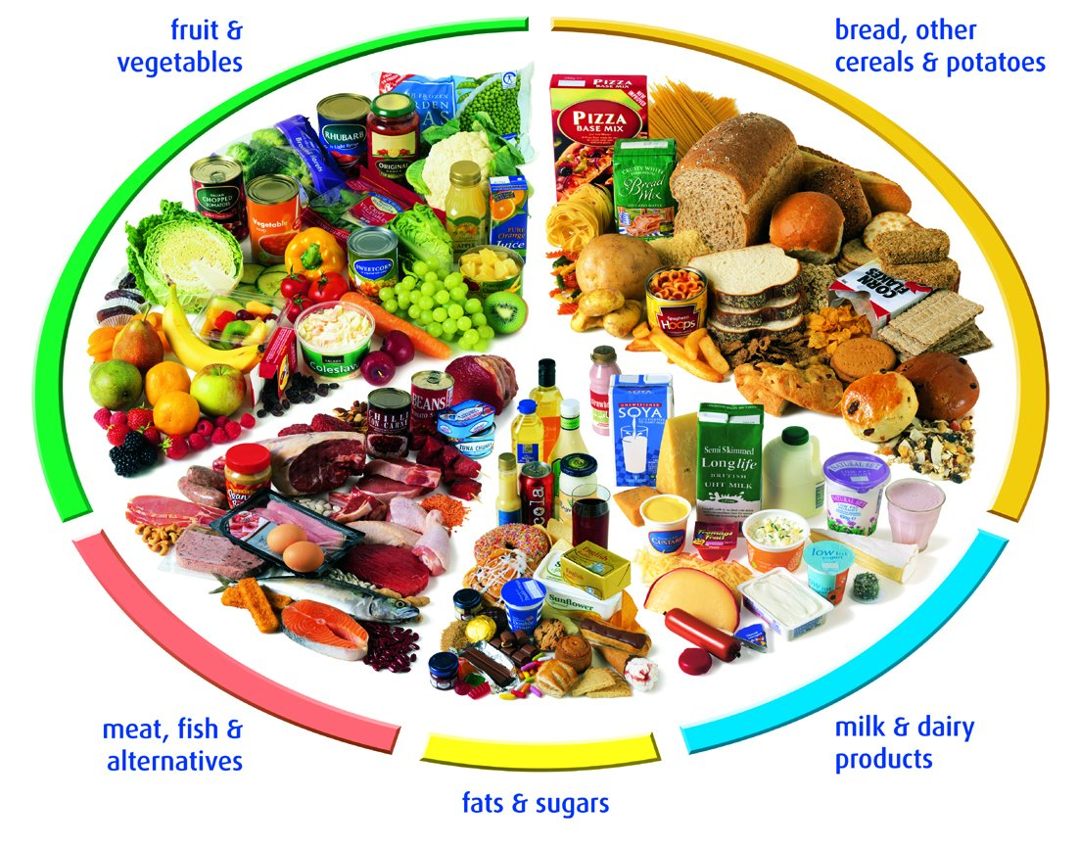

Day:

Starchy foods-bread, rice, cereals, potatoes, pasta | Proteins-meats, fish and alternatives | Fruit and vegetables | Dairy-milk, cheese, yogurt | Sugars and fats
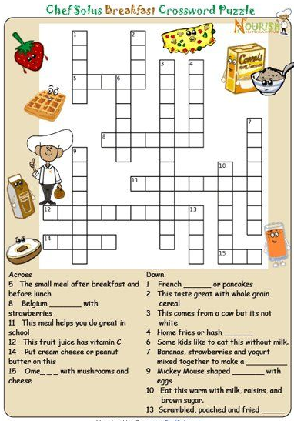
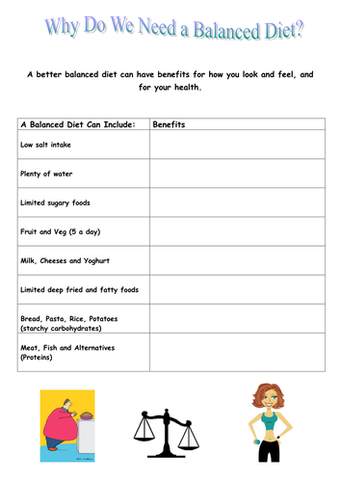
TASK 3: Complete the sheet below TASK 4: Complete the crossword puzzle

