**St Brigid’s PS**

**Castle Street**

**Ballymoney**

**BT53 6JXso**

**Principal: Mr Kieran O’Neill**

[**koneill580@c2kni.net**](mailto:koneill580@c2kni.net)

**Tel: 028 2766 2664**

**Wednesday, 26 January 2022**

Covid-19 Update

Dear parents/guardians,

Thank you for all your support throughout the school year so far. With the onset of the new Omicron variant of the Covid-19 virus there has been an overall increase in the number of people testing positive for the virus.

In school we have kept many measures in place to mitigate against the risk of the virus spreading. However, with all our best efforts, it is still impossible to eradicate risk completely and there have been cases reported across the school.

As yet, we have not needed to move to remote learning but with access to staff cover always an issue, this may still need to be used as an option moving forward. Whilst we will always endeavour to give good notice, remote learning may have to be introduced at short notice. We want schools to remain open and operate as close to normal as possible.  Everyone can play their part.

**Procedures to follow:**

* If you, your child or anyone in your household is feeling unwell with any of the known covid symptoms or just generally too unwell to be in school, please be cautious and stay at home.
* Please use the Lateral Flow Test to check for Covid-19.
* If the test is positive, please isolate for 10 days. **This is Day 0.**
* From day 5 onwards, 2 negative Lateral Flow results in a row, 24 hours apart, will allow for an early release from isolation.

Please scan the QR code below for information on **using lateral flow testing and potentially ending self-isolation early or view the flowchart on the school website.**

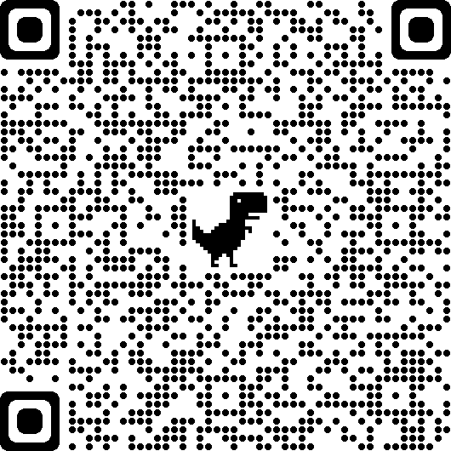

**Pupils Testing Positive or Having to Self-Isolate**

* When a child tests positive please forward the positive result to:

[info@stbrigidsps.ballymoney.ni.sch.uk](mailto:info@stbrigidsps.ballymoney.ni.sch.uk) or by contacting the school on 028 27662664.

**Close contacts in the household:**

* All other close contacts in the house must isolate immediately and need to be monitored daily using Lateral Flow Tests.
* If the lateral flow is negative, other children can return to school provided they are well enough.
* If you are unsure you can check other children daily before school using a Lateral Flow test.
* Lateral Flow tests should be taken each morning before school and as long as it remains negative other children in the house can continue to attend school.

**How to keep the school safe:**

* Please continue to wear a face covering whilst gathering on the school playground.
* Keep your distance from others.
* Use the hand sanitiser provided.

The procedures and measures above help to contribute to a safe environment for everyone. Thank you for all your efforts in supporting the school.

Regards

Mr O’Neill

Principal