

**School Information for Parents/Guardians**

**Monday 15 May 2023**

Follow us now on **the web** for news updates

**www.stbrigidspsballymoney.com**

**Leavers’ Mass 2023**

The Year 7 Leavers’ Mass will be on Monday 26 June at 1.00 pm in Our Lady and St Patrick’s Chapel and the children and parents will return to school after mass for refreshments and a Leavers’ presentation. The school will close at 12.30 pm on this day for all other classes to allow staff to attend the Leavers’ Mass. This will be the last day of school for the Year 7 pupils.

**Monday 15 May**

**Sports Day Provisional Dates**

**Option 1**

Wednesday 14 June

**Option 2**

Thursday 15 June

**Option 3**

Monday 19 June

**Option 2 & 3 if weather affected.**

**More details to follow about Sports Day later this month.**

* New Dinner Menu - **Menu Cycle Week 3**
* **Year 7, School and ECO Council Trip to Stormont**
* **Year 1 Visit from PSNI**
* **Year 4 Mass and Confession in preparation for**

**Holy Communion**

**Tuesday 16 May**

* Guitar and Singing tutor in
* **Swimming Class B (1.00-1.30pm) and Year 7 (1.30-2.00 pm)**

**£3.50 per week**

**Wednesday 17 May**

* Violin tutor in
* Holy Communion Practice
* **Year 4 Council Sports:**

(5 weeks - £1.50 per week or £7.50 for 5 weeks)

**Thursday 18 May**

* **School Closed – Local Election Polling Station**

**Friday 19 May**

* **Principal Awards**
* **Piano tutor in**
* **GAA Fridays**
* **Hurling Blitz in Ballycastle – All day**

**NUT FREE SCHOOL**

**St Brigid’s PS is a Nut Free School. There is a child in our school with a Nut Allergy.**

**Please do not send in Nuts or Nut Spreads to school.**

**Saturday 20 May**

* **Holy Communion Year 4 – 10.30 am in Our Lady and St Patrick’s Chapel**

**Up and coming dates for your diary**

* **Term 3 Holidays/School Closures:**

**Thursday 18 May: Local Council Elections – School Closed Polling Station**

**Monday 29 & Tuesday 30 May: May Bank Holiday**

**Summer Break: School Closes 12noon Friday 30 June**

Have a very enjoyable weekend and thanks for your continued support.

Mr K O’Neill Principal

**St Brigid’s Primary School – Castle Street – Ballymoney – BT53 6JX – 028 27662664**

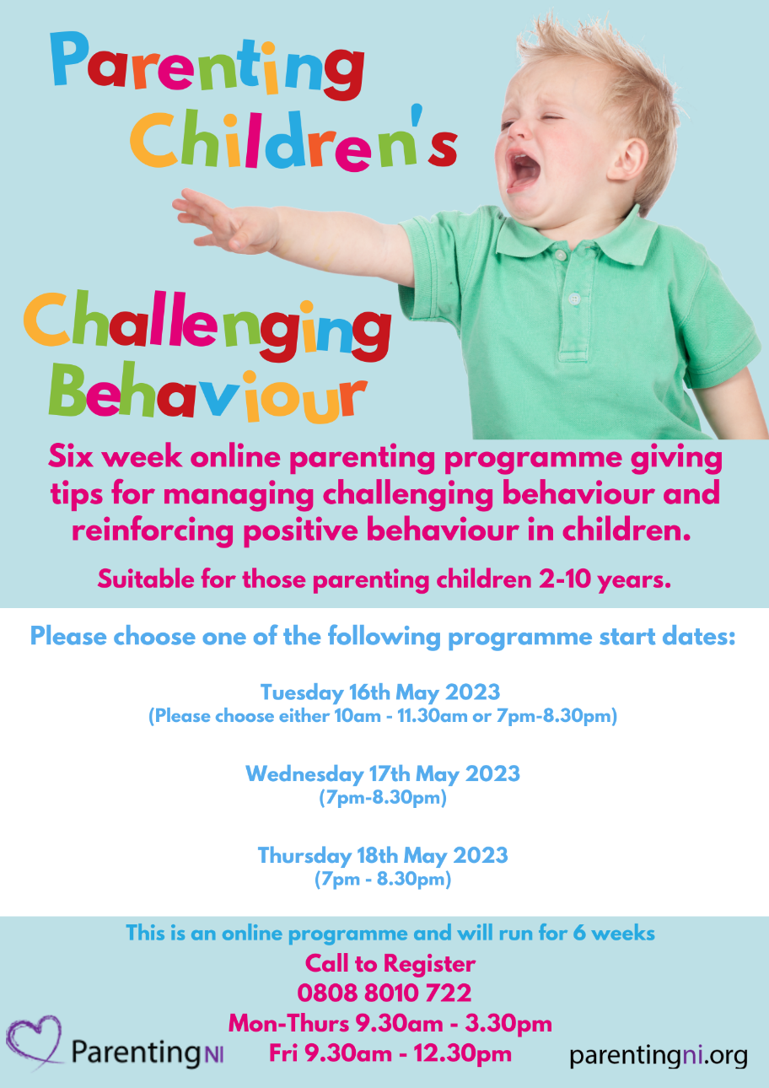

**2023-2024 – Holiday List – Pupils**

**First Term: Thursday 31 August 2023 – Thursday 21st December 2023 [inclusive]**

First Day - Thursday 31st August – School Closes 12 noon

Staff Development Day: TBC

Halloween - Monday 30th October – Friday 3rd November **[inclusive]**

Christmas - Friday 22nd December – Friday 5th January **[inclusive]**

**Second Term: Monday 8th January – Thursday 28th March 2024 [inclusive]**

Mid-Term Break - Monday 12th – Friday 16th February **[inclusive]**

St Patrick’s Day Holiday -Monday 18th March **[inclusive]**

Easter Break - Friday 29th March – Friday 5th April **[inclusive]**

**Third Term: Monday 8th April – Friday 28th June 2024 [inclusive]**

May Bank Holiday - Monday 6th May

June Holiday - Monday 27th May – Tuesday 28th May **[inclusive]**

**School Trips 2023**

**Year 7 Leavers’ Trip**

Thursday 8 June

Lisburn Leisureplex

Cost per child £15.00

**Yr 5 & 6**

**Airtastic Belfast**

Thursday 8 June

Cost per child £15.00

**Year 3 & 4**

**W5 Belfast**

Wednesday 21 June

Cost per child £15.00

**Year 1 & 2 & CA**

**Sperrin Fun Farm**

Friday 23 June

Cost per child £12.50

We have kept the trip cost at no more than £15.00 per child. The transport cost and entrance fees have risen considerably. The PTA will help with a contribution to help subsidise the cost of the trips.

**Confirmation**

**Congratulations to all the children in Year 7 who recently celebrated the Sacraments of Confirmation.**

**The service was a beautiful occasion and it was wonderful to see a full chapel of parents, family and friends there to celebrate with the children.**