

**School Information for Parents/Guardians**

**Monday 16 May 2022**

Follow us now on **the web** for news updates

**www.stbrigidspsballymoney.com**

**Leavers’ Mass 2022**

**The Year 7 Leavers’ Mass will be on Friday 24 June at 10.30 am in Our Lady and St Patrick’s Chapel**

**Monday 16 May**

* Breakfast Club open every day 8.00 – 8.45 am (£2)
* After School Club open every day 2.00 - 5.30pm
* Dinner menu Week 3

**Tuesday 17 May**

* Swimming Year 7 and CB
* Singing tutor in

**Wednesday 18 May**

* Violin tutor in
* Council Sport Hockey Yr 4 (£7.50 for 5 weeks)

**Thursday 19 May**

* Guitar tutor in
* Netball Blitz in Coleraine Leisure Centre

**Friday 20 May**

* Piano tutor in
* Outdoor Hurling Blitz in Cushendall
* Principal Awards

**Up and coming information & dates for your Diary**

* June Bank Holiday: School Closed **Thursday 2 & Friday 3 June**
* Staff Dev. Day: School Closed **Monday 6 June**
* Summer Holidays: School Closes **12 noon Thursday 30 June**

(No Dinner or After School Club on this day)

* **Holy Communion** Saturday 28 May (Year 4) 10.30 am
* **Confirmation** Wednesday 8 June (Year 7) 10.30 am

Have a very enjoyable weekend and thanks for your continued support.

Mr K O’Neill Principal

**St Brigid’s Primary School – Castle Street – Ballymoney – BT53 6JX – 028 27662664**

**Fun Sports 2022**

**Yr1-3 & CA Sports Week will be Tuesday 7 – Friday 10 June**

**Yr4-7 and CB Sports Week will be Monday 13 to Friday 17 June**

**More information to follow with regards to dates for class events.**

**Parents will be invited and we will be in touch with regards to dates and times for specific classes early next week.**

**We will still be operating with smaller bubbles and not multi-class groups.**

**NUT AWARE SCHOOL**

St Brigid’s PS is a Nut Aware School. There is a child in our school with a Nut Allergy.

Please do not send in Nuts or Nut Spreads to school.

**COVID-19 - Reporting Positive Cases**

If there are any COVID-19 positive tests for any of the children, please let the school know via email @ [info@stbrigidsps.ballymoney.ni.sch.uk](mailto:info@stbrigidsps.ballymoney.ni.sch.uk)

or by phoning the school after 8.30 am

028 27662664

**Primary School Age Children**

**and**

**Social Media**

In this highly digital world many questions and worries come from parents with regards to children and either the use of social media or their desire to use platforms like e.g. Tik Tok.

The image below sets out the legal age (13+) to access certain apps that are popular amongst children.

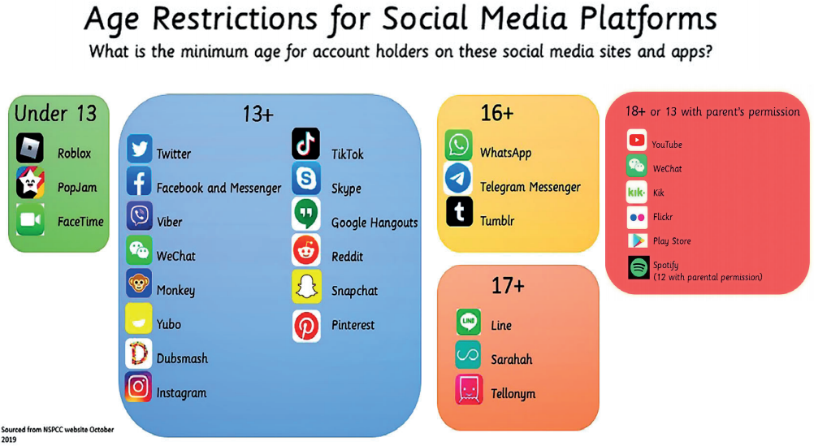

**Please view the school website for a poster giving parents information about the app Tik Tok.**

**Sacrament Classes Dates**

**Holy Communion**

Saturday 28 May (Year 4) 10.30 am

**Confirmation**

Wednesday 8 June (Year 7) 10.30 am

