

**School Information for Parents/Guardians**

**Monday 18 September 2023**

Follow us now on **the web** for news updates

**www.stbrigidspsballymoney.com**

**Sacrament Dates 2023-24**

**Sacrament of Penance:** (Year 3) Thursday 21 March 2024

11.00 am in Our Lady and St Patrick’s

**Sacrament of Confirmation:** (Year 7) Friday 26 April 2024

10.30 am in Our Lady and St Patrick’s

**Sacrament of Communion:** (Year 4) TBC

**Monday 18 September**

* Breakfast Club open every day 8.00 – 9.00 am
* After School Club open every day 2.00 - 5.30pm
* **School Photographer in**
* Dinner menu Week 4
* Violin Tutor in
* Year 7 Library Visit (Weather permitting. Ensure your child brings a coat)

**Tuesday 19 September**

* Swimming Class B (1.00-1.30pm) and Year 5 (1.30-2.00 pm) £3.50 per week
* **School Photographer in**

**Wednesday 20 September**

* Year 7 Hockey: (5 weeks - £2.00 per week or £10.00 for 5 weeks)

**Thursday 21 September**

* Singing Tutor in

**Friday 22 September**

* Principal Awards
* Piano Tutor in

**Up and coming information & dates for your Diary**

**After School Childcare – Spaces available!!!**

* Sunshine Club: 2.00 – 3.00 pm (£2) 3.00 – 5.30 pm (£2 per hour or part thereof)

Breakfast Club: 8.00 – 9.00 am (£2 per day)

* **Mid Term Break October/November 2023:**

Monday 30 October to Friday 3 November (inclusive)

**Christmas Break 2023:**

12 noon Thursday 21 December – Friday 5 January (inclusive)

Have a very enjoyable weekend and thanks for your continued support.

Mr K O’Neill Principal

**St Brigid’s Primary School – Castle Street – Ballymoney – BT53 6JX – 028 27662664**



**Child Protection and Safeguarding**

**Reminder for all parents**

If collecting your child outside of the normal school finishing times, please come to the main front door. Someone will organise for your child to be informed and brought to the foyer.

To safeguard all the children, parents are not permitted to move around the school unsupervised.

Parents should not go their child’s class without permission and a member of staff must be present.

**Online forms to be submitted**

The following forms are available by using the links below. **Please complete and submit the forms before Friday 8 September.** The electronic forms do not take long to complete, and they mitigate against paper copies going back and forward between school and home. A text message was sent with quick access to the forms.

**ICT CODE OF PRACTICE AGREEMENT FOR PUPILS AND PARENTS**

<https://forms.office.com/r/cZCCD83QsC>

**CONSENT FORM FOR PHOTOGRAPHS, FOOTAGE AND EDUCATIONAL TRIPS/VISITS OUT OF SCHOOL**

<https://forms.office.com/r/RvV1isxq5V>

**Speed in the Chapel Car Park**

Please be mindful of your speed in the chapel car park when dropping off and picking up the children. The car park is busy with children moving to and from cars. All drivers must be careful. Speed limit is 10 miles per hour.

**NUT FREE SCHOOL**

**St Brigid’s PS is a Nut Free School. There is a child in our school with a Nut Allergy.**

**Please do not send in Nuts or Nut Spreads to school.**

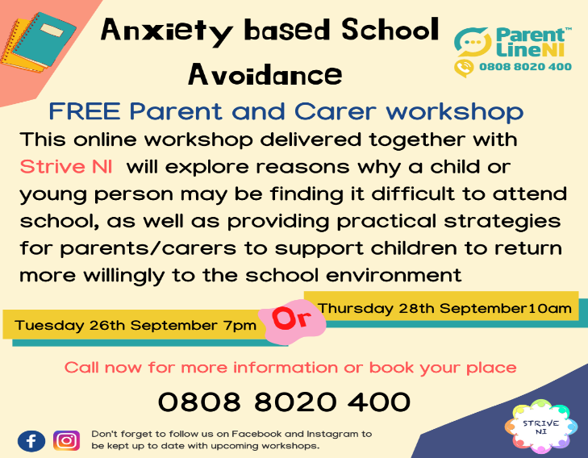

**Beginning of school year mass.**

[](http://www.google.co.uk/url?sa=i&rct=j&q=&esrc=s&source=images&cd=&cad=rja&uact=8&ved=2ahUKEwj8i9mCwajdAhVRQ8AKHU6DBtUQjRx6BAgBEAU&url=http://presentationcastleisland.ie/event/beginning-year-school-mass/&psig=AOvVaw1jsqgWj6ltYumi1EkxKehs&ust=1536396456824846)

**Monday 25th September 2023**

**10am in Our Lady and St Patrick’s**

All family members welcome to join with us to celebrate together.

**Pupil Absence**

If your child is absent from school please contact the school office on the first day of absence, give the reason for absence and possible duration.