

**School Information for Parents/Guardians**

**Monday 19 April 2021**

Follow us now on **the web** for news updates

**www.stbrigidspsballymoney.com**

**School Dinners**

The new dinner menu is on the school website.

**Breakfast, 2-3 and Sunshine Club**

**Reopen Monday 19 April**

Breakfast and Afterschool booking forms on the school website.

**Monday 19 April**

* Breakfast Club 8.00-8.45 am (£2 per child per day)
* **Dinner menu Week 2**
* 2-3 Club open (£2 per child per day)
* Sunshine Club 3.00 – 5.30 pm open (£2 per child per hour or part thereof)

**Tuesday 20 April**

**Wednesday 21 April**

* **Year 3, 4 and 7 Sacrament information letters out**

**Thursday 22 April**

**Friday 23 April**

* Principal Awards

**Up and coming information & dates for your Diary**

* **Reminder: St Brigid’s PS is a Nut Free School. Please do not send in Nuts or Nut Spreads to school.**
* **Term 3 Holidays:**

**May Day Weekend** Friday 30 and Monday 3 May

**May Holiday:**  Friday 28 May, Monday 31 May and Tuesday 1 June

**Summer:** School Closes 12noon Wednesday 30 June

Have a very enjoyable weekend and thanks for your continued support. Mr K O’Neill Principal

**St Brigid’s Primary School – Castle Street – Ballymoney – BT53 6JX – 028 27662664**

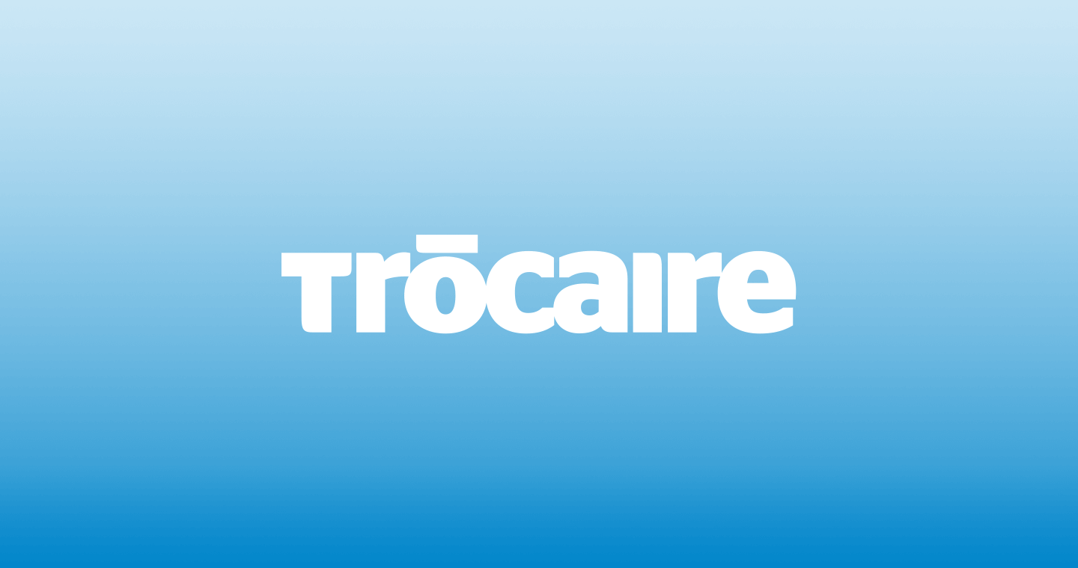

Trocaire Collection 2021

A massive thank you to everyone who made a donation this year through the '5 Day Fitness Challenge' for Trocaire.

An amazing £2576.53 was raised. In such difficult times this will go a long way to supporting many people in need of our help.

Thank you

**Pupil Absence**

If your child is absent from school please contact the school office on the first day of absence, give the reason for absence and possible duration.

Thank you

**Reminder**

There is a child in the school with an immune deficiency disease.

Please remember to contact school if your child or children are unwell. Even if they are in school.

**COVID-19**

**Face Covering on the school premises.**

Unless exempt, please could all adults entering the school playground/premises wear a face covering.

**Sacraments 2021**

Penance:  Year 3 Wednesday 5 May 10.30 am

Holy Communion: Year 4 Saturday 22 May 10.30 am

Confirmation: Year 7 Wednesday 9 June 5.00 pm

More information with regards to each Sacrament will be issued next week.

**Zomba Action Project**

Thanks to the donations of uniforms that the children had outgrown last year from St Brigid's PS, they have now made it all the way to Africa and they have been put to good use.

Really appreciated in these worrying Covid times.

You can view the photo and read more about the project on the Zomba Action Project Facebook Page

