

**School Information for Parents/Guardians**

**Monday 23 May 2022**

Follow us now on **the web** for news updates

**www.stbrigidspsballymoney.com**

**Leavers’ Mass 2022**

**The Year 7 Leavers’ Mass will be on Friday 24 June at 10.30 am in Our Lady and St Patrick’s Chapel**

**Monday 23 May**

* Breakfast Club open every day 8.00 – 8.45 am (£2)
* After School Club open every day 2.00 - 5.30pm
* Dinner menu Week 4

**Tuesday 24 May**

* Swimming Year 7 and CB
* Singing tutor in

**Wednesday 25 May**

* Violin tutor in
* Council Sport Hockey Yr 4 (£7.50 for 5 weeks)

**Thursday 26 May**

* Guitar tutor in

**Friday 27 May**

* Piano tutor in
* Principal Awards

**Saturday 28 May**

* **Holy Communion** Our Lady and St Patrick’s Chapel (Year 4) 10.30 am

**Up and coming information & dates for your Diary**

* June Bank Holiday: School Closed **Thursday 2 & Friday 3 June**
* Staff Dev. Day: School Closed **Monday 6 June**
* Summer Holidays: School Closes **12 noon Thursday 30 June**

(No Dinner or After School Club on this day)

* **Confirmation** Wednesday 8 June (Year 7) 10.30 am

Have a very enjoyable weekend and thanks for your continued support.

Mr K O’Neill Principal

**St Brigid’s Primary School – Castle Street – Ballymoney – BT53 6JX – 028 27662664**

**Fun Sports 2022**

**Yr1-3 & CA Sports Week will be Tuesday 7 – Friday 10 June**

**Yr4-7 and CB Sports Week will be Monday 13 to Friday 17 June**

**More information below with regards to dates for class events.**

**We will still be operating with smaller bubbles and not multi-class groups.**

**NUT AWARE SCHOOL**

St Brigid’s PS is a Nut Aware School. There is a child in our school with a Nut Allergy.

Please do not send in Nuts or Nut Spreads to school.

**COVID-19 - Reporting Positive Cases**

If there are any COVID-19 positive tests for any of the children, please let the school know via email @ [info@stbrigidsps.ballymoney.ni.sch.uk](mailto:info@stbrigidsps.ballymoney.ni.sch.uk)

or by phoning the school after 8.30 am

028 27662664

**Fun Sports Day 2022**

Please see the dates and times below so that you can come along and watch the children participate in their fun sports. The fun sports events will all take place on the green and access will be via the Foundation Stage playground or through the main front door. Please bear in mind that parking in the front of the school will be limited and most parking will be available in the chapel car park.

|  |  |  |
| --- | --- | --- |
| **Date** | **Time** | **Class** |
| **Tuesday 7 June** | **9.30 – 10.30 am** | **Year 1, 2 & CA** |
| **Thursday 9 June** | **10.45-11.30 am** | **Year 3** |
| **Monday 13 June** | **9.30 – 10.30 am** | **Year 7 & CB Year 7** |
| **Tuesday 14 June** | **10.45 – 11.30 am** | **Year 4** |
| **Wednesday 15 June** | **9.30 – 10.30 am** | **Year 6 & CB Year 6** |
| **Thursday 16 June** | **9.30 – 10.30 am** | **Year 5 & CB Year 5** |

**Primary School Age Children**

**and**

**Social Media**

In this highly digital world many questions and worries come from parents with regards to children and either the use of social media or their desire to use platforms like e.g. Tik Tok.

The image below sets out the legal age (13+) to access certain apps that are popular amongst children.

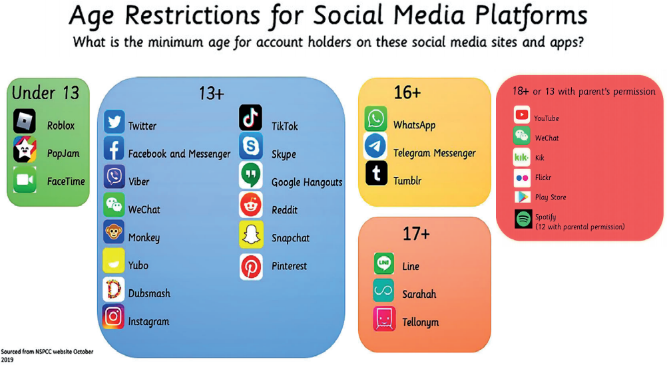

**Please view the school website for a poster giving parents information about the app Tik Tok.**

**Sacrament Classes Dates**

**Confirmation**

Wednesday 8 June (Year 7) 10.30 am