

**School Information for Parents/Guardians**

**Monday 26 September 2022**

Follow us now on **the web** for news updates

**www.stbrigidspsballymoney.com**

[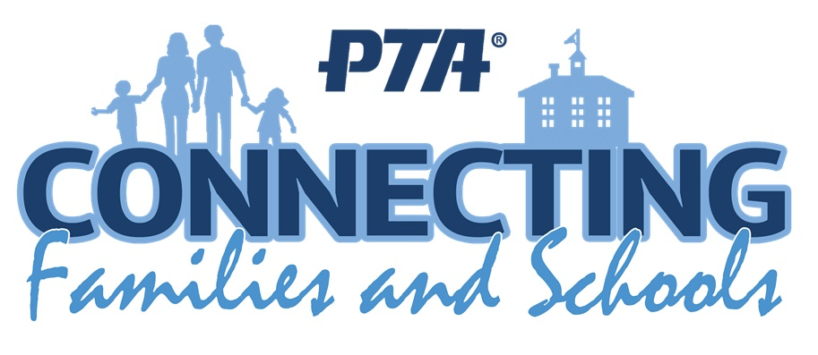](http://www.google.co.uk/url?sa=i&rct=j&q=&esrc=s&source=images&cd=&cad=rja&uact=8&ved=2ahUKEwiEnayCsajdAhXEK8AKHVmtCFUQjRx6BAgBEAU&url=http://www.katyisd.org/campus/HE/Pages/PTA.aspx&psig=AOvVaw2Pet2zGg8sjf3JuWqVy3kD&ust=1536392124057568)

**St Brigid’s PS Parent Teacher Association (PTA) Meeting**

**We would like to invite any parents interested in getting involved in the work of the PTA in planning events and raising funds for the school to come along to the first meeting.**

Wednesday 5th October at 7.00pm in St Brigid’s PS

**Monday 26 September**

* Year 1 children stay for full day 9.00 – 2.00 pm
* Beginning of school year mass – 10 am in Our Lady and St Patrick’s
* Breakfast Club open every day 8.00 – 9.00 am
* After School Club open every day 2.00 - 5.30pm
* Dinner menu Week 1

**Tuesday 27 September**

* **Swimming Class B (1.00-1.30pm) and Year 5 (1.30-2.00 pm) £3.50 per week**
* Singing and Guitar Tutor

**Wednesday 28 September**

* **Year 7 Hockey:** (5 weeks - £1.50 per week or £7.50 for 5 weeks)
* Strings Tutor in

**Thursday 29 September**

* Guitar Tutor
* School Council Election Day

**Friday 30 September**

* Principal Awards and Safeguarding Assembly
* Piano Tutor
* **Football 2-3 pm Year 6 & 7:** (£1 per week or £10 for 10 weeks)

**Up and coming information & dates for your Diary**

* **Staff Development Day: Wednesday 12 October School Closed.**
* **Mid Term Break October/November 2022:**

Monday 31 October to Friday 4 November (inclusive)

**Christmas Break 2022:**

12 noon Wednesday 21 December – Friday 6 January (inclusive)

Have a very enjoyable weekend and thanks for your continued support.

Mr K O’Neill Principal

**St Brigid’s Primary School – Castle Street – Ballymoney – BT53 6JX – 028 27662664**

**Parent Interviews**

Parent interviews will take place during the week beginning

**17 October 2022**

This year the interviews will return to an in school meeting with your child's class teacher, however, to remain flexible for parents, the choice of a phone call interview will also be available.

A text message will be sent next week, with a link to a form to fill in for each child, to express a first and second preference for an interview time and to select the option of a face-to-face meeting or phone call.

Each interview will be no more than 10 minutes.

**During the week of Parent Interviews, the school will close at 2.00 pm for all children each day.**

**Parent Interviews Time Schedule**

**Monday 17 October: 2.10 – 4.00 pm**

**Tuesday 18 October: 2.10 – 4.30 pm**

**Wednesday 19 October: 2.10 – 4.00 pm**

**Thursday 20 October 2.10 – 4.00 pm**

**Friday 21 October 2.10 – 3. 30 pm**

**There will be no Year 5 swimming during this week.**

**The After School Club will be open as normal from 2 – 5.30 pm.**

Staff Development Day

School Closed

**Wednesday 12 October**

**2022**

**Speed in the Chapel Car Park**

Please be mindful of your speed in the chapel car park when dropping off and picking up the children. The car park is busy with children moving to and from cars. All drivers must be careful. Speed limit is 10 miles per hour.

**NUT FREE SCHOOL**

**St Brigid’s PS is a Nut Free School. There is a child in our school with a Nut Allergy.**

**Please do not send in Nuts or Nut Spreads to school.**

**Sacrament Dates 2022-23**

**Sacrament of Penance:** Thursday 23 March 2023

10.30 am in Our Lady and St Patrick’s

**Sacrament of Confirmation:** Friday 5 May 2023 – **Provisional date – if the Bishop is coming the date could change. Time: TBC in Our Lady and St Patrick’s**

**Sacrament of Communion:** Saturday 20 May 2023

10.30 am in Our Lady and St Patrick’s

[](http://www.google.co.uk/url?sa=i&rct=j&q=&esrc=s&source=images&cd=&cad=rja&uact=8&ved=2ahUKEwj8i9mCwajdAhVRQ8AKHU6DBtUQjRx6BAgBEAU&url=http://presentationcastleisland.ie/event/beginning-year-school-mass/&psig=AOvVaw1jsqgWj6ltYumi1EkxKehs&ust=1536396456824846)

**Beginning of school year mass.**

**Monday 26th September 2022**

**10am in Our Lady and St Patrick’s**

All family members welcome to join with us to celebrate together.

**FREE SCHOOL MEALS and UNIFORM GRANTS**

All details with regards to eligibility and application can be found on the Education Authority website:

<https://www.eani.org.uk/financial-help/free-school-meals-uniform-grants>