

**School Information for Parents/Guardians**

**Monday 5 December 2022**

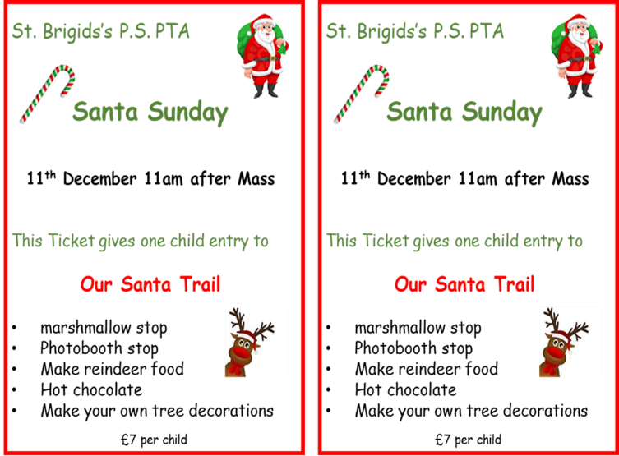

Follow us now on **the web** for news updates

**www.stbrigidspsballymoney.com**

Live entertainment in the hall!

Tea, coffee shortbread, mulled wine and mince pies

School choir opening our event

Ping pong cups

Christmas tree ring toss

Glitter tattoos

Face painting

Mrs Claus’ storytelling

Christmas movie

Mr Slushtail

**Santa Sunday**

**11th December 2022**

**In**

**St Brigid’s P.S.**

**( After 10am Mass)**

**Tickets on sale this week.**

**Or may be purchased on the day.**

**NUT FREE SCHOOL**

**St Brigid’s PS is a Nut Free School. There is a child in our school with a Nut Allergy.**

**Please do not send in Nuts or Nut Spreads to school.**

**Monday 5 December**

* After School Club open every day 2.00 - 5.30pm
* Dinner menu Week 3
* Doherty Cup Match 2.15 pm @ University

**Tuesday 6 December**

* Swimming Class B and Year 5 (1.00-1.30pm)

£3.50 per week (Last Swimming Session Term 1)

* Singing and Guitar Tutor

**Wednesday 7 December**

* Year 5 & 7 GAA coaching
* Year 6 Hockey and Multi-Sports: (5 weeks - £1.50 per week or £7.50 for 5 weeks)
* Violin tutor in

**Christmas Show**

**Matinee Tues 13th Dec**

**Evening Show 14thDec**

**Tickets go on sale from**

**Monday 5th December**

**(2 per family per show)**

**Thursday 8 December**

* Guitar Tutor
* Christmas Dinner Party Box Day (Christmas Jumpers)

**Friday 9 December - Children may wear Christmas jumpers**

* Principal Awards
* Piano Tutor

**Up and coming dates for your diary**

* **Christmas Break 2022:**

12 noon Wednesday 21 December – Friday 6 January (inclusive)

Children may wear Christmas jumpers every Friday in December.

Have a very enjoyable weekend and thanks for your continued support.

Mr K O’Neill Principal

**St Brigid’s Primary School – Castle Street – Ballymoney – BT53 6JX – 028 27662664**

[](https://www.bing.com/images/search?view=detailV2&ccid=jk8N/iMe&id=06AC5E8CEAC3274E315EBD619FBAD96A202DE7AC&thid=OIP.jk8N_iMeXl-g_OU1j4ALnwHaGo&mediaurl=http://cleaprimaryschool.com/cmsfiles/items/news/IMG_1445_2.jpg&exph=600&expw=670&q=christmas+school+show&simid=608006125896075436&selectedIndex=66&adlt=strict)

**Matinee: Evening Show:**

**Tuesday 13/12/19 1.00 pm. Wednesday 14/12/19 7.00pm**

**Health and Safety**

Parking available in the school playground and church car park. Please contact the school if you require disability access.

Unfortunately, as the hall is at full capacity, there will be no room for buggies in the hall during the shows.

**Tickets**

Tickets will go on sale on Monday 5 December. The capacity of the hall is limited, therefore, there will be 2 tickets available per family for each show if required. Class A are only doing the Matinee performance.

Unfortunately, the hall has a limited capacity and this means we cannot guarantee any requests for additional tickets. We will keep a list of anyone interested in additional tickets and if any are available we will endeavour to allocate extra tickets to those who have made requests.

**Tickets are £3.00 each**

**PTA Christmas Draw - Selection of Prizes**

**PTA Grand Christmas Draw** – **tickets are on sale and the deadline for all returns is Friday 9 December. Tickets will also be available at the Santa Sunday event.**

Thanks to so many people for their kindness in making donations to the PTA Christmas Draw. The many prizes that have been donated have led to some great prizes this year.

