World Maths Day 2019 Parents’ Problem Solving Competition

Name_______________________Child’s Name_____________Class______

I am a palindrome (I read the same forwards and backwards, eg 10201, 343). I am greater than the number of days in a year and less than the product of 19 and 20. What number am I?

­­­­Answer:_____________________________

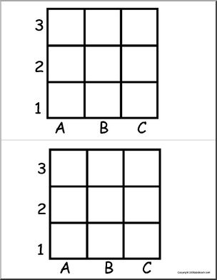

­­­­How many squares can

you see?

Answer:________________

Two ducks in front of a duck, two ducks behind a duck, a duck in the middle. How many ducks?

­­­­Answer:______________

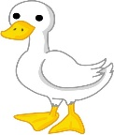

There are five gears connected in a row, the first one is connected to the second one, the second one is connected to the third one, and so on.   
If the first gear is rotating clockwise what direction is the fifth gear turning?

Answer:_______________





Frank's father has 5 sons. If the names

of his 4 sons are Fefe, Fifi,

Fofo, Fufu, respectively,

what would be the name of his 5th son?

­­­­Answer:_______________

Subtract 1000, add 40 add 1000 more, add 30, 1000 more, plus 20 plus 1000 and plus 10...

­­­­Answer:________________



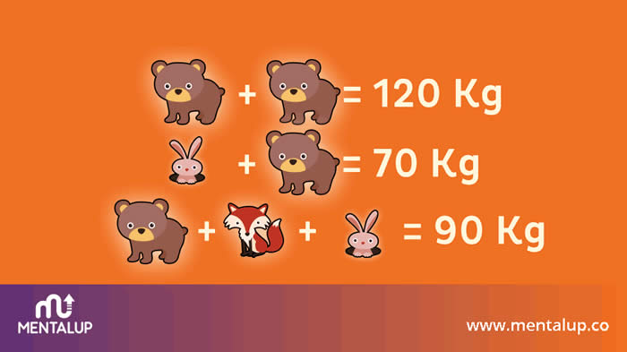

­­­­Find the weight of

each animal.

Answer: Bear__________ Rabbit___________

Fox__________________

Good luck and enjoy!!!