

**School Information for Parents/Guardians**

**Monday 21 November 2022**

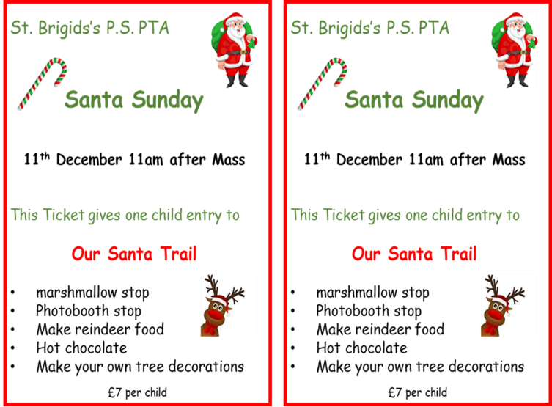

Follow us now on **the web** for news updates

**www.stbrigidspsballymoney.com**

Live entertainment in the hall!

Tea, coffee shortbread, mulled wine and mince pies

School choir opening our event

Ping pong cups

Christmas tree ring toss

Glitter tattoos

Face painting

Mrs Claus’ storytelling

Christmas movie

Mr Slushtail

**SANTA SUNDAY**

**11TH December**

**in St. Brigid’s PS**

**after 10 am Mass**

**Tickets go on sale next week and can be purchased on the day also.**

**Monday 21 November**

* After School Club open every day 2.00 - 5.30pm
* Dinner menu Week 1

**NUT FREE SCHOOL**

**St Brigid’s PS is a Nut Free School. There is a child in our school with a Nut Allergy.**

**Please do not send in Nuts or Nut Spreads to school.**

**Tuesday 22 November**

* **Swimming Class B and Year 5 (1.00-1.30pm)**

**£3.50 per week**

* Singing and Guitar Tutor
* STEM event for Y4/5 in school
* Cross Community event for P7s at the Ulster Scots Centre

10.30 – 11.30

**Wednesday 23 November**

* **Year 5 & 7 GAA coaching**
* **Year 6 Hockey and Multi-Sports:** (5 weeks - £1.50 per week or £7.50 for 5 weeks)
* Violin tutor in

**Thursday 24 November**

* Guitar Tutor
* STEM event for Y1/2 in school

**Friday 25 November**

* Principal Awards
* Piano Tutor

**Up and coming information & dates for your Diary**

* **Christmas Break 2022:**

12 noon Wednesday 21 December – Friday 6 January (inclusive)

Children can wear Christmas jumpers every Friday in December.

Have a very enjoyable weekend and thanks for your continued support.

Mr K O’Neill Principal

**St Brigid’s Primary School – Castle Street – Ballymoney – BT53 6JX – 028 27662664**



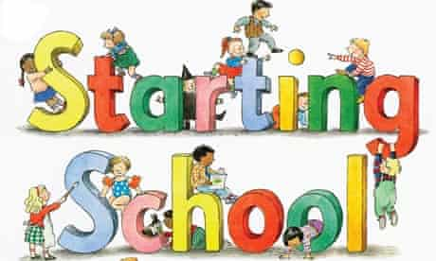

St. Brigid’s PS

OPEN MORNING

Tuesday 29th November

10 am

**Registration P1 September 2023**

**If you have a child starting school in September or know someone who is, please contact the school to register your interest.**

**There is a special section on the school website, Starting our School, and there is a virtual tour of the school already available. It’s well worth a watch for everyone.**

Application process is online this year and opens on 10 January 2023 at 12noon (GMT) and closes on 27 January 2023 at 12noon

**All the information and guidance will be on the Education Authority website (link below) from the 13 December 2022.**

[**https://www.eani.org.uk/parents/admissions**](https://www.eani.org.uk/parents/admissions)

**Please contact the school if you have any questions about the school. Information on our ‘Open Day’ will be published soon.**

**028 27662664**

**Sacrament Dates 2022-23**

**Sacrament of Penance:** Thursday 23 March 2023

**Sacrament of Confirmation:** Friday 5 May 2023

**Sacrament of Communion:** Saturday 20 May 2023

**PTA Grand Christmas Draw**

Every year we are blown away by the generosity of local businesses and parents in donating great prizes for our PTA Christmas Draw.

Last year we had almost 30 great prizes that were donated.

The draw was an amazing success raising **£2732**

This amount helped us to be able to complete the process of replacing all the interactive boards in the school.

It’s always the children that benefit from all the donations and fundraising efforts.

Thank you everyone.

**Christmas Draw Prize**

**Donation Appeal 2022**

We begin our appeal now for support in donating a prize towards the draw.

We acknowledge the pressures businesses are currently facing and we would appreciate any support you can give us this year.

We will also be having a bottle stall at our Santa Sunday, so any bottle donations would be greatly appreciated.

If you feel you can support us, please let us know your pledge of support before next Friday 18 November.

This is to give us time to get the tickets printed.

Further information about the tickets and all our other plans for Christmas will be communicated during November.